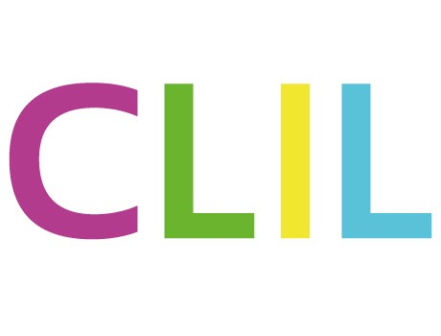
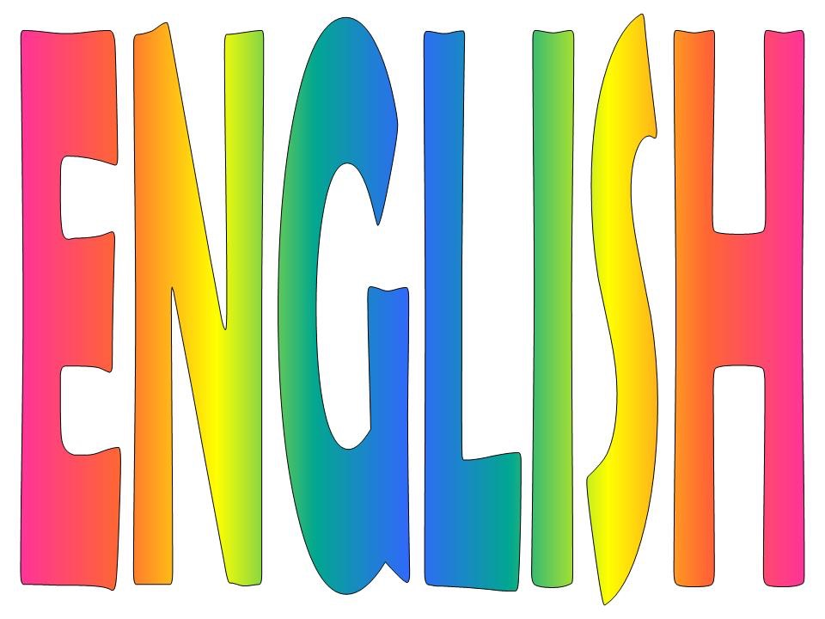
CLIL lesson

CLASS: ………… COUNTRY………………

TOPIC:
SCHOOL SUBJECT
STUDENTS’ AGE
LANGUAGE LEVEL
CONTENT
COMMUNICATION

COGNITION

CULTURE

ACTIVITIES (list them)

EVALUATION RUBRIC
(write the link or upload the pdf)
MATERIALS
(write the link or upload them)

