Easterfield Bla Bla 3




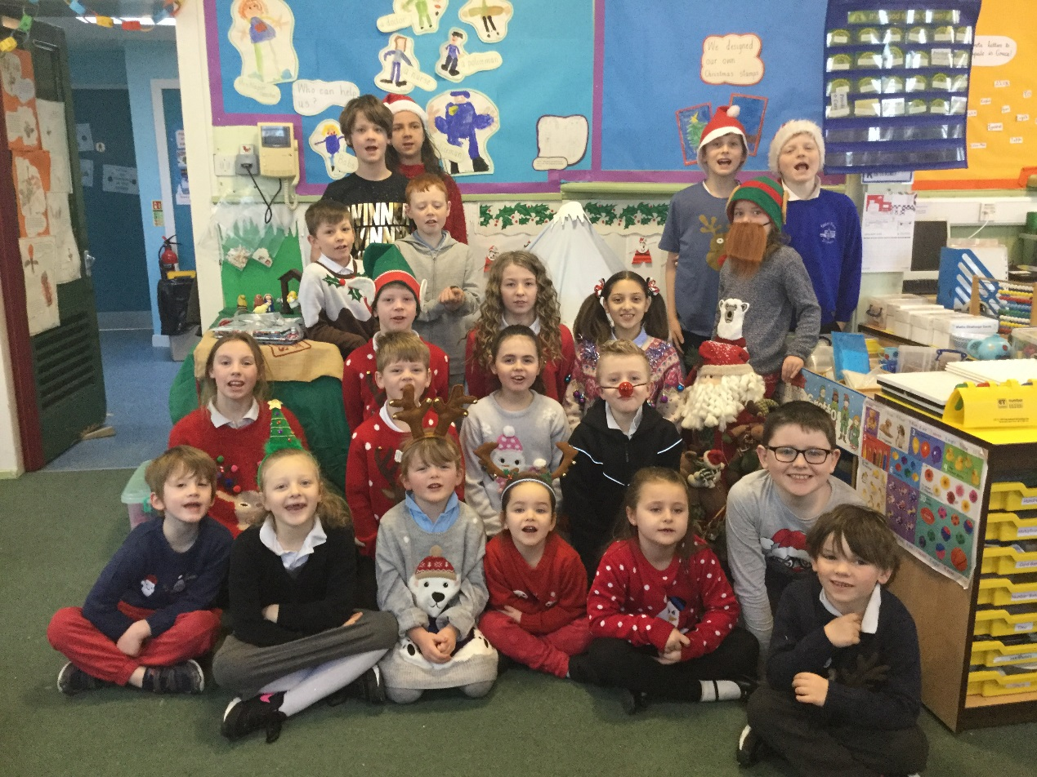

Friday 15th December was ‘Christmas Jumper Day’ in aid of ‘Save the Children’. We wore our Christmas jumpers (and hats) to raise money for the charity. We had to give £1 to wear our Christmas jumper. We raised £17



