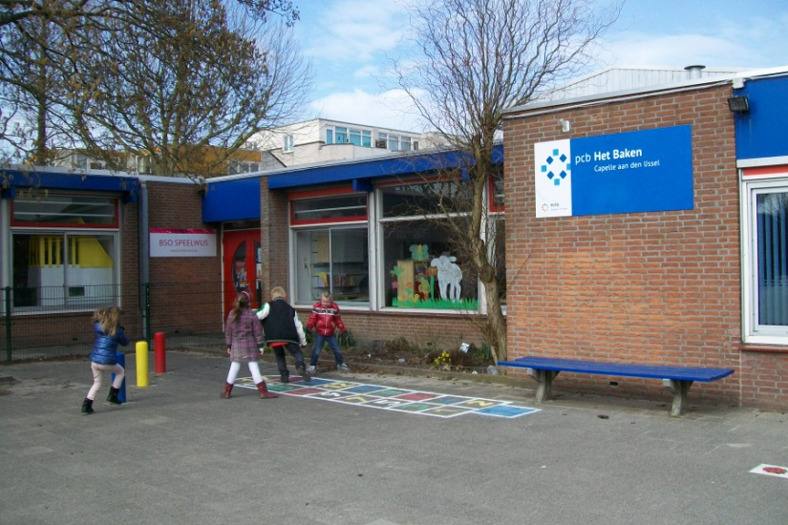
Introduction of our school:

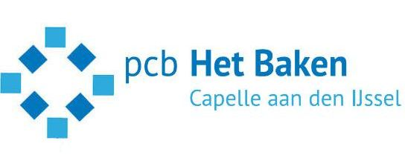

School: Pcb Het Baken,
Adress: M. Danneelserf 18, 2907 BD,
Capelle aan den IJssel, The Netherlands
Telnr: 0031104503015
Email: directie@hetbakencapelle.nl
Principal: Tineke Straver
Coördinator: Hans van Embden h.embden@stichtingpcpo.nl; 0031621484159
Facebook: Hans Van Embden
Website: www.hetbakencapelle.nl
Our school is situated in the 35 year old suburb Schollevaar, East of Rotterdam, province South Holland. The population of our school is most autochtone, with a lot of children from our former colonies Surinam and Antilles. The suburb population consists of many working parents (both) , also a lot divorced families. In our school we have, more than average, children with special needs such as children with motor handicaps, Downsyndrom, adhd, ppd-nos, autisme and diabetic. We have children with parents from : Brasil, Poland, Turkey, Bulgaria, Iran, Surinam, Neth. Antilles, Korea, Japan, Marocco, Italy, Scotland, Czech Rep.
Because of the good result of the former schoolpartnership, the staff recognize the internationalization is a high quality project. And a important innovation to become awareness to be a European citizen. As well for pupils as teachers it gives the curriculum a very important and interesting boost. We want to profile our school as a European school.
We toke part in Comenius schoolpartnersships: Europe through the eyes of a child 2007-2010; U+me=Us 2011-2013
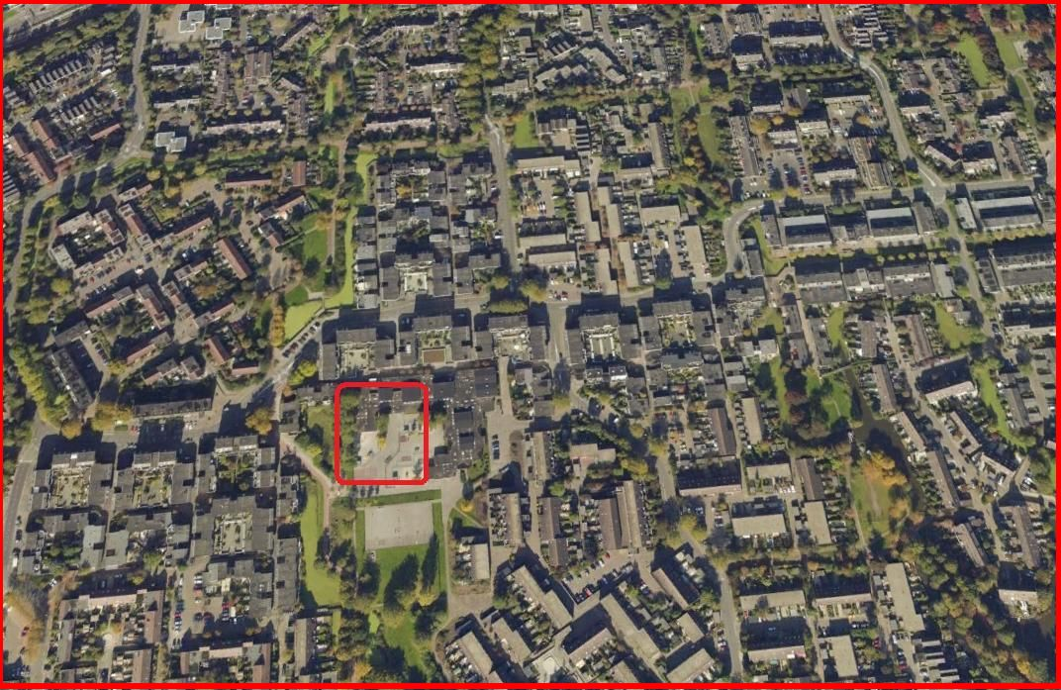
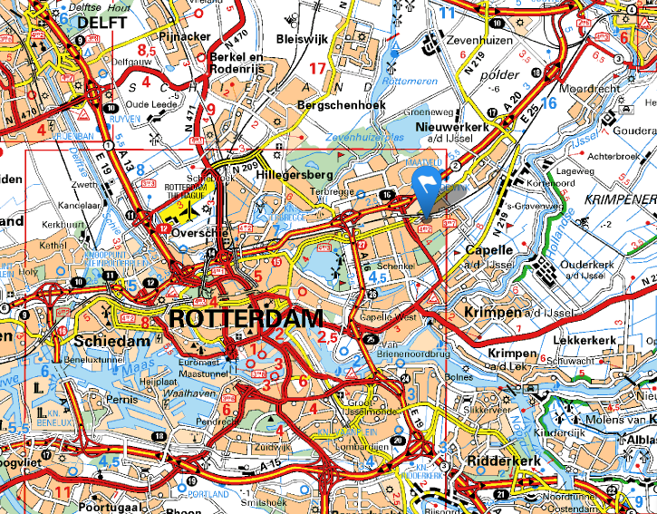
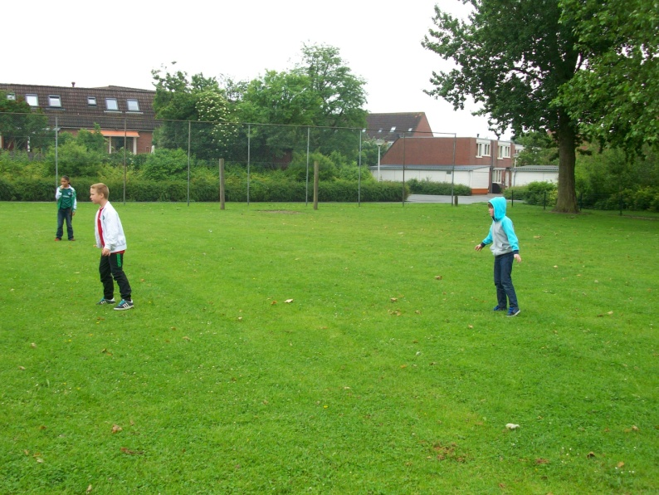
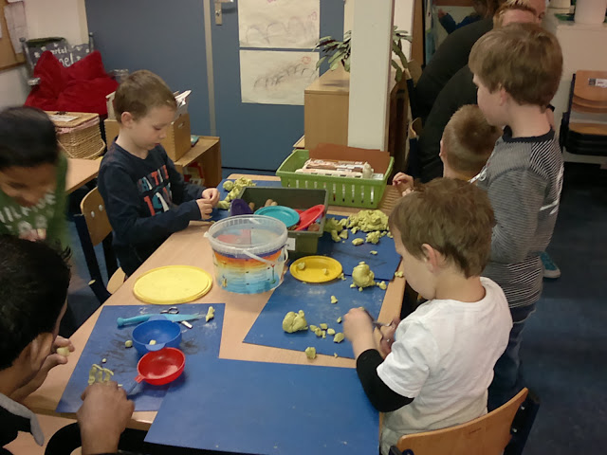
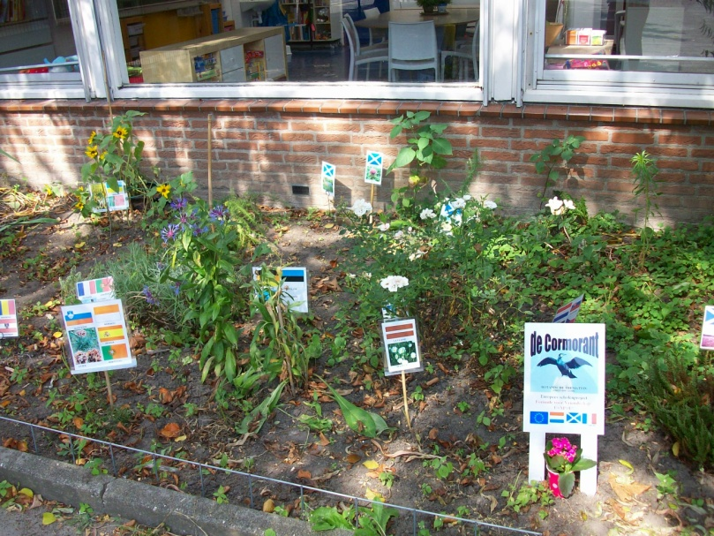
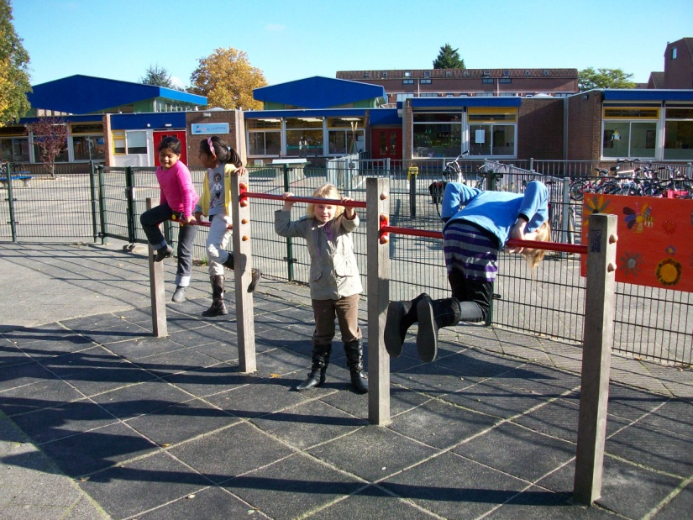
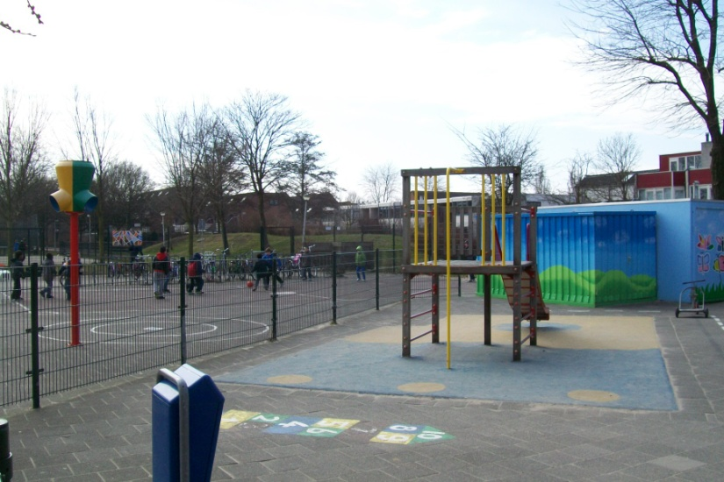
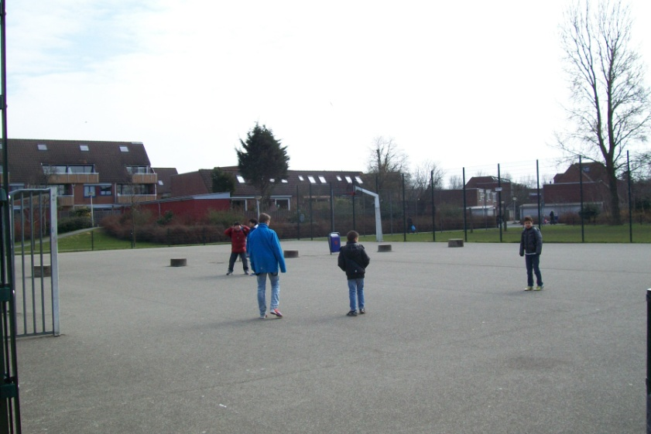
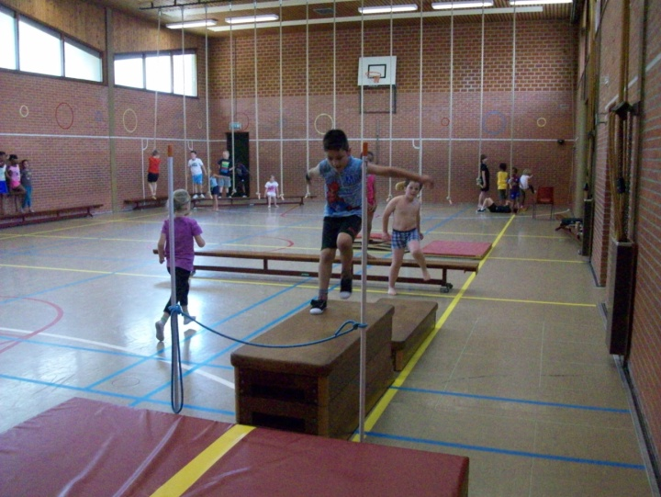
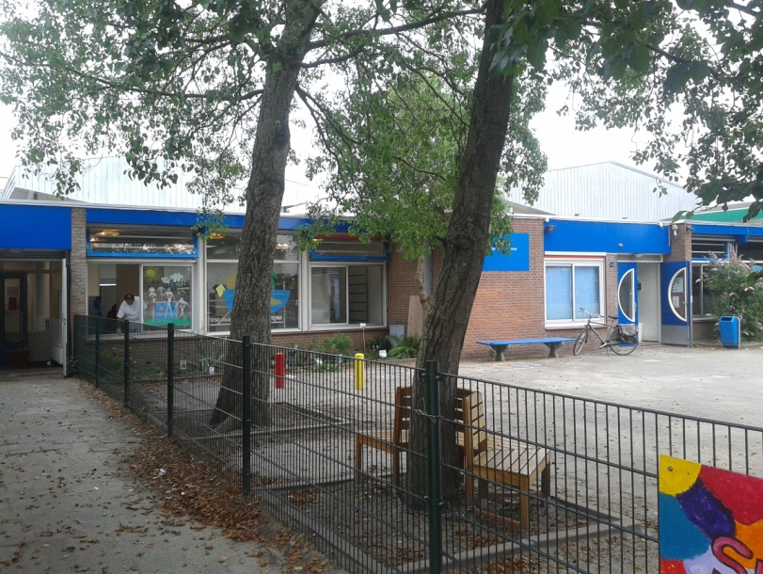

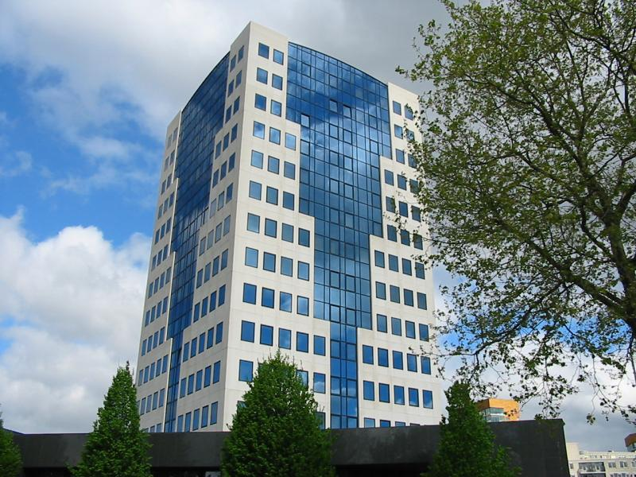
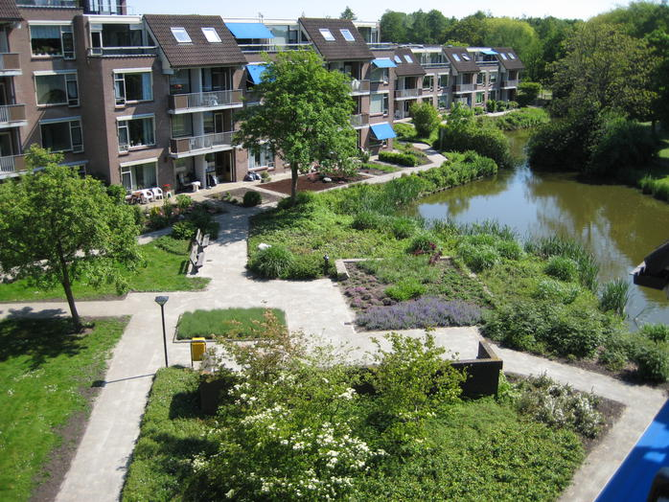
SUBURB Schollevaar townhall

Church park
