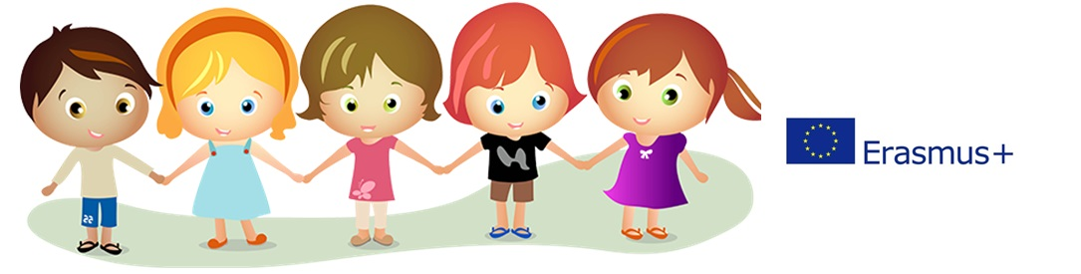

BULGARIA
HASKOVO
Primary school "St. Kliment Ohridski"
www.kliment-hs.com / oy.kliment.hs@gmail.com
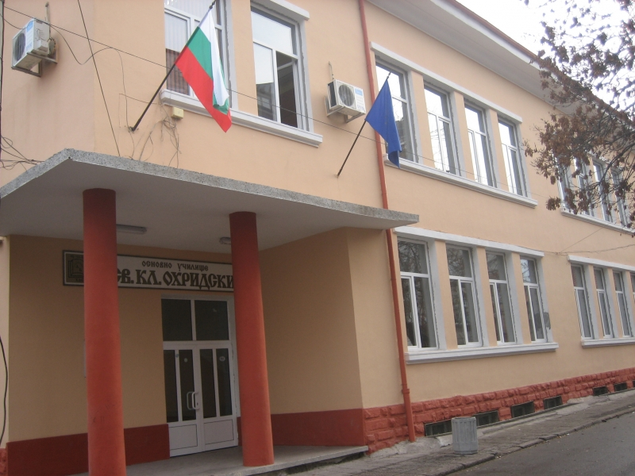
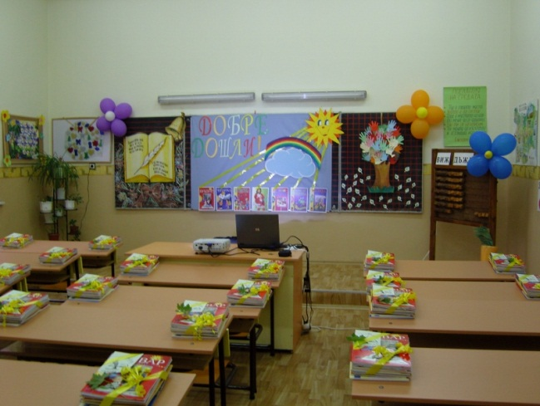
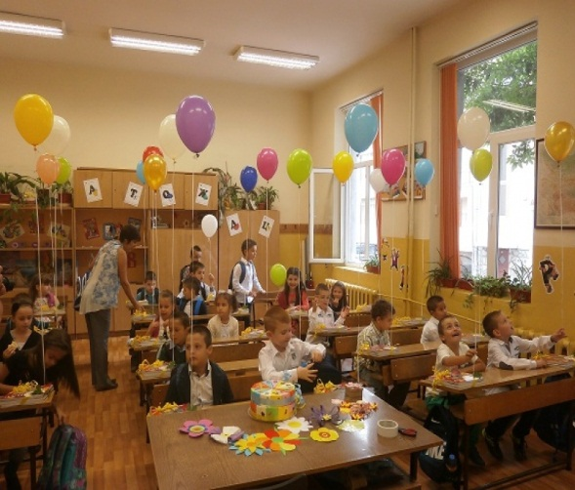
Primary school "St. Kliment Ohridski" is one of the leading schools in the region.It's named after St. Clement and it's a school with rich traditions, which leave lasting traces not only in the life of its students but also in the life of the people in Haskovo. The qualified teaching staff and generations of students keep the values of Bulgarian education.Our school has three solid buildings and a big gum. We have three computer labs equiped with new modern computers and internet connection. The school trained 671 students from first to seventh grade. There are a lot of extracurricular activities: Art Club, Sport Club, Mathematics and Information Technology, Music and Folk dances club. The school has disadvantaged children, children with dyslexia and children with special educational needs. For these children special care.
Outside of school, children are free to pursue their interests and they learn how to play basketball or the quitar, they learn how to skate or play videogames but during a typical six hour school day, how much ownership do students have of their learning?Practically none. It’s not surprising that their interest in learning dissipates and that teachers complain of unmotivated students.
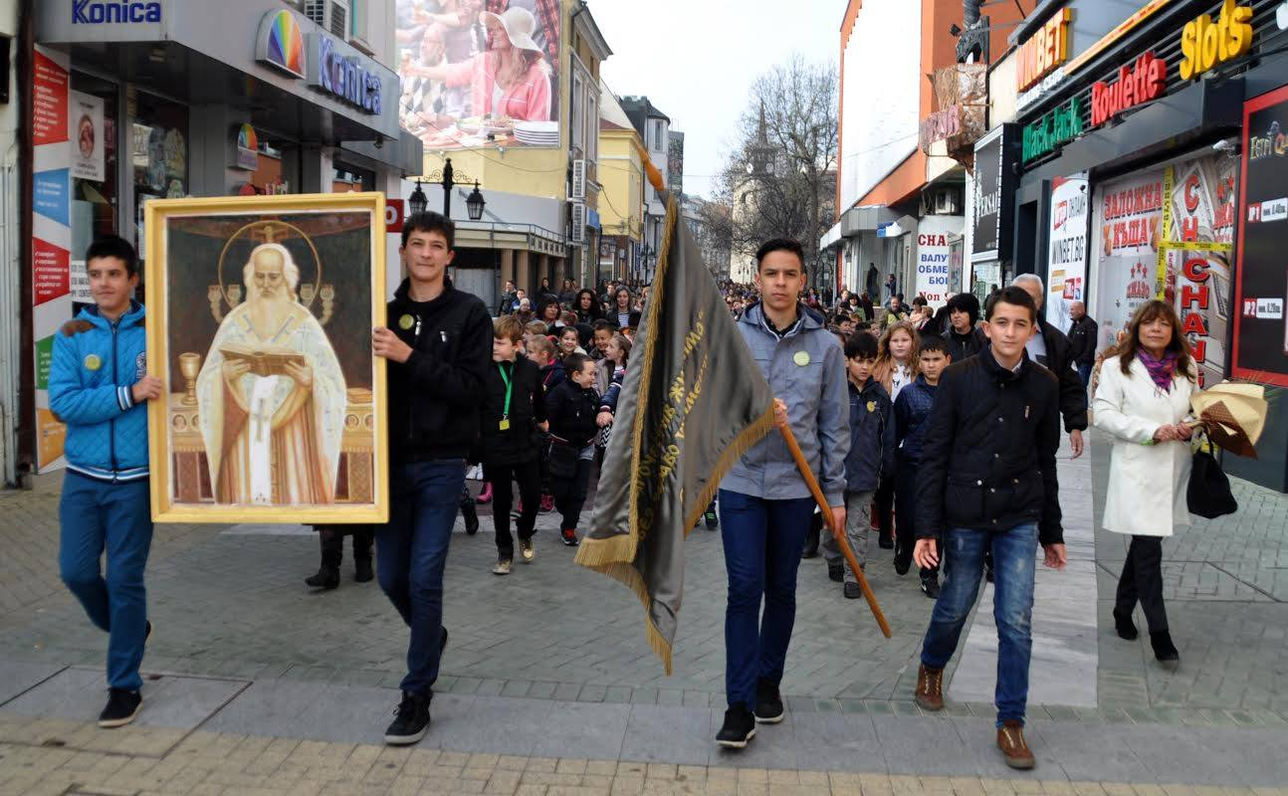
The reason why this project is needed is that joy in different subjeets will have important effects on children. With this project we’ll give students and teachers choice to introduce Art, Music, PE, Maths, English and ets. in JOY. It wiil be golden opportunities for us – as well as for our students – to experience the joy in the school. It was important to the teachers that the children understand how important education is but also to understand the JOY that education can bring into their lives.We have experience in Comenius and eTwinning projects.We want to participate in this partnership because we will help young people and educational staff better to understand the range of European cultures, languages and values. This project will help young people acquire the basic life skills and competences necessary for personal development. Meeting other cultures and intoducing our, will raise the quality of the school education. Making friends with people from other coutries will bring together us and will help to improve our English skills.

