POLAND
Poland was The conclusive stage of the Erasmus project Orions+ 2016\2017. When we arrived on 15th may 2017 in Swidnica a group of pupills and their families welcomed us and they showed us their availability and their hospitality.
SWIDNICA
While visiting Lower Silesia it is worth staying in Swidnica for some time- a historic town with over seven tundre and fifty-year-old tradition and a lot of valuable historic sites. Swidnica lies as close as 50 k from the capital of Lower Silesia, Wroclaw. Swidnica being the capital of the former Swidnica- Jawor Duchy lay on the most important trade routes of Silesia and the beer which was brewed there was famous across Europe.
The main monuments are Church of peace, Cathedral of Swidnica, monument of Maria Kunic and Town Hall Tower.
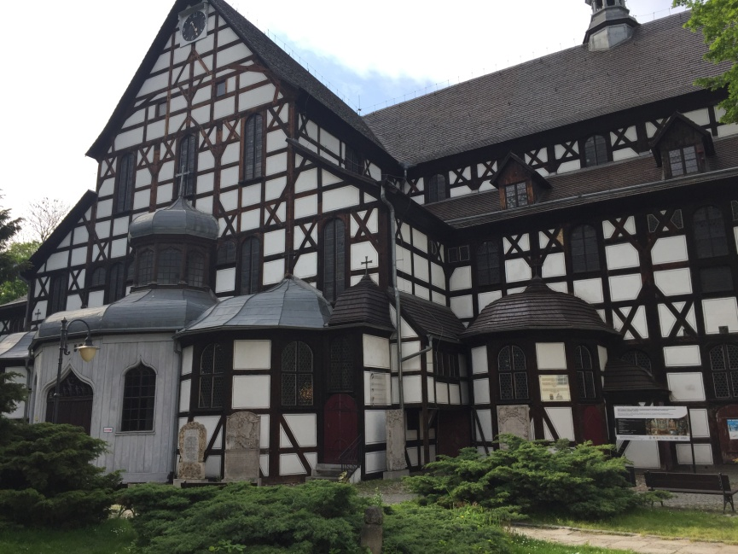
CHURCH OF PEACE
Church of Peace was built in XVII century only with wood, clay, sand and straw and it was a Lutheran Church. This structure was registered on the Unesco World Culture Heritage List. Church of Peace i san example of baroque artistic craft and care about decorative details.

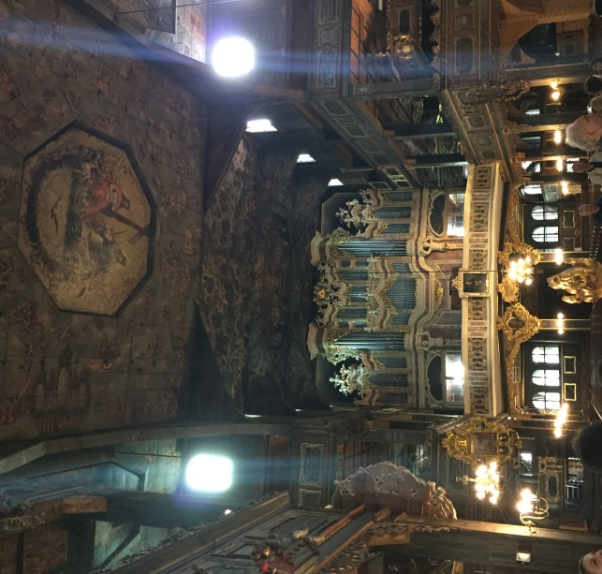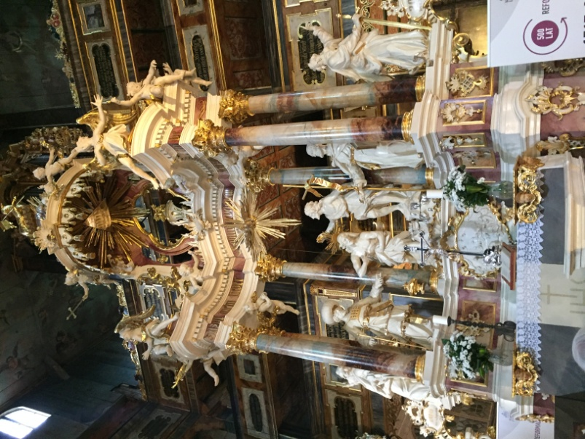

MARIA KUNIC
Maria Kunic was a German astronomer. She wrote a book “Urania Propitia”, in which she provided new tables, new ephemera, and a more elegant solution to Kepler’s problem, which is to determine the position of a planet in its orbit is a function of time. Today, her book is also credited for its contribution to the development of the German scientific language.
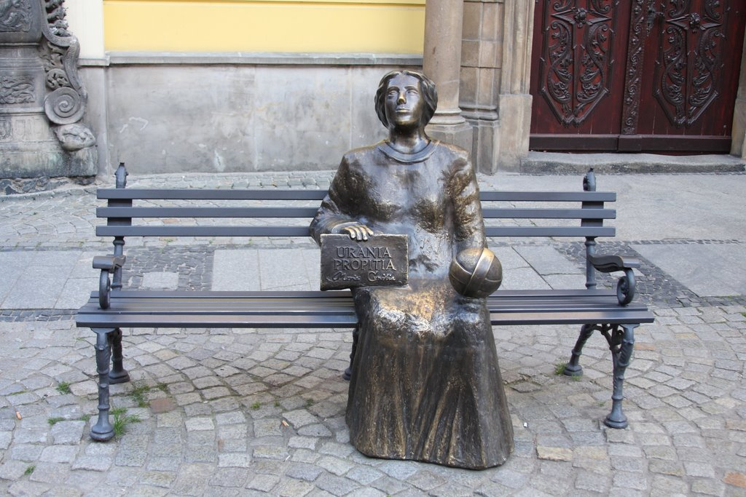

CATHEDRAL OF SWIDNICA
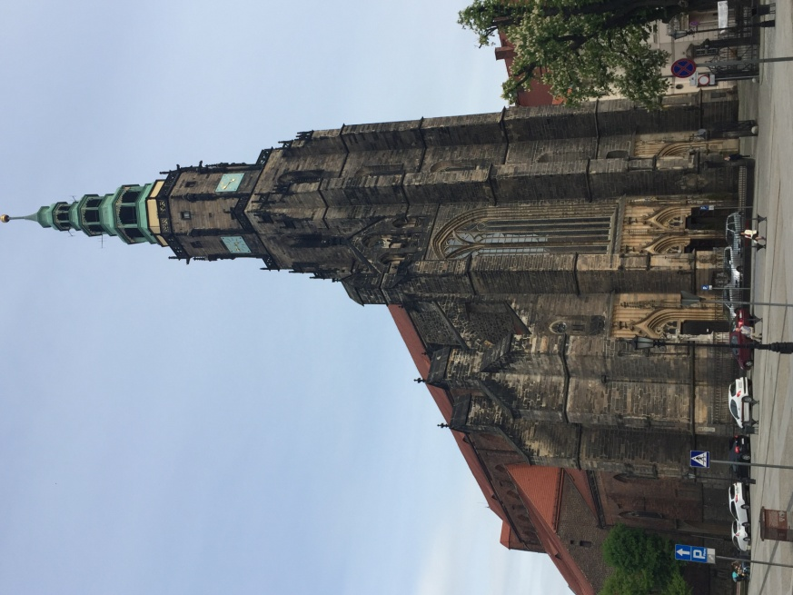
This huge building made in Gothic style amazes its impetus and characteristic interior decoration representing mixture of styles. Interior of Cathedral strikes, above all, with the magnitude of high on 25 meters building.

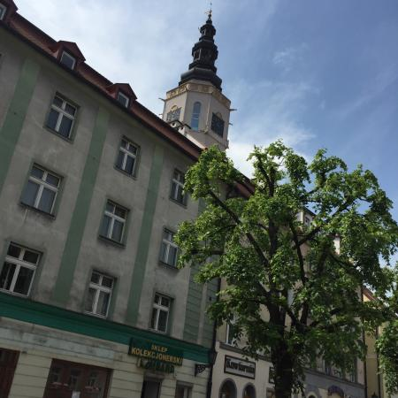
TOWN HALL TOWER
For centuries the Town Hall was a symbol of magnificence and honorable traditions of Swidnica. First mention of it appeared in 1393. The town hall tower it’ s also a place where numerous cultural events and exhibitions take place.

CASTEL OF KSIAZ AND BUNKER OF OSOWKA
Castel of ksiaz
On the 17th may we went by buss to the castle of Książ that we visited after a lesson in the Geophysical institute of the Polish Academy of Sciences about Earthquakes and their propagation waves. Than we went to the castle. This castle is one of the largest in Poland, but unfortunately only a small part of it is open to visitors. The original building was built in the 13th century, and in the 18th century it was rebuilt in Baroque style. The castle spaces are huge, there are about 400 rooms, for a total of 150 thousand cubic meters, around the building there are wonderful terraces open to visitors. Was destroyed and rebuilt several times, passed on property in Austrian, Prussian property, and finally remained in the hands of the aristocratic Hochberg family until 1941, when it was seized by the Nazis as a future residence for Hitler. The Nazis then began building a bunker about 50 meters below ground with the aim of protecting the Führer from allied bombs. The labyrinth of tunnels and bunkers was built using forced labor from the nearby Gross-Rosen. Today the tourists can visit 1500 meters of corridors or undergrounds and World War II Weapons and Tools Exhibitions.

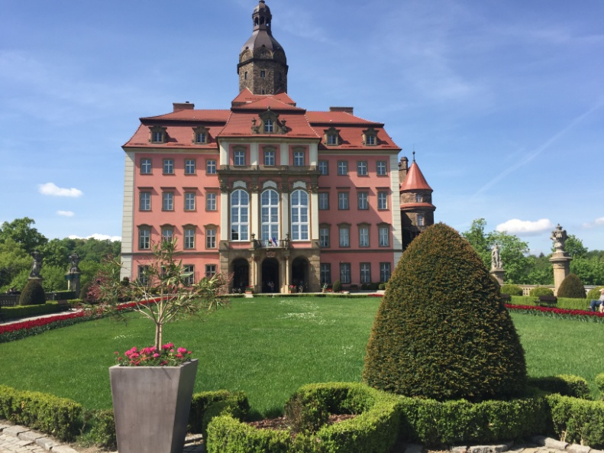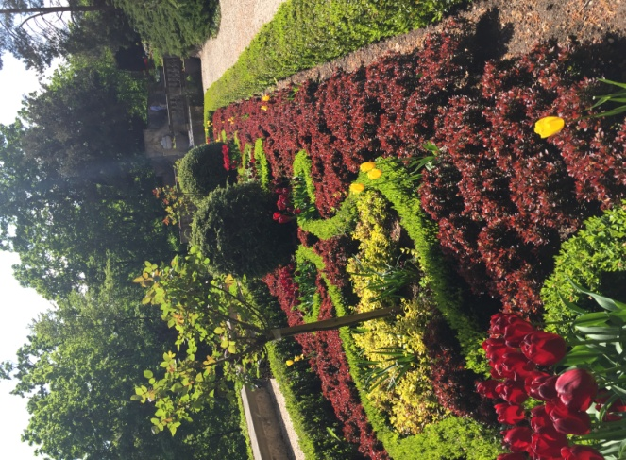
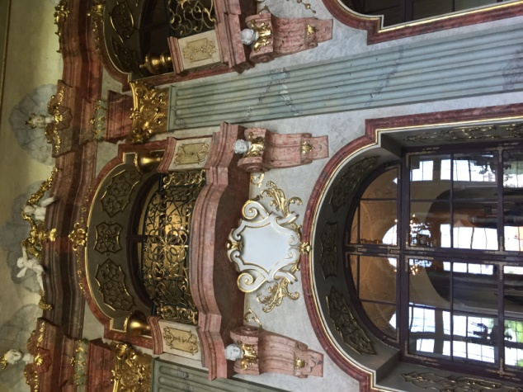
In the afternoon we went to the Osowka complex. One of the largest buildings built by prisoners under German supervision. It was built in the years 1943 - 1945 under the same castle program. To date, documents on the intended use of the complex have not been found. Only some information on the structure of the Riese complex in the Owls Mountains has been preserved. Among these information is the testimony of Albert Speer, Minister of Weapons of the Third Reich, according to which the Germans wanted to build us an underground city for twenty thousand armed soldiers, with Hitler's residence in Książ Castle. Today tourists can visit 1500 meters of corridors and underground classrooms, see different stages of the excavation and construction of underground structures, visit exhibitions and exhibitions of weapons and utensils used by the Germans themselves.
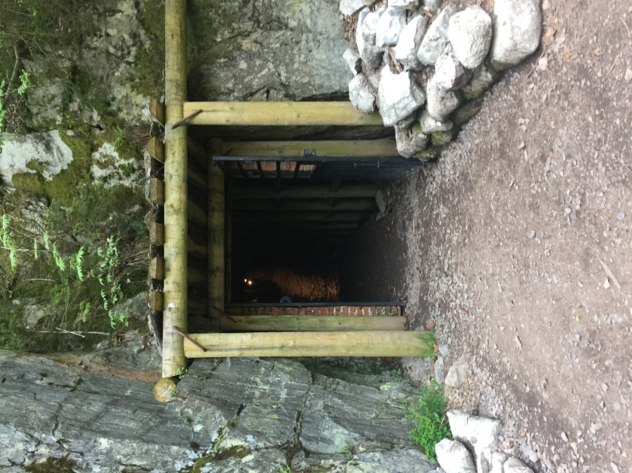
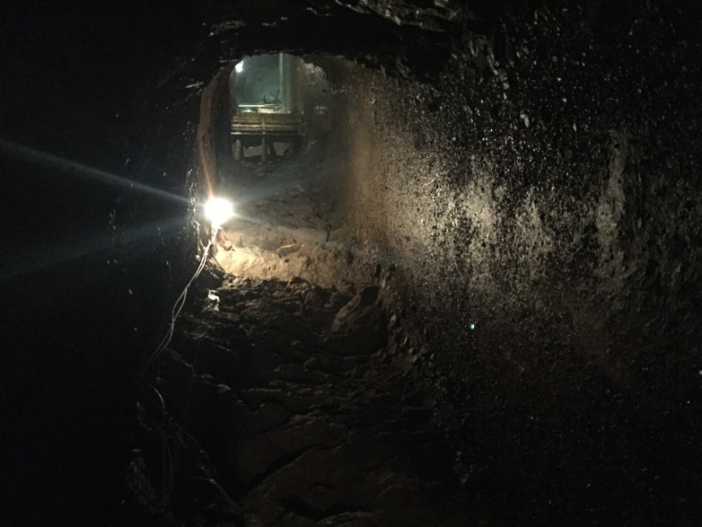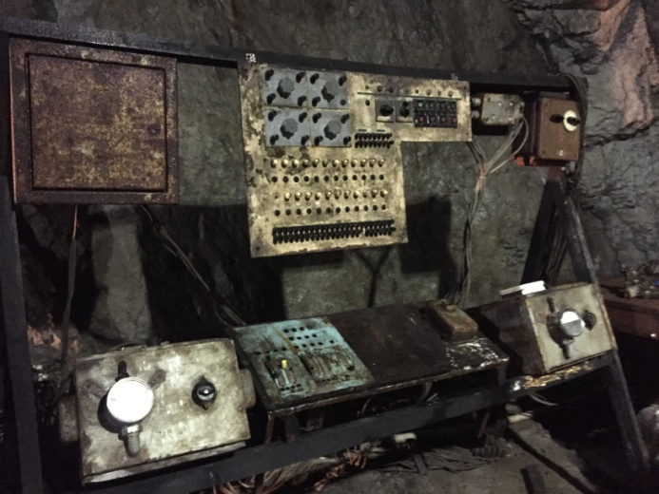

WROCLAW
Among the many activities included in our experience in Poland regarding the Erasmus project, the visit of the city of Wroclaw was one of the most beautiful.
During the fourth day of our residence in Poland, we traveled with the teachers from other countries and the Polish guys in the city of Wroclaw.
The first part of the day was devoted to the visit of Hydropolis, a wonderful museum dedicated to water, seen from different points of view, from the world and the underwater life to its importance to human life and to the evolution of the Earth.
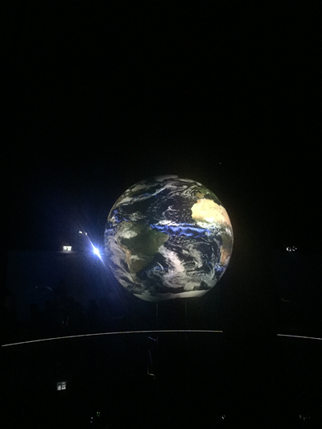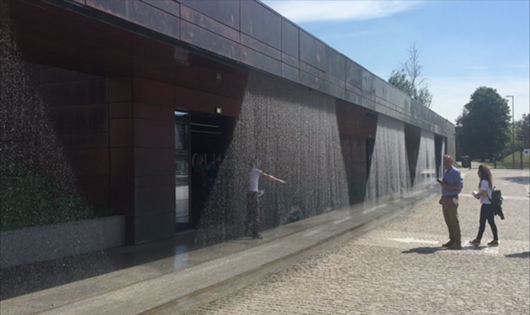

Later, we went to the center of town where we had some free time before lunch.
After lunch, a local guide led us to visit the most significant places in the city, starting with the Town Hall. Later on, we saw one of the biggest churches in the city, long controversial among Catholics and Protestants.
The visit continued with a long walk that led us to the cathedral after crossing the river that runs along the city and a bridge characterized by the presence of the padlocks.
Our tour ended with the visit of the cathedral, after which we went on the bus to return to Swidnica.

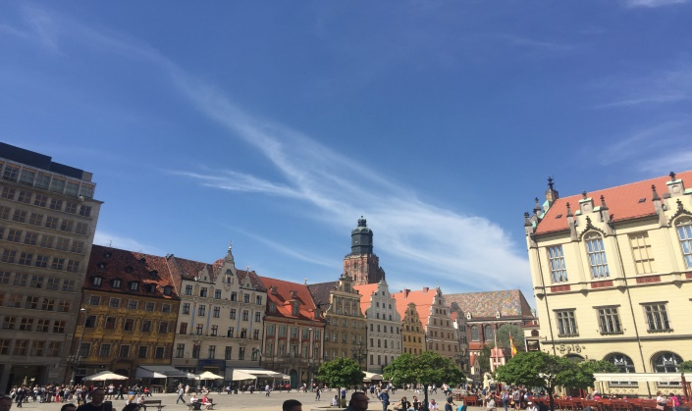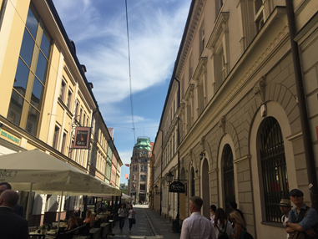
One of the most interesting activities we witnessed during the second day was the observation of some physical experiments made by the Polish guys. In particular, these experiments concerned the electric field and the resulting attraction or repulsion between equal or opposite sign charges. The most interesting experiments consisted in the use of 2 metal plates attached to thin strips of paper. The plates were connected, via a cable, to a positive or negative pole belonging to a machine that generated electricity. We observed that when the plates were loaded opposite, paper strips tended to attract each other, just because they were electrified with opposing charges. The same experiment was done later with the use of two metal balls instead of the plates, but the result was always the same.

