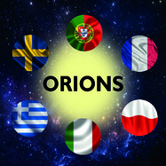

Questionarre
118 students (65 girls) took part in final Questionaire. There were 10 questions. The results are below
1. Is physic difficult for you?
2. Is mathematics difficult for you?

Students were asked the same questions before project started. There is comparison between 2015 and 2017, represented below

3. How often did you use OER (Open Educational Resourses) during the project?

4. Do you intend to partcipate in international projects in the future?
100% students answered YES.

