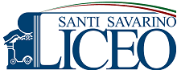
ERASMUS 2016

The Erasmus project (European Region Action Scheme for the Mobility of University Students) is a European Union (EU) student exchange programme established in 1987. Erasmus+, or Erasmus Plus, is the new programme combining all the EU's current schemes for education, training, youth and sport, which was started in January 2014. Last year, our school joined the Erasmus plus project and after an exam I was chosen to go to Greece for a week together with other two mates of my school.
Before going to Greece, we did many studies about some ancient Greek scientists and we did experiments about the calculation of the earth’s circumference and the measurement of the length of a river.
My experience in Greece started on the 18th of March 2016. There were three teachers, our headmistress and the school secretary.
The same day we landed to Atene. We stayed there for a day and we visited the Pantheon and a museum of Greek art.

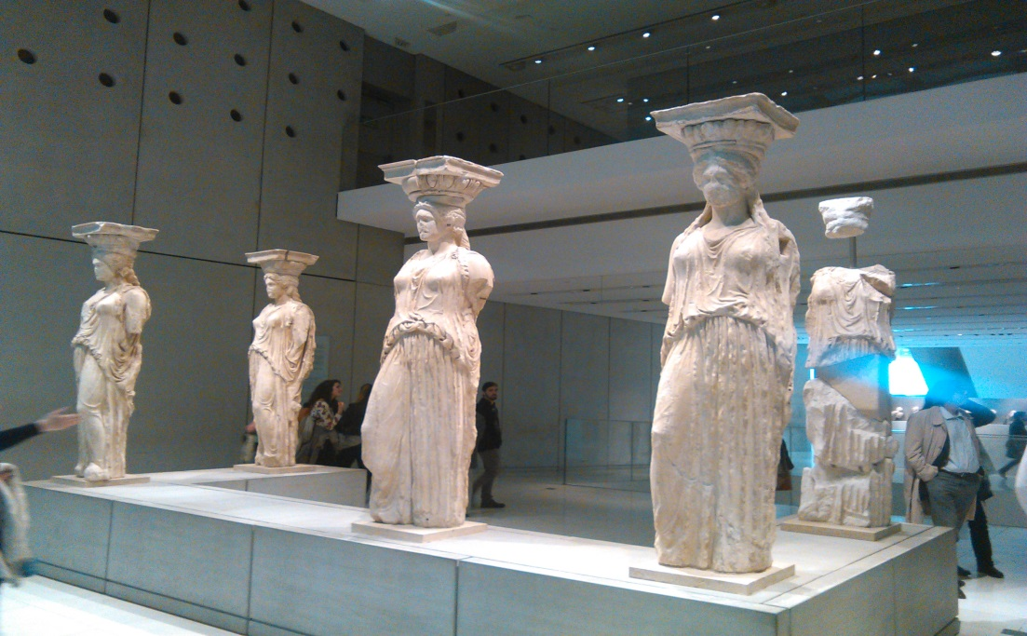
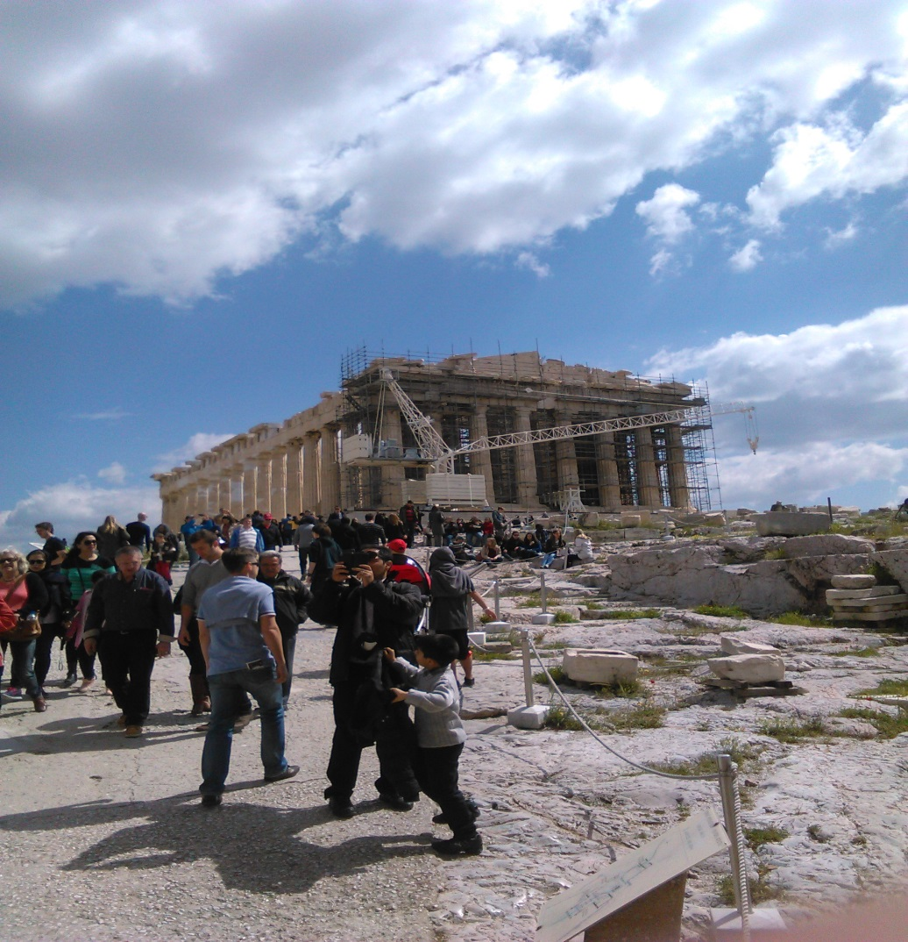
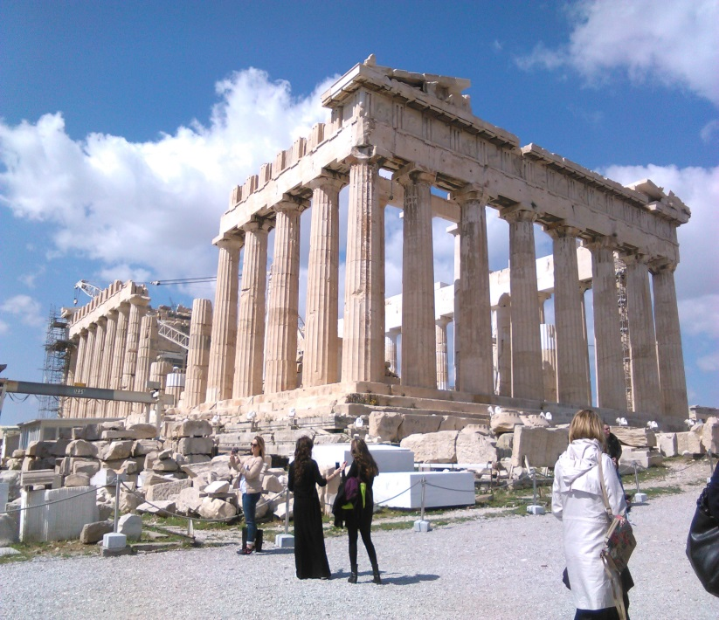
The next day we went to Creta where we met the other mates from other European countries (Poland, Sweden, Portugal, Reunion Island).
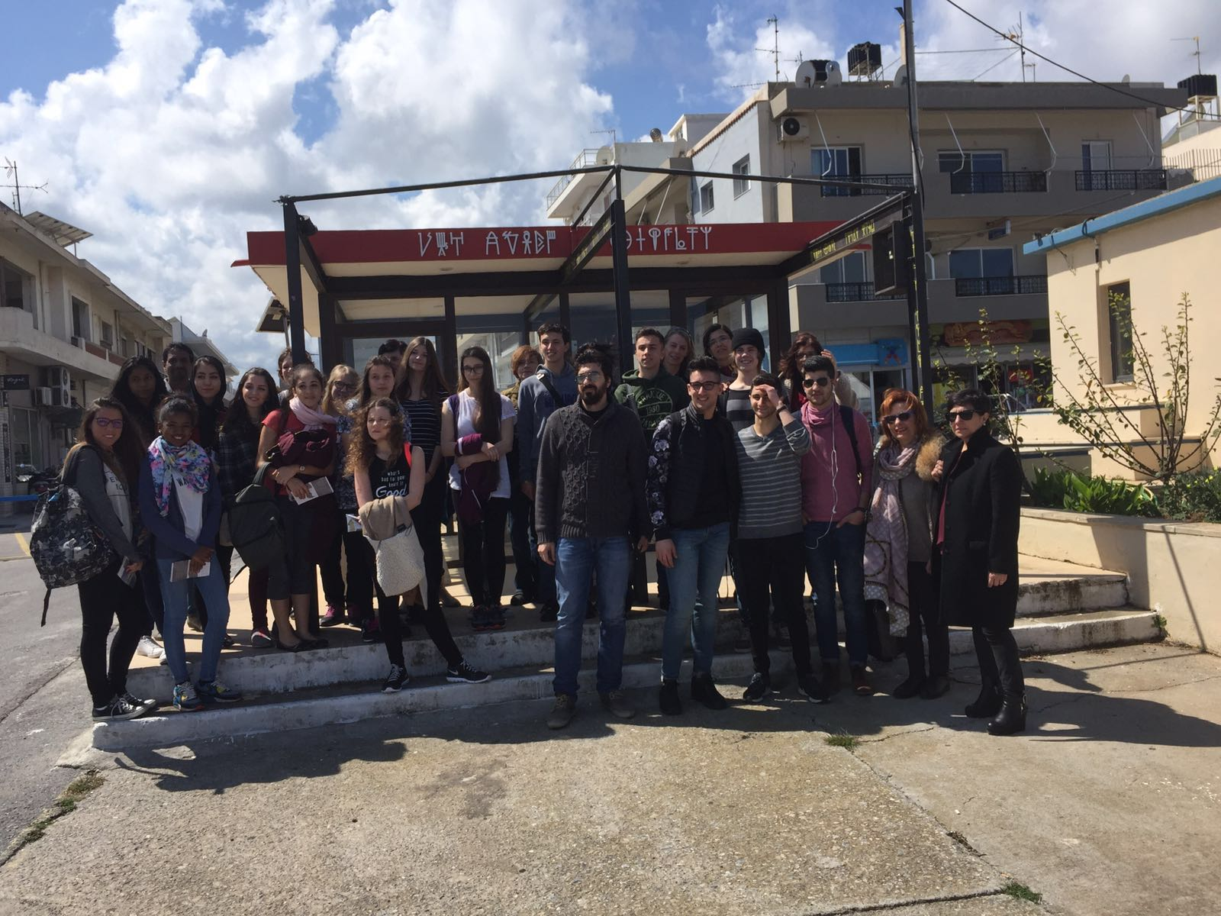
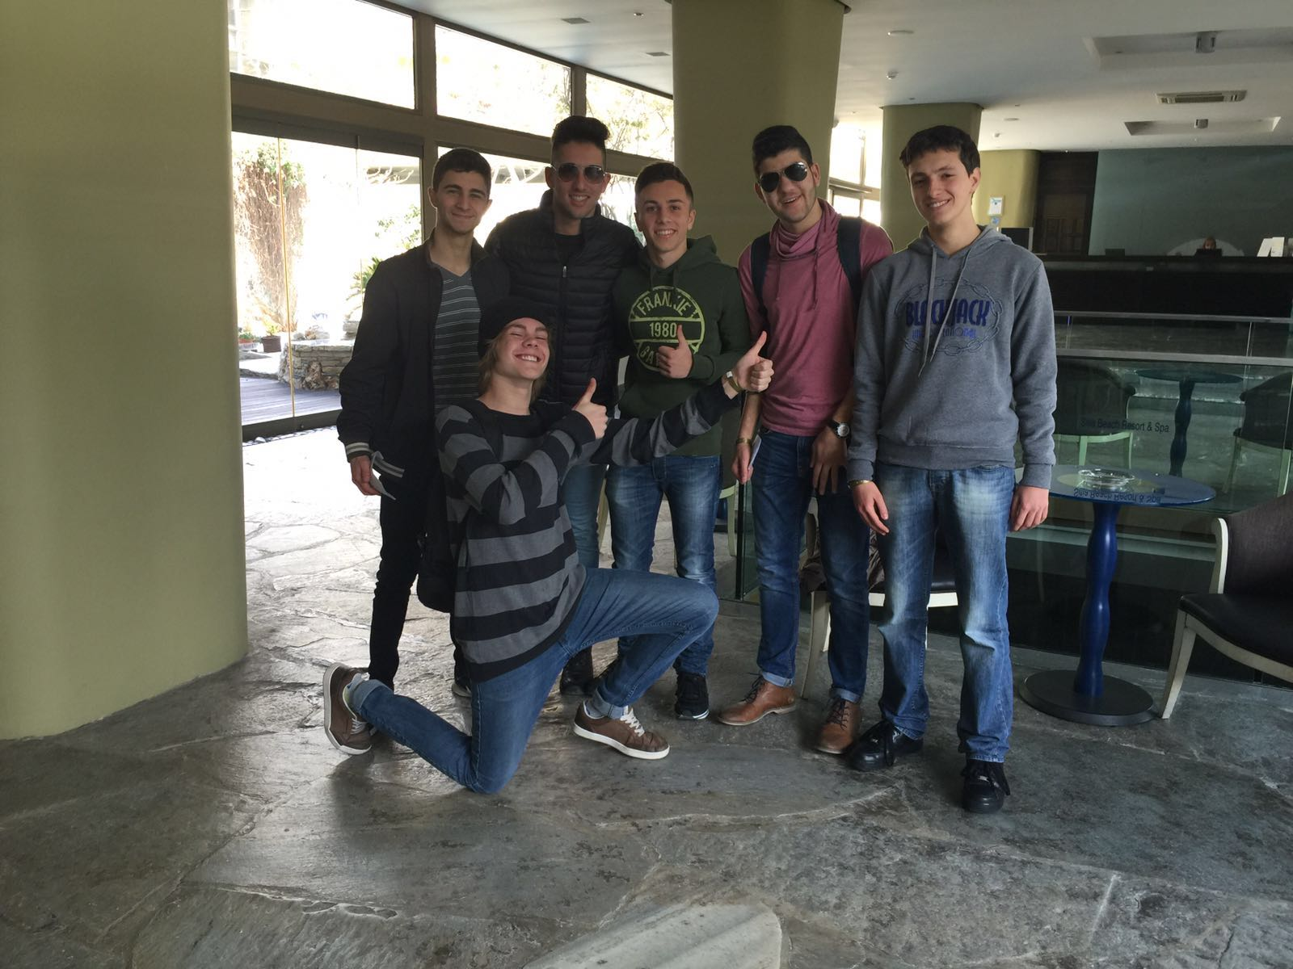
All together we stayed in a beautifull hotel in Palekastro for four days. During the first day in Creta we visited an historical museum with ancient archeological finds from the 5th century B.C.

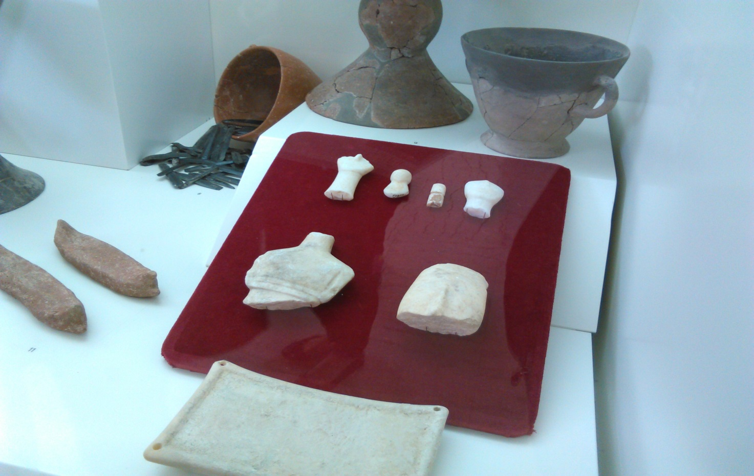
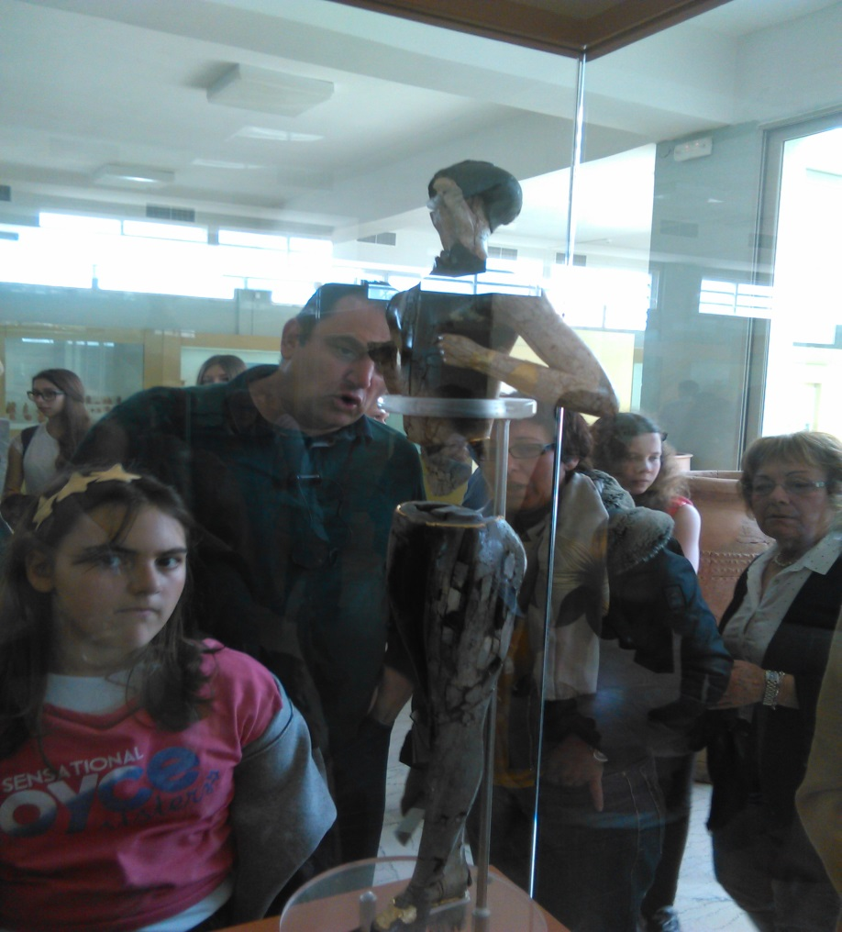
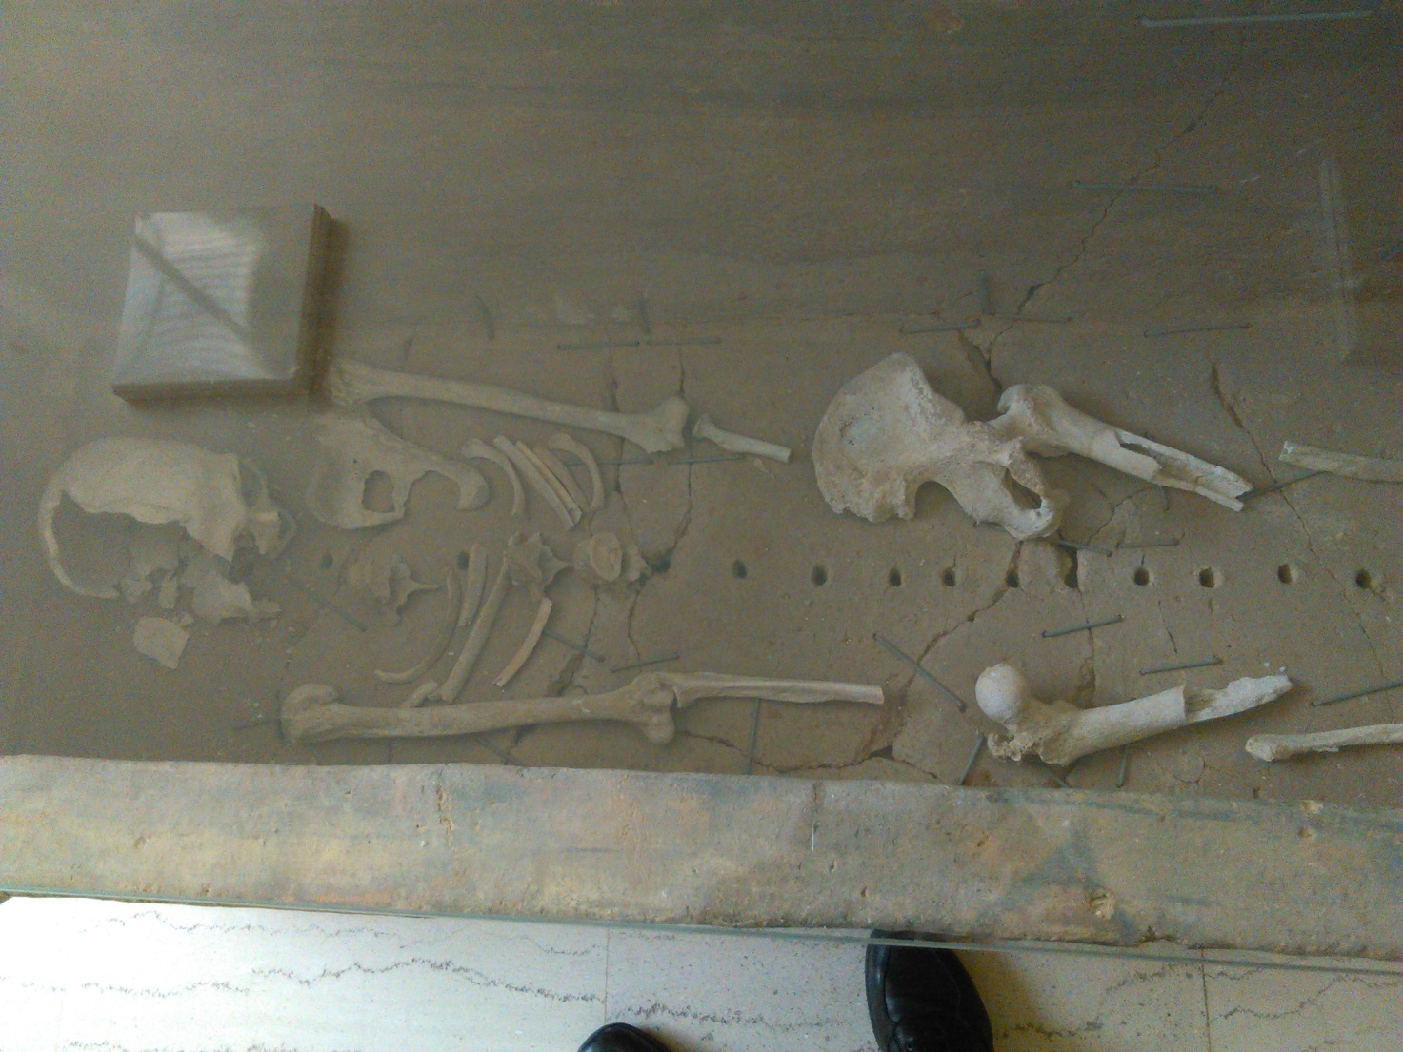
On the 21st of March (Spring equinox) we went to a greek school where we did the Eratostene’s experiment and we built a solar clock in a wall of the school using an iron pipe and drawing the hours with a felt-tip pen. we also went to the planetarium and we attempted to an astronomical lesson about the constellations.
The last day each school reported the experiments the made before coming in Crete and we explained how we calculated the earth circumference in our school.
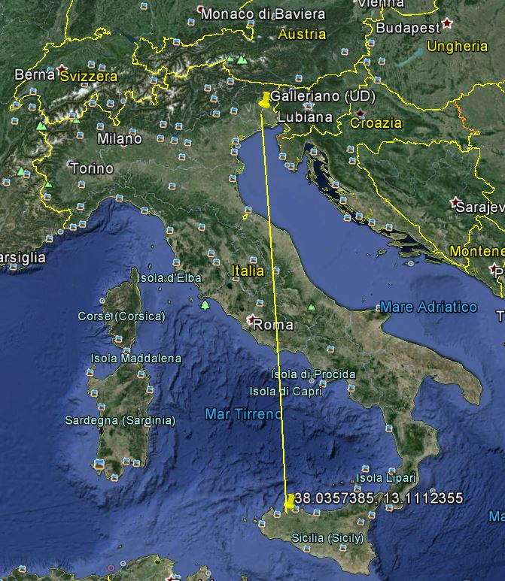
Distance from our school( Liceo Santi Savarino Partinico) to Galleriano.
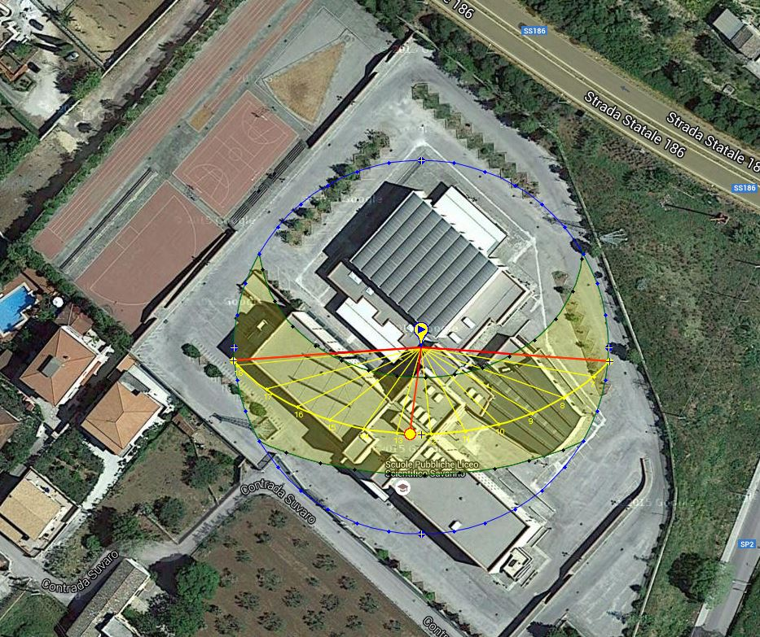
The Erasmus project was very useful in order to improve my English and it also was very funny because new could meet people from other countries of Europe and enjoy staying together sharing our different cultures and experiences.
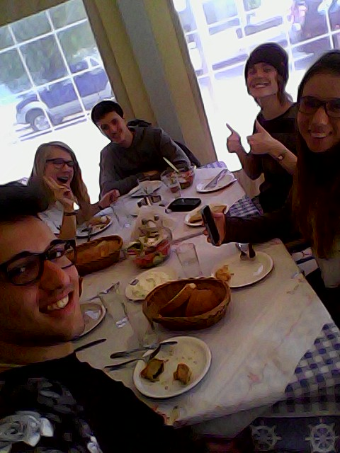
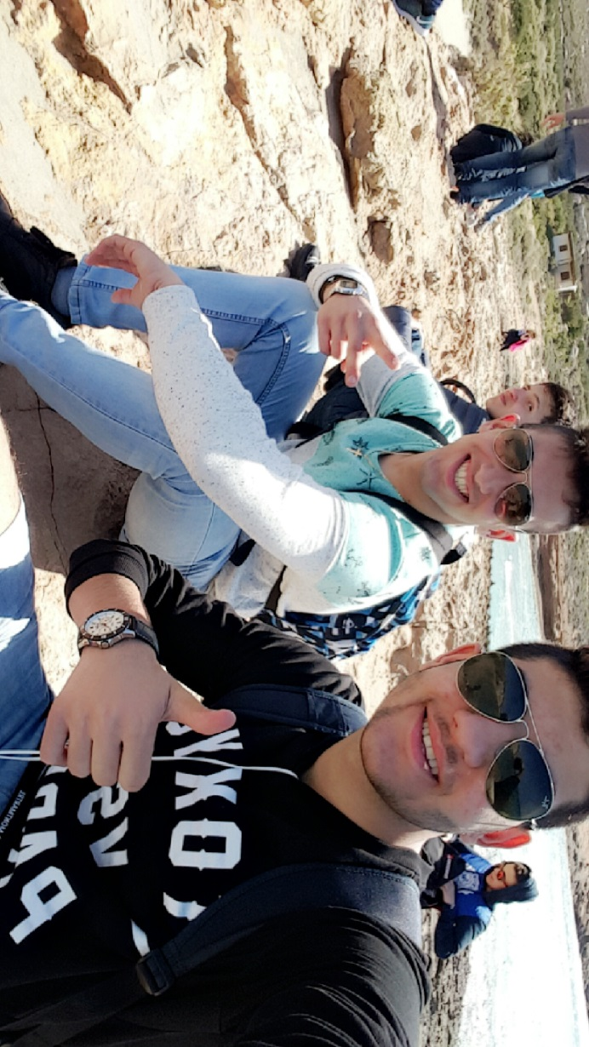
The Erasmus was a wonderful experience, not only for the trip or for the studies I did but also for the people I met and I’m sure it will be important in my future studies and in my life.

