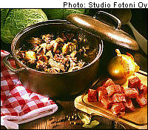
Karelian hot pot
Erasmus+ team Finland | 23.5.2016

ingredients:

600 g karelian roast meat
2 pcs carrots
2 pcs onions
1 ¼ tsp salt
1 tbsp allspice
1 tsp blackpepper
2 pcs bay leaf

directions:

Preheat oven to 200 degrees celsius.
Cube the meat into one inch cubes. Roughly chop onions. Add oil to a heavy Dutch oven and add the meat and onions to it. Roast in the oven for at least 30 minutes, or until the meat is nicely browned.
Add the diced carrots, allspice and beef stock. Cover and place back in the oven for about 2 1/2 to 3 hours, or until the meat is tender.
Serve over mashed potatoes.

