**Arctic fox:** Predatory animal of  the canine.

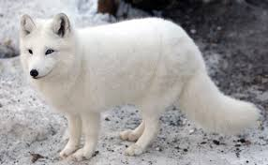

**Saimaa ringed seal:** Seal who only lives in Finland.

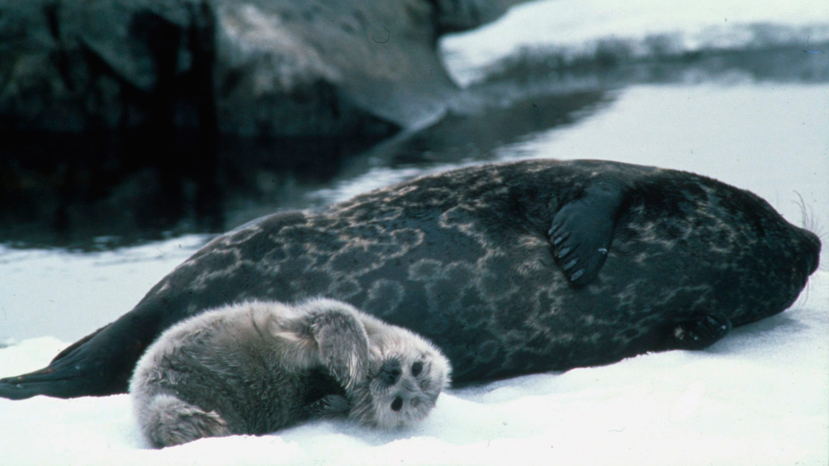

**Lynx:** Medium feline who lives in Eurasia.



**Garden dormouse:** Really rare rodent.

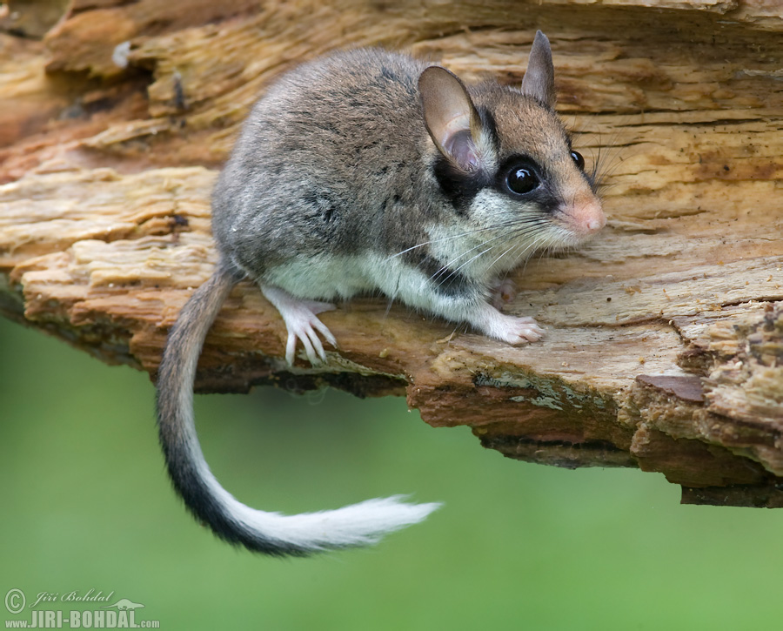

**Snowy owl:** Big sized owl who lives in t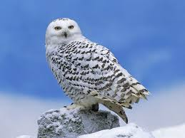he Arctic regions.

**Lesser white-fronted goose**: The most endangered goose in Eurasia.

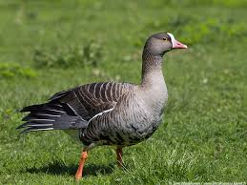

**Wolverine:** The largest marten who is predatory animal.



**Flying squirrel:** Rodent species found in the north-Eurasian region.

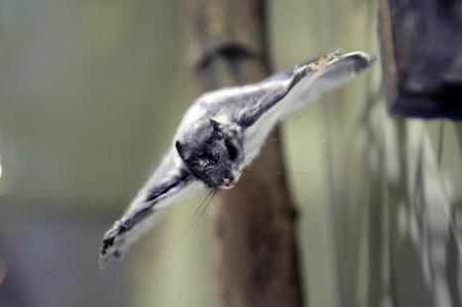

Endangered animals in Finland

*“Animal is endangered, if the animal have a risk to disappear for keeps”.*

*In Finland we have 2 124 endangered species.*

May 25 , 2016