Seasons in Lithuanian: winter
Climate in Lithuania is temperate continental. Typically there are one or two very cold weeks in winter (with night time temperatures going under -20C). In winters it snows but the snow cover is rarely stays for more than a couple of days before melting.

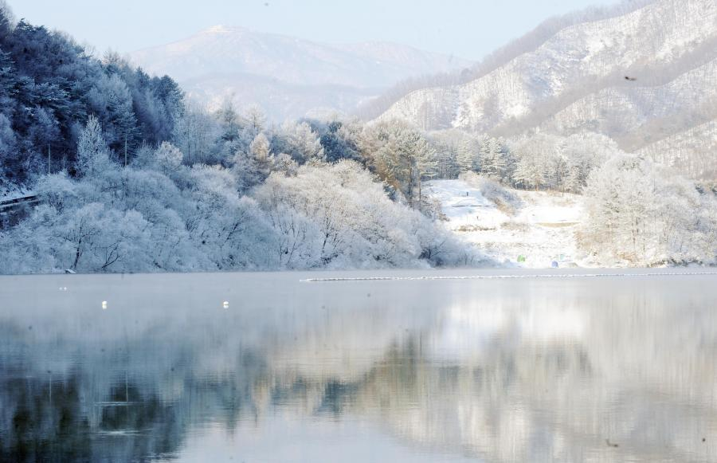

Weather in Lithuania can be compared with the climate of Great Britain or Sweden with a lot of fog and a great number of cloudy days for a year. In winter it is not very cold but sometimes frosts are strong and at the same time it is wet. But the Lithuanians have forgotten about very cold weather for the last ten years, maybe because of the global warming on the planet. There is not enough sunshine in Lithuania in winter. The sky is cloudy on the whole territory of the country. The average temperature from November till March is about zero. The fact that Klaipeda is the only port of Eastern Baltic where water never freezes proves the fact that the weather in winter is not harsh nowadays.
Snow and ice are likely in Lithuania during the winter. Most people wear coats, well-insulated gloves or mittens, and fur caps. Warm socks are a must, especially if ice and snow cover walkways.

Road crews keep walkways salted and sprinkled with sand, which helps with traction, but icy patches under drainage pipes or in areas of sunken pavement become treacherous, especially at night when they are less visible. Though local women hobble around confidently in heels, snow boots with rubber tread are more practical and safe.

