Spring in Lithuania is a wonderful season.
The nature, liberated from the cold grip of winter, wakes up, and begins a new life – birds return
to the forests, awakening animals poke their noses out of the caves after hibernation.Bees start
humming from one flower to another. In spring.
Rivers are bubbling, murmuring, liberated from the ice cover, lakes splash on the meadows –
it's time to pull out the kayaks, dive into your first swimming and open a picnic season.
The average temperature in spring iss about 15˚C.

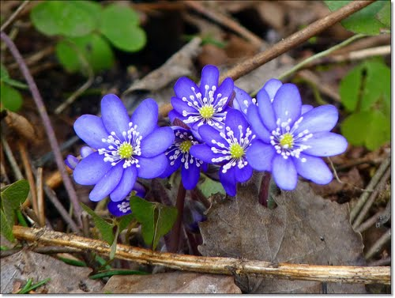

Written by Ugnė ir Kornelijus

