In summer daytime temperatures reach 20-25°C, but sometimes quite higher, 30°C or more. In most of the time it is dry weather with sunny spells, rain often falls with sometimes heavy thunderstorms that can occur at the end of the day.
Required clothing:
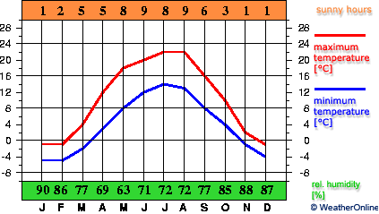
Light- to medium-weights are worn during the summer months. Rainwear is advisable all year.

Written by Akvile and Almantas

