Skellig Michael

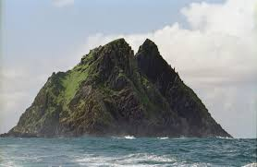

Skellig Michael is a monastic island that is located about 11 and a half kilometres off the coast of County Kerry.

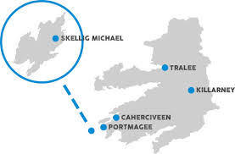

The island was originally used by Irish to carry out what they saw as the Lord’s work.

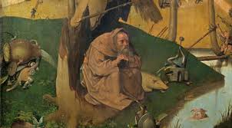
Surprising to many, the Puffin Penguin is a native to Skellig Michael and had been living there long before its discovery by the monks.

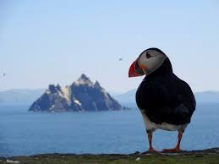

Though it was very famous around the world beforehand, the island became more noteworthy for its role in the new Star Wars movies.

Cormac O’Farrell

