

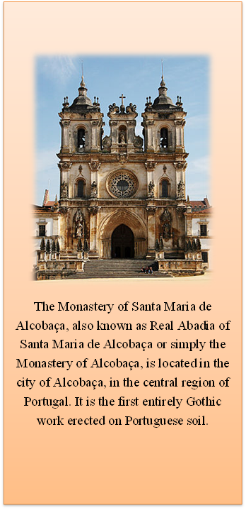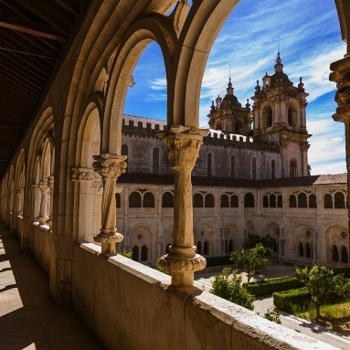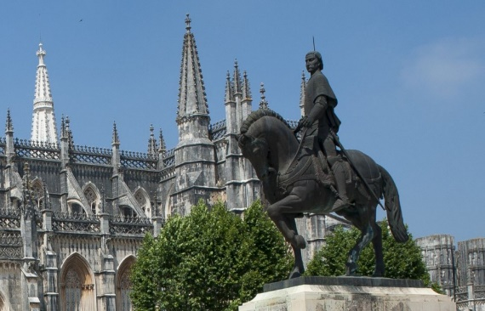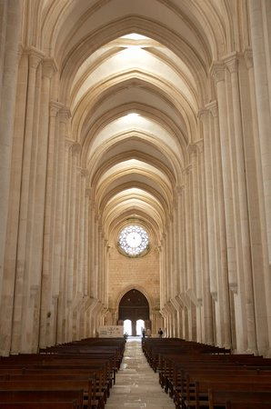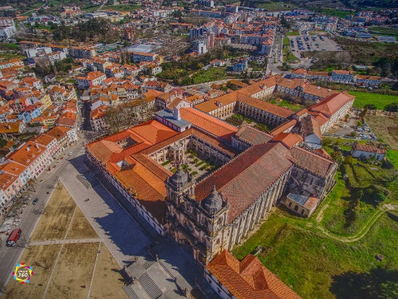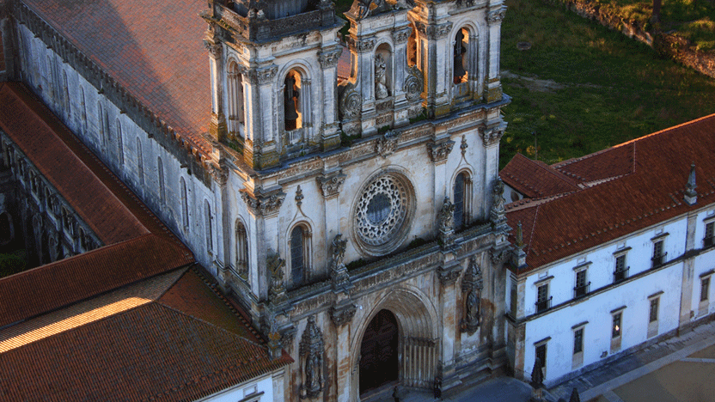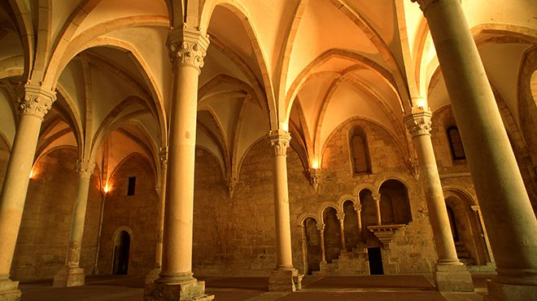

*SCHEDULE:*

*OCTOBER UNTIL MAY*

*FROM 09:00 TO 18:00-LAST ENTRANCE 17:30*

*APRIL TO SEPTEMBER*

*FROM 09:00 TO 19:00-LAST ENTRANCE 6:30 pm*

*THE TICKETSHOP CLOSED AT 30 MINUTE BEFORE THE FERMATURE OF MONUMENT*

*CLOSED: 1ST JANUARY, SUNDAY PAUES, 1 MAY, 20 AUGUST and 25 DECEMBER*

*PLACE 25 APRIL*

*2460 - 018 ALCOBAÇA*

*CELLPHONE: +351 262 505 12*

**

Alcobaça Monastery

*While D. Afonso Henriques was engaged in the Reconquest, the Cistercian monks who founded the Monastery of St. John the Baptist of Tarouca around 1140 arrived in Portuguese territory. D. Afonso Henriques, the first king of Portugal, donated and gave to S. Bernardo many lands in the region of Alcobaça, in fulfillment of the promise made in 1147, when the conquest of Santarém.*

It is about 1152 the beginning of the provisional construction of the monastery, and in the same year a reference to its abbot is known. The letter of donation was signed by D. Afonso Henriques the following year, 1153. If one compares the floor plan of the church of the Monastery of Alcobaça with that of the second church of Claraval, we see that they have almost the same size and spatial layout. The first monks of Alcobaça, known as white monks, had a remarkable civilizing action. They also performed assistance and charity actions through the apothecary, the pharmacy, and the concierge alms.

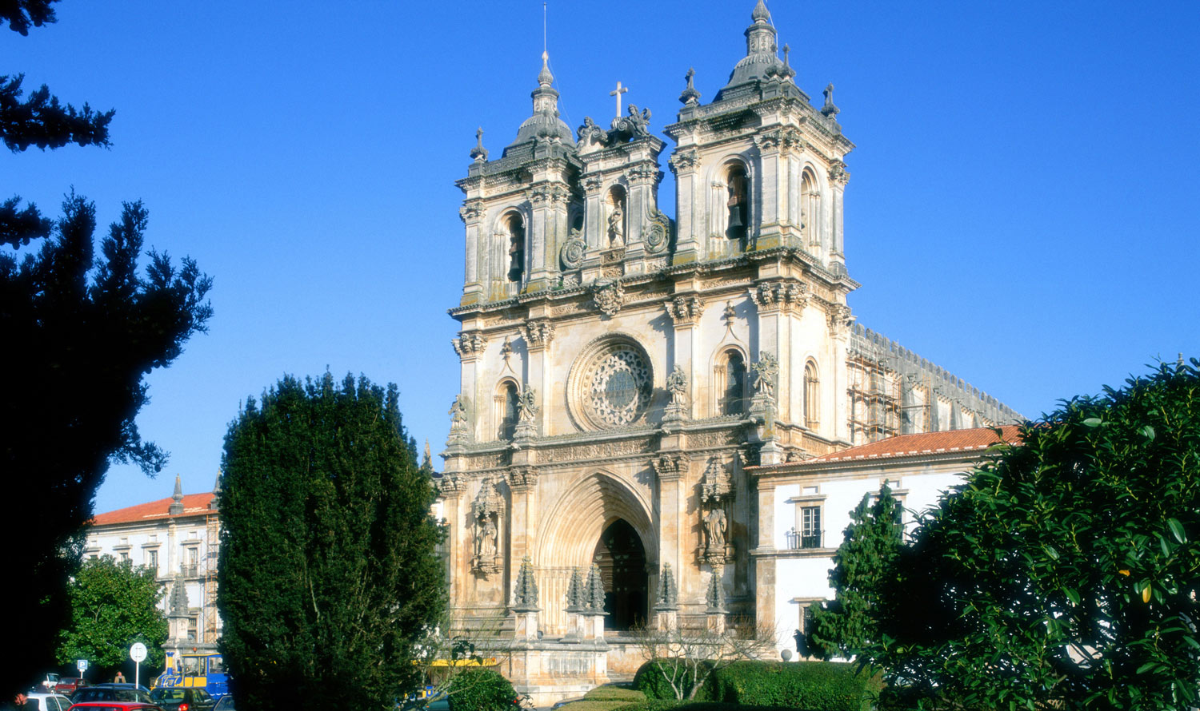

*At the end of the tenth century a new Benedictine monastery was organized in Cluny, Burgundy, which sought to follow the Rule of St. Benedict with fervor. However, over time, this fervor faded, the Rule of St. Benedict was "lightened" and in 1098 some monks left their monastery of Molesme, also in Burgundy, to found a new monastery in Cister, south of Dijon The religious of Cister sought to follow the Rule of St. Benedict, they wanted to live off their work and not accumulate wealth. Bernardo de Claraval, who had retired in 1112 in Cister, from where he left in 1115 to found the Abbey of Claraval, greatly encouraged this reform that restored to the Rule of St. Benedict all the initial rigor.*

