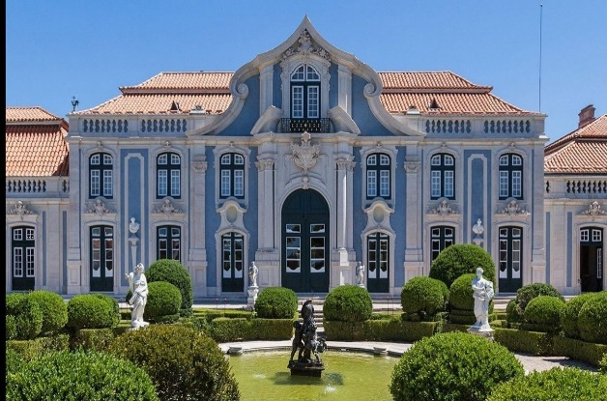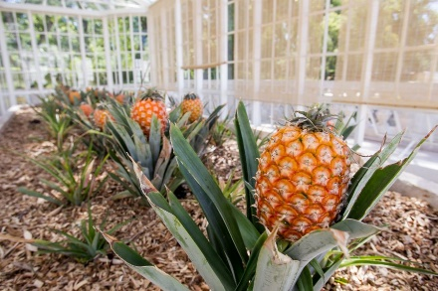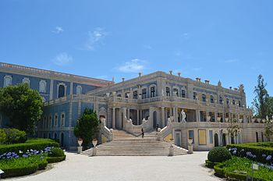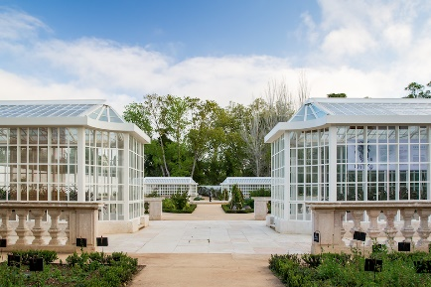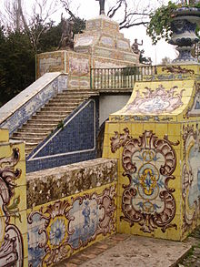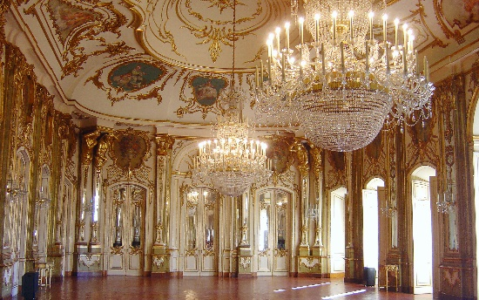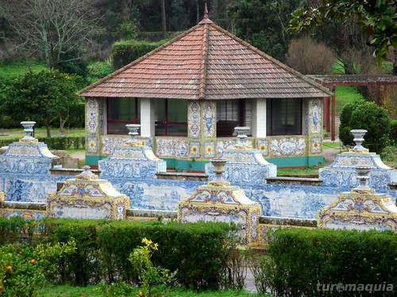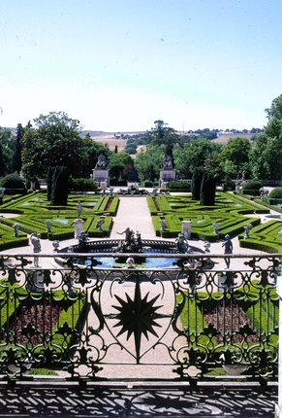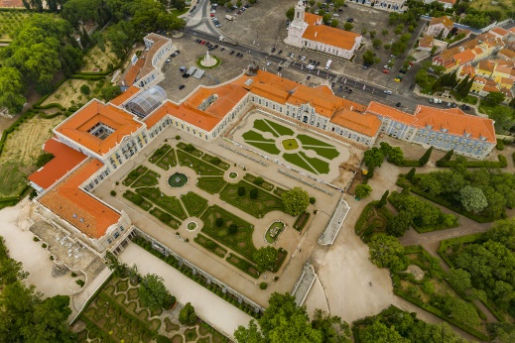

Queluz National Palace

Travel back to the past and immerse yourself in the rich history of this ornate palace and its gardens. Considered Portugal's response to Versailles, it was originally designed to serve as a summer residence for the royal family, before King D. Pedro III transformed it into a complete palace. Queue in and discover for yourself the majesty of the 18th century aristocracy!

**SCHEDULE:**

**ENTRANCE 9:00pm**

Queluz Palace and Gardens Open all days.

Schedule until March 23, 2019

9am to 6pm (last entry 5pm)

After March 23, 2019

9am to 7pm (last entry 6pm)

Address: Largo Queluz Palace. 2745-191 Queluz.

CELLPHONE : *+351 21 923 73 00*

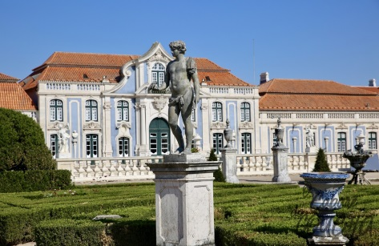

With the discovery of gold in Brazilian lands in 1690, the Portuguese royal family was feeling quite wealthy. The Queluz National Palace and Gardens are a perfect example of the opulence and splendor of this period. Described as "a very expensive birthday gift," the palace and its gardens exude excess by blending Baroque, Rococo, and Neoclassical styles to create an impressive effect.

And your jaw will drop as you glimpse the tiled canal. This artificial lake is decorated with thousands of glazed tiles, reproducing scenes from Portuguese legends and victories.

The site was designed to be the perfect synthesis of landscaping and architecture and was the scene of many grand celebrations and festivities. Just enter the palace to understand why, as the star-shaped garden design also echoes through the palace.

