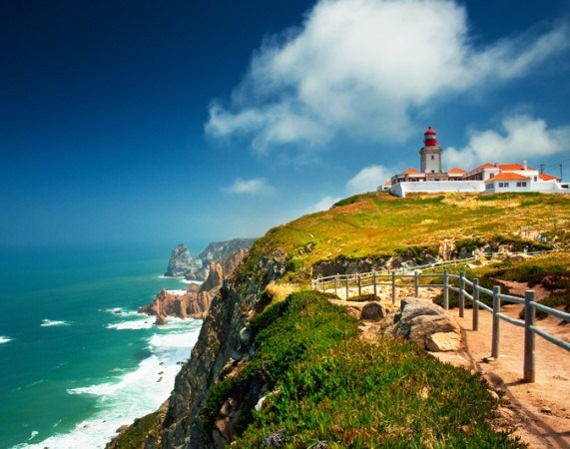

Address: Cabo da Roca Road s / n, 2705-001

Elevation: 140 m

Hours: Open 24/7

Phone: 21 928 0081

Area: Serra de Sintra

“Here…Where the land ends and the sea begins”

Luís de Camões

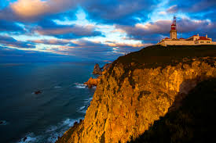

About 150 meters from the sea, here you can have a comprehensive view of the Serra de Sintra and the coast, which is worth the visit.

It is part of the Sintra-Cascais Natural Park and is one of the interesting points of the hiking trails that can be done here along the coast.

Cabo da Roca is the westernmost point of mainland Portugal as well as continental Europe. It is located in Colares parish, Sintra municipality and Lisbon district. The site is visitable, not to the extreme but to an area at an altitude of 140 m. The cape forms the western end of the Serra de Sintra, precipitating over the Atlantic Ocean.

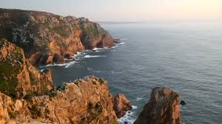

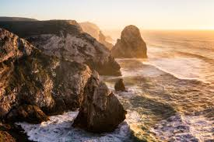

**Information about Cabo da Roca**

Cabo da Roca has a lighthouse called the Cabo da Roca Lighthouse which was the first purpose-built lighthouse in Portugal and was completed in 1772, and also a souvenir shop that is usually only open in the summer. All its surroundings are inserted in the Natural Park of Sintra / Cascais, with easy access and paths adapted for those who have more difficulty, without, however, disturbing the geography of motorbikars. Motorcyclists love this place because of its roads and end view. On Sundays it is very common to have concentrations of these athletes at the top. Cabo da Roca is a very windy place, so be careful of the wind force and your belongings.



