- 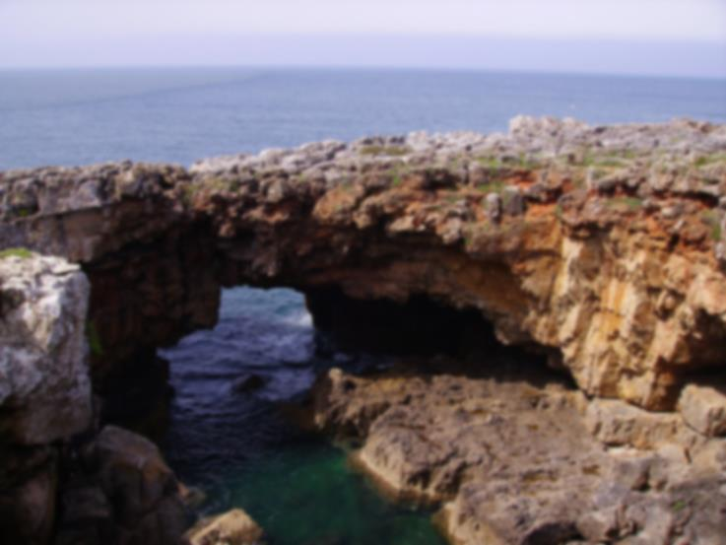
Today, the sea with violent and ruthless clashes rises in a deadly white foam for tens of meters, continuing to erode the millennial rock, thus increasing the spectacular and dimension of the Boca do Inferno.
On days of rough seas you can hear the sound of water striking the rocks, a noise so unique that it is analogous to the name of the place.

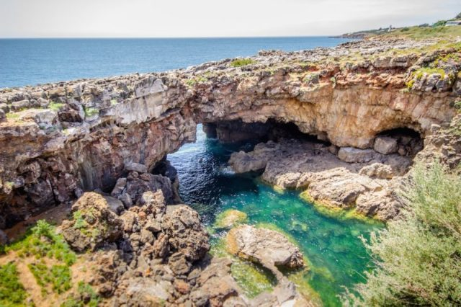
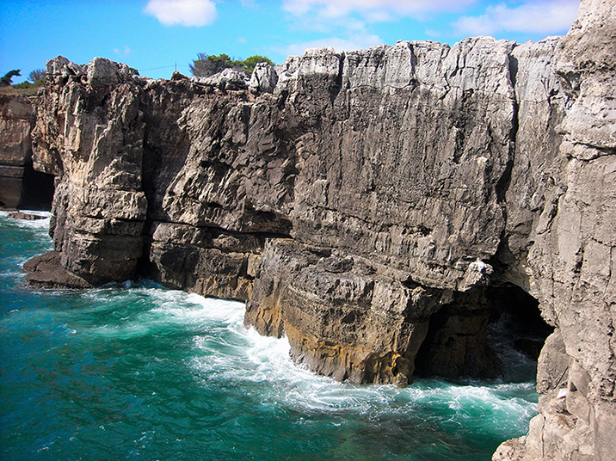
HELL`S MOUTH
Boca do Inferno is located on the Costa da Guia, in the west of Cascais, Portugal.
The name "Hell's Mouth" attributed this place is related to the morphological analogy and the tremendous and frightening impact of the waves on the clifts.
The boca do inferno was formed by the erosion of a week vein of limestone in the cliff face. This initially lead to a cave being excavated which slowly expanded over the generations.
The tougher outer rock remained while the weaker rock was eroded to such a stage that the roof of the cave collapsed forming the unique Boca do inferno.

BOCA DO INFERNO

The Boca do Inferno is an interesting cliff formation close to Cascais, which has been given an overly dramatic name of Hell’s Mouth. The ceaseless pounding of the Atlantic Ocean on the cliffs chiselled out a small cave, which subsequently collapsed forming a small bay and natural arch.

In the summer these waves merely splash around in the open cave, but during winter storms the full force of the ocean is funnelled into the chasm which gives rise to the name of the rock formation. Boca do Inferno

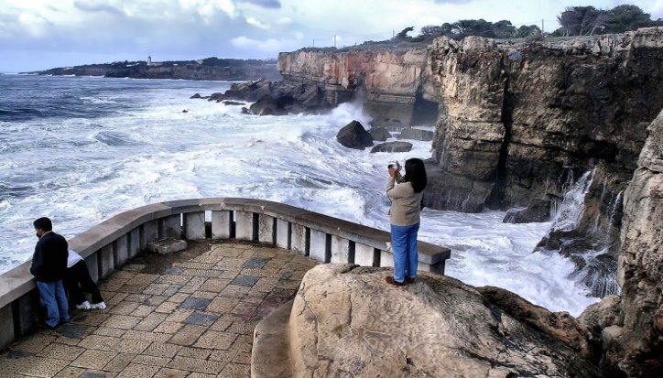
In the summer these waves merely splash around in the open cave, but during winter storms the full force of the ocean is funnelled into the chasm which gives rise to the name of the rock formation. Boca do Inferno is a
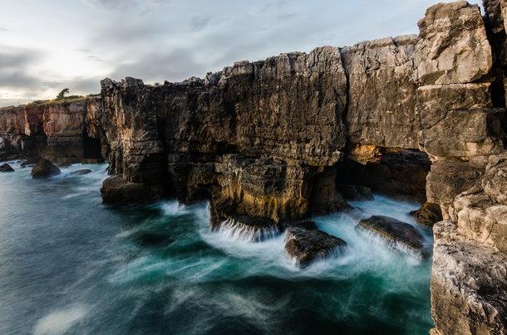
popular excursion from Cascais, commonly as a short walk or bike ride. At Hell's Mouth, there are pathways allowing tourists to climb down the cliff face and view the unique formation from both sides.
It is believed that this place was formerly a cave that with time and the force of the sea gave way and gave rise to the scenery as it is known today.

With unique features, a place of recreation, where you can enjoy a divine landscape and magnificent sunset, being only overshadowed by the rare suicides committed on its dangerous and unprotected cliff.

