History of the town of České Budějovice

The town of České Budějovice is located in the Basin of České Budějovice at the confluence of the rivers Vltava and Malše.
The town was founded in 1265 by the Czech king Přemysl Otakar II. The king needed to increase his power in this region and he founded this city and the monastery of Zlatá Koruna.
České Budějovice had a lot of rights in the Middle Ages, for example brewing beer or collecting toll. The city was very small compared to the present, with only 4000 citizen. But he was rich because he was on trade path to Freistadt.
At that time, Gothic monuments were built, such as the Dominican monastery, the city fortifications with the tower of Iron Maiden and the Rabenstein Tower. Gothic houses were built around the square.
In 1529 the Czech land council, the highest administrative body of the country, met in České Budějovice. České Budějovice is at that time a regional center of crafts and trade. Guilds, associations of people engaged in the same profession were emerging. The city traded with salt and competed with the nearby Prachatice. In the area of ​​České Budějovice silver was also mined and silver coins were made there. During the thirty-year war, crown jewels of the Czech Kingdom were hidden in the town. At that time, the rebuilding of the city center in Renaissance took place.
In the Baroque period were built the cathedral of St. Nicholas, the Church of Our Lady of Sorrows in Dobrá Voda or the fountain in the main square. As a gratitude for the end of the plague epidemic, Marian column was built in Marian square. St. Auracian, the patron of the town is depicted on it. In 1785 a bishopric was established in the city.
In the 19th century, business developed. A horse railway directed to the city. Businessman Adalbert Lanna supported transport along the Vltava river. The Hardtmuth family founded KOH-I-NOOR factory here. People moved to the city for work and new suburbs emerged.
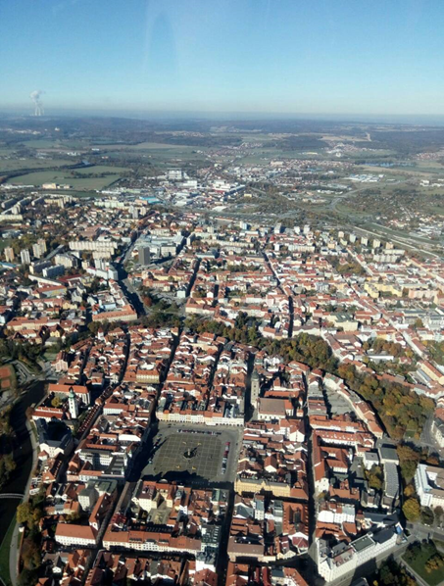
After the establishment of Czechoslovakia in 1918, the city's cultural and economic expansion took place. For example, a statue of local bishop Jan Valerian Jirsík was created by Josef Vaclav Myslbek.
At the time of the occupation of Czechoslovakia during World War II, local Jews faced the Holocaust. In a total, 900 people were deported into the concentration camps. Only 30 of them lived to see the end of the war.
After World War II, panel housing estates called Máj and Vltava was build. Since 1945, the population of the city has doubled to today's 100,000 citizens. Now, České Budějovice is the center of the South Bohemian Region. There is the University of South Bohemia, the Budvar and Samson breweries, and other food and engineering factories.

Source: http://encyklopedie.c-budejovice.cz/

