

**LOGO COMPETITION**

Flora vidaregåande skule, Norway



Belgium logo 2

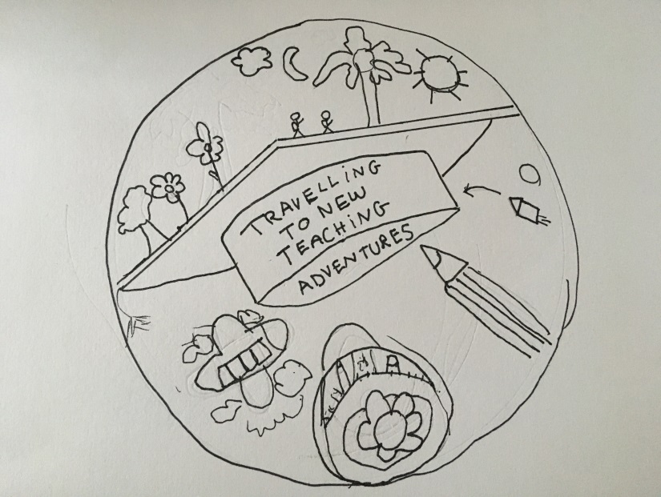

Belgium logo 1

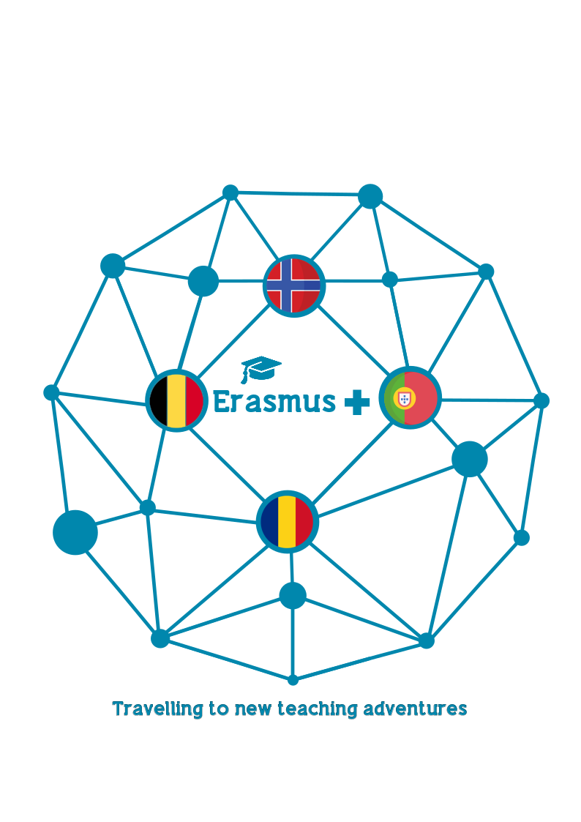

Portuguese logo 2



Portuguese logo 1

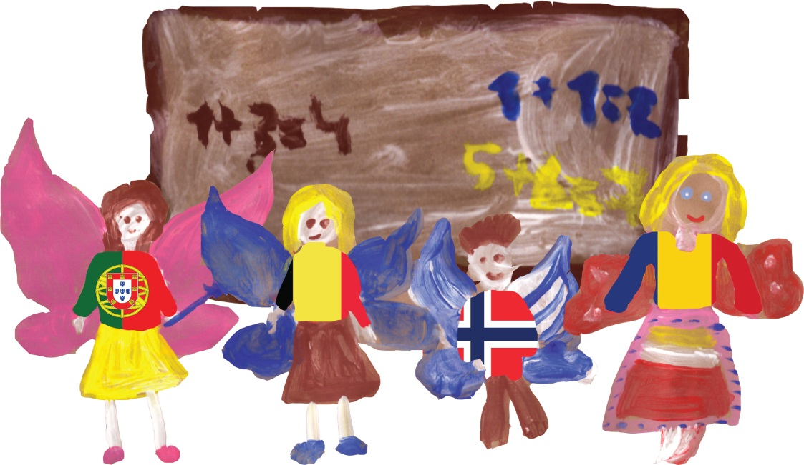

Romanian logo 1

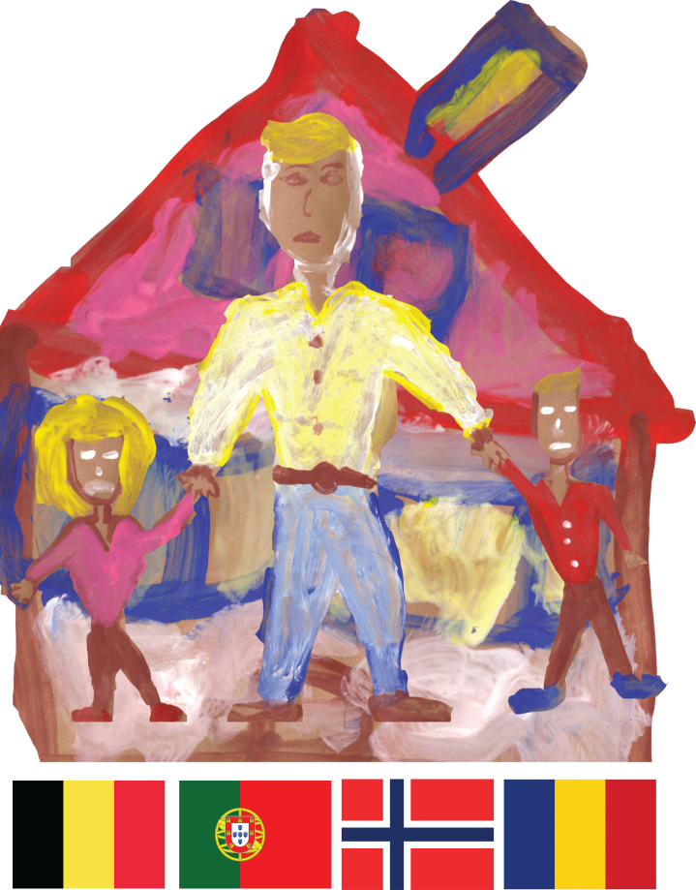

Romanian logo 2

|  |  |  |  |  |  |  |
| --- | --- | --- | --- | --- | --- | --- |
| LOGO | Belgium logo 1 | Belgium logo 2 | Portuguese logo 1 | Portuguese logo 2 | Romanian logo 1 | Romanian logo 2 |
| POINTS |  |  |  |  |  |  |

* The **best logo** draft will get **6** points
* The **least best** draft will get **1** point

! All 6 Logo drafts must have a different score from 1 to 6!

**GOOD LUCK!**