Chapter 6

When they came out to the huge arrivals lobby in Barcelona airport, the children were amazed to see the wideness of the place and the crowd of people waiting for travelers. Among all those people, they immediately recognized their uncle, Khaled, their mother’s brother. They ran to hug him with great emotion. No one can imagine the feeling of find a familiar face between strangers in a country that is not yours.

Finally, the uncle asked them for Amina, and they told him that she had to stay in Lithuania because she couldn’t leave her job.
Immediately, they asked him for their father and the uncle replied that he was waiting for them in a town called Les Franqueses del Vallès, where he had found a job in a factory.

- Anyway, my dear nephews, before going there, and taking advantage that you are already Barcelona, we can go for a little walking tour round this wonderful city, said Khaled.

Although they were impatient to see his father, they were also very eager to get to know Barcelona. They had heard that it was a very interesting city.
So they took a bus that left them in the city center, from there they started their journey.

- There are so many places to visit, but today we’ll just have a little taste of the city and you will come back with your parents later on. Khaled said. Ahmet and Dahlia looked at each other’s eyes trying on how to make sense of the of what Khaled had just said , but before they could react, the uncle immediately corrected: - Ehem, with your father, I meant to say...

At that time, a dark shadow went through the children’s mid, but this dark thought vanished when they heard Khaled’s voice shouting out loud enthusiastically

- Look, La Pedrera! Isn’t it nice?
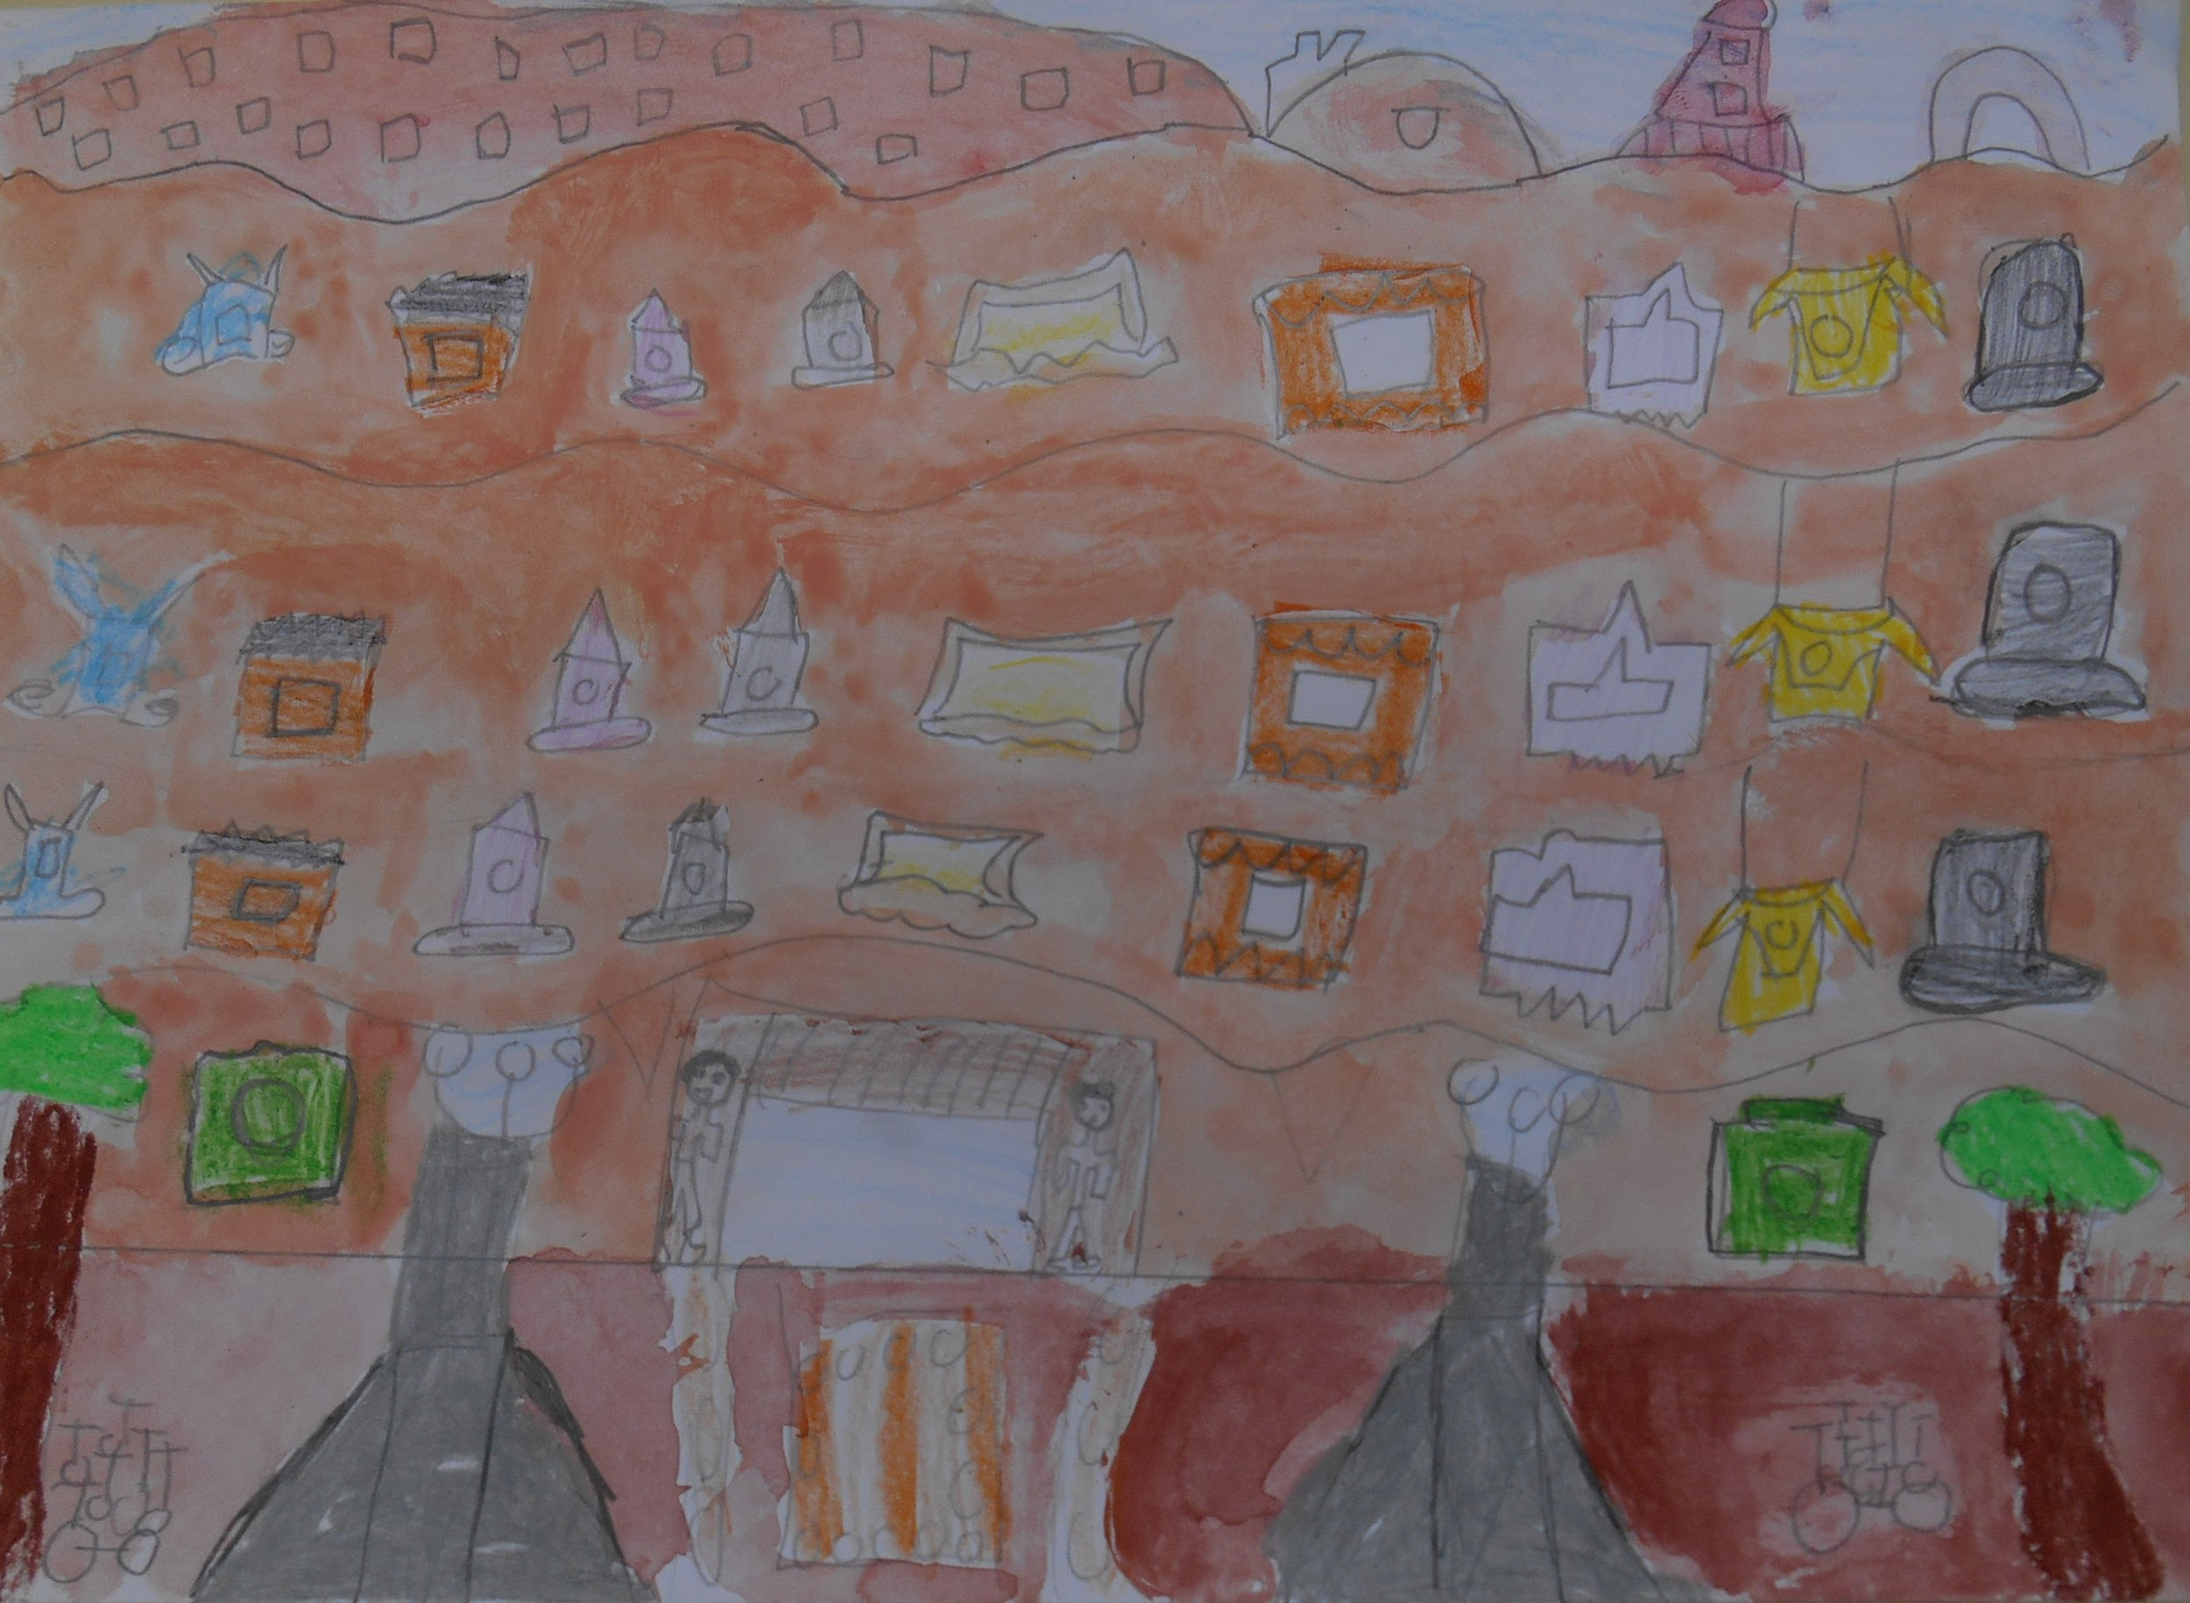

They had never seen a building with so many round shapes on it..

- It looks like a mountain that has been digged to make houses! - Dalia exclaimed.
- Indeed, their uncle replied. It was designed by Gaudí, a catalan architect from the last century, who designed buildings as imaginative as this one.

They were so impressed by the building that the uncle decided to go in. Once inside, the children were astonished to see the decorations, the interior courtyards ... There was a group of children visiting the place. They were a Year 3 group from Joan Sanpera i Torras School, The had just visited the house and they explained to them the broken tile mosaics technique, called ‘Trencadis’ in catalan.
They liked la Pedrera so much that the next stop in their journey was “El park Güell”, on their way there they saw “La casa Batlló” and they could admire its spectacular colorful façade .
Once in the park they took lots of pictures with the dragon statues that were there, and enjoyed the great views from the city that can be seen from the park.

They also went to La Sagrada Família, a modernist temple designed by Gaudi that is a world heritage site and from there to Santa Maria del Mar, a 14th century Gothic Cathedral that has inspired many novels and films.

They would have loved to visit El Camp Nou, the football grounds of Barcelona football team, but it was getting late and they were happy just to see it just from the outside.

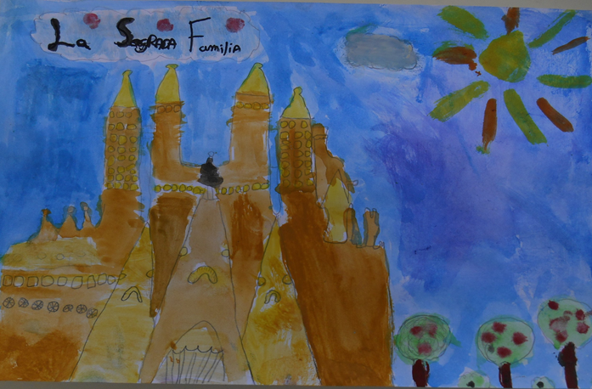

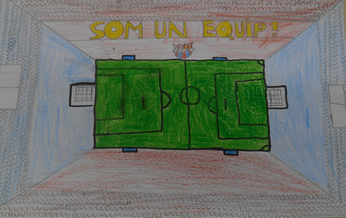

They were all very hungry and they went to have lunch in a restaurant that was in a narrow street next to Les Rambles.

- Oh, there are so many Flowers! What a lovely walkway! Yes, said Khaled, this is one of the most remarkable landmarks in Barcelona. That building over there is “El Liceu” We will have lunch near it.

They went to a restaurant, they thought that their uncle knew the owners very well as he was treated with great kindness. -No, No explained Khaled, I have only been here two or three times.Over here people are always very friendly, whether you're going to a restaurant or going to a shop.

A friendly waiter took their order and he also recommended a few typical dishes from the catalan cuisine to them: Escudella soup with meat, white beans with butifarra, catalan cannelloni, scrambled mushroom with prawns from Palamòs...they decided to have the white beans with butifarra because those type beans were called “ mongetes del ganxet” and that variety of beans was grown very close to where their dad was working, a place that belongs to the municipality of Les Franqueses del Vallès, called LLerona. And, for dessert they had... Crema Catalana (home-made crème brûlée!)!

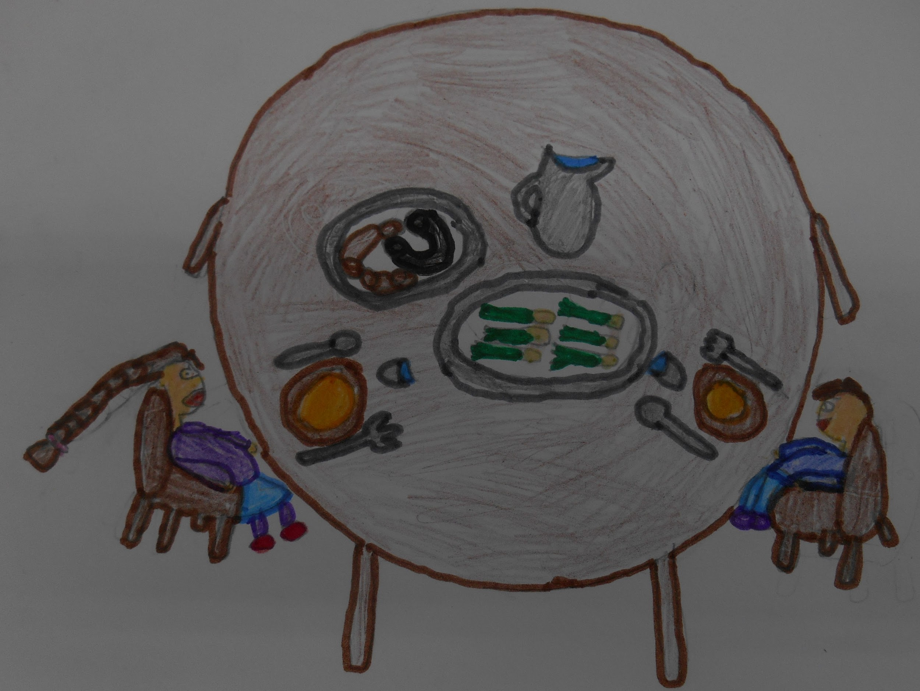

After a journey packed with lots of activities they went to the train station to catch a train to Les Franqueses. Bit by bit they were approaching the time to meet their father, they were looking at the landscape thought the train window thinking all the time that at the end of this small trip they would finally meet their father.

Before the train completely stopped at Granollers station, a neighboring municipality of Les Franqueses, Ahmet could see his father. He was in the middle of all the people that were waiting on the train platform. -Father! Father! Shouted the boy, at the same time Dalia was following her brother’s gaze to meet her father’s one. Oh Father, my beloved father - Burst Dalia when she saw her father who had seen them, too.

When the train door opened the first to come out were the two children, followed by the uncle smiling happily at seeing the family reunion.
The father and the children, embraced in a great big hug, were crying of happiness, the uncle, that stayed a few steps back to let them have their intimate moment, was crying too. He had experienced a similar situation not long ago.

-And, now, my dear children, we will go to les Franqueses del Valles, The place where I live and work. In fact, I have a surprise for you: I have enrolled both of you to Joan Sanpera i Torras School. We will go there and I will show it to you. The school is very big and it has many playgrounds for you to play.

The children did not know if to cry or to laugh. On one had , they were happy to be in such a welcoming country but in the other hand they missed their own country…. The one before the war, and of course … they missed their mother.

When they arrived at the school, they could not believe what they were seeing: The whole school, students and teachers were waiting for them with a great big banner where you could read BENVINGUTS!
They entered the school and they could see a big table in the school hall, the table was set for dinner.

Everyone received them with great warmth and, for the first time, they really felt almost at home. Almost, because the children, even they did not say so, they were constantly thinking about their mother. Where could she be? Would she have survived the bombing?

Everyone started to settle around the huge table: there was a translator who
was translating everything that was said to them. Some children commented that near there there was a refuge from the time of the Spanish war, it was the refuge of Can Sorgas which was in LLerona.
- Damn wars! The children exclaimed.

They began to serve the dinner: bread with tomato and ham, potato omelette, cheese, fuet... These meals were familiar to them. They had seen them in the restaurant where they had lunch and in other restaurants that had their menus with colorful pictures of the dishes displayed on the street.

There were also large trays with all kind of fruits. “Coca de vidre”, “carquinyolis” and ... a tray with” baklava”, a traditional syrian dessert! When Ahmet and Dahlia looked up to see who was carrying the tray, they almost dropped on their backs. So, the surprises were not over yet! It was Iman, their mother! She was over there! They could not believe it!

The surprises were not over on that emotional day.

The tree of them hugs endlessly, their father joined then after a few seconds.
When the embrace was over, their mother told them how she had been injured and how she had been taken from one country to another until she arrived to Barcelona, where she had been reunited with their father. From then on until now there had been searches and lots visits to embassies.
She had been offered work at the school, as a cook. In fact, she didn’t start her job as yet because she had just been released from hospital. That is the reason why they did not say anything to the children about her state. She only had time to make that magnificent Baklava.
Being reunited with her husband and knowing that her children were on their way to Les Franqueses help her to recover. Now only the oldest daughter, Amina, was missing.

That night, the brother and sister felt asleep with a great big smile on their faces. The caterpillar rested on the bedside table and also seemed to be satisfied, as if it knew that he would no longer go from one place to another, inside the children's backpack. It had been a real magical day. At the end of the evening, they were told that Amina was on his way to Catalonia, finding out the good news about Amina made them very happy.

The next day, they all went to Les Franqueses station, to pick up the Amina. She had requested a special permit to visit her parents. The station was small, painted in red and with white frames round the doors and the windows. It seemed to be taken out of a fairy tale.

On one of the days, the whole family went to Figueres, to visit the Dalí Museum. They were very surprised to see a facade full of giant eggs! They had great enjoyment, the enjoyed the lovely environment and the fact that they were together safe and sound after all what had happened to them.

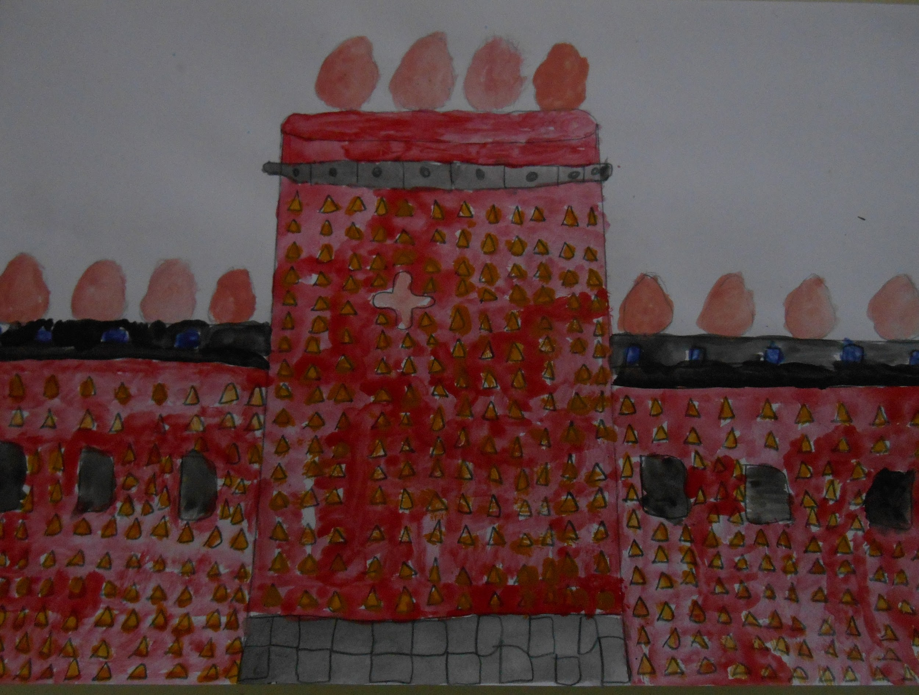

Everything in Catalonia, Lithuania, Slovakia, Poland, Italy and Greece was beautiful!
Also in Syria, before the war broke out! It had been a terrifying experience, but they had also found out in that long trip that, after all, the nicest thing was the people they met along the journey, people who, had helped them without expecting nothing in return and they had helped them to put a smile to all those very unhappy moments.
Inside themselves they felt joyful and they had hope for their country to come out of that nightmare very soon.

This thought and the good people who surrounded them kept them alive and strong.

The End.

