Chapter 5

After a short trip the green coach arrived in Lithuania. The two children got off. They looked anxiously around, trying to find their sister and they were worried about whether they would recognize her. Suddenly, Dalia burst into tears.
-What has happened? Asked Ahmed, not understanding.
-Our sister! There she is! The girl shouted.
-What? Amina? Where? He asked, looking around.
Suddenly, their elder sister Amina came up to them. She was tall, with brown eyes and like almost all Syrian girls, she was wearing a headscarf. All three were very glad. The family hugged each other and stood for a long time.
-Well, are you ready to see Vilnius? Said their sister with a smile.
When I, a Lithuanian girl, Gabriele, and my mother were walking along the street in the Old Town of Vilnius, saw the arrival of the Syrians. I decided to get to know them better!
-What are your names? Where are you from?
-We are from Syria. Now there is a war there, so we had to run away. My name is Dalia; here is my brother Ahmet and my sister Amina.
-How long have you been in Lithuania? I wanted to know.
-My brother and I have been here for just a few hours, Dalia replied.
-Really? You have to see our famous Gediminas Hill and the Castle, Trakai, the Kernavė hills and the whole of beautiful Lithuania, straight away!
I asked my mother to allow them to spend time with us, but first of all to have lunch, because we saw that the children were hungry and I was also hungry. We drove to the restaurant. I ordered a cold red beet soup and dumplings for everyone. After a few minutes the dishes were brought.
-Very tasty! Said Amina.
-To tell the truth, that's very delicious! Dalia agreed with her.
-How do you find traditional Lithuanian dishes, Ahmet? I asked, curiously.
-These are the best that I have ever tried! Said the boy. How are the dumplings made?
-This is a grated potato dish stuffed with meat, I explained.
After the rich dinner, the children enjoyed a magnificent tour of the capital of Lithuania. Amina told them about Vilnius. The mysterious narrow streets of the Old Town... There it's like in a fairy tale or in a dream of the child who wants to be happy. Ahmet and Dalia had almost forgotten the echo of the explosions or how the bullets whistled over their heads.

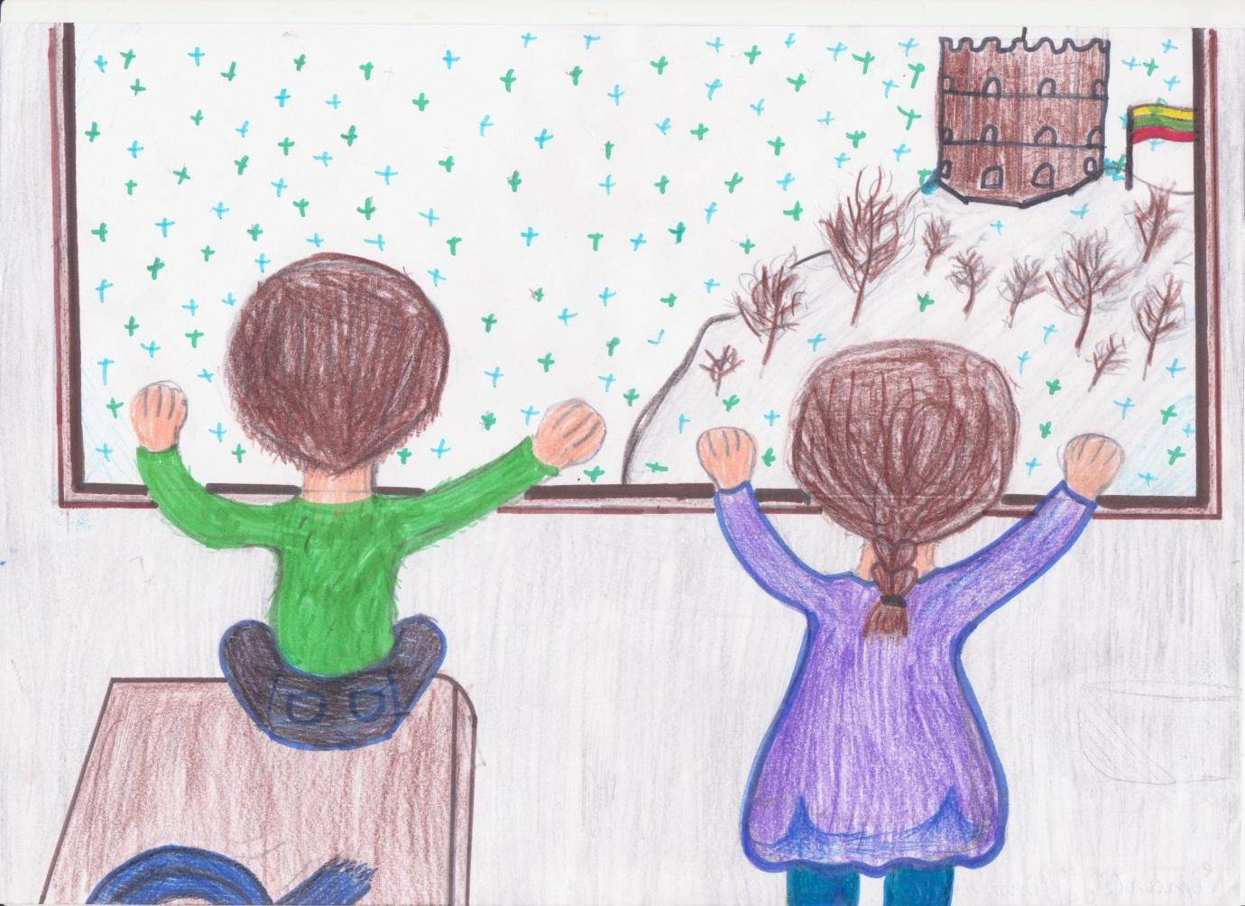
After visiting Gediminas' Castle, we got into the car and went on a fun trip. First of all, we decided to visit Kernavė.
-How green Lithuania is! The trees, the grass and even some cars are green!
-Yes, this is Lithuania! My Mum’s voice was heard from the driver's seat.
We arrived in Kernavė. We climbed the hills until Amina said she was tired. Although Dalia and her brother did not want to leave there, they realized that their sister was really exhausted, so we all went back to the car.
-The next stop is Trakai! The car navigation announced.
We arrived in Trakai. Unfortunately, it was evening already and the castle was closed, so we could not get inside. But there were lots of other fun things in Trakai!
-Would you like to try out water biking? I asked the guests of the country.
-What is it? , asked Dalia.
-Let’s go, I'll show you, answered my mother.
We had a great time. We ate ice-cream and laughed, but Amina was strangely thoughtful. In the evening she said she had found their father. He was in Spain. Ahmet could not asleep. Before his eyes he saw his lovely Dad's face, a calm evening at home, when their Dad served dinner to each member in the family. But, suddenly ... A huge explosion! Everything came down in dust, and he no longer saw Dalia, Amina, Dad or Mum, there was only the sound of coughing, crying and moaning heard around him. Ahmet was scared of such unpleasant memories. He tried to fall asleep and thought about the images of their special day in Lithuania.
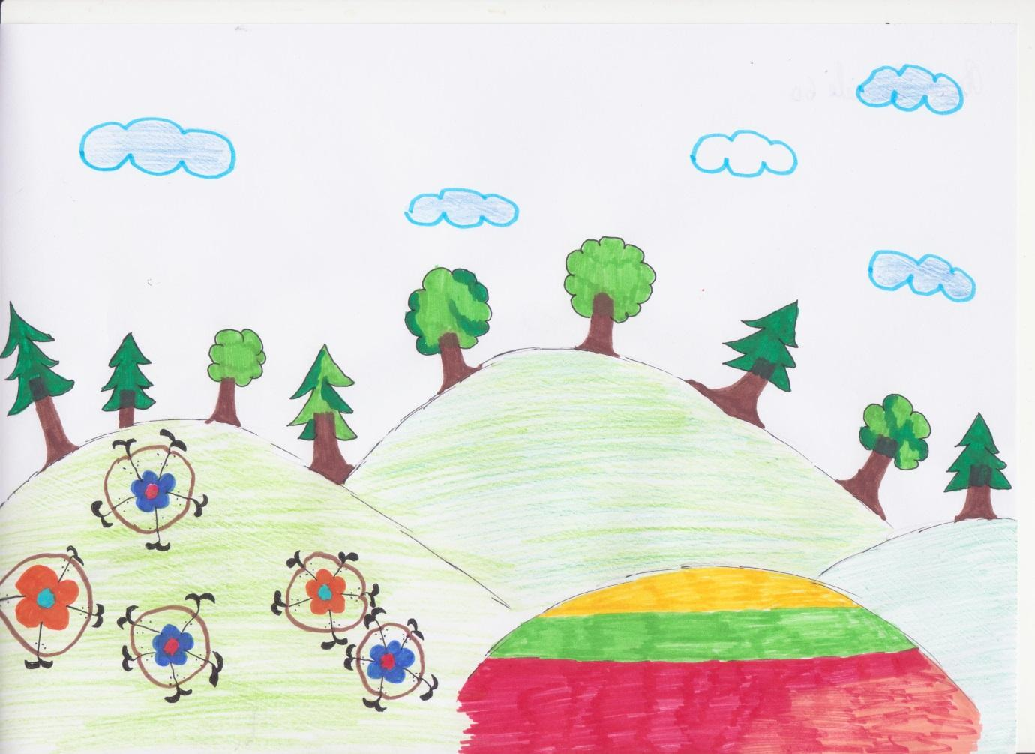

In the morning Amina booked plane tickets to Spain, Catalonia, because their Dad was waiting for them there. They all went to the airport.
-Amina, why don’t we go together? Asked Dalia.
-I have already been there. I have a job here, I can’t leave. I will be waiting for you to come to me again", said Amina.
-We will miss you very much!”
And the children were gone.
Soon the plane took off and Ahmet and Dalia left for Barcelona, to their father. They saw a very flat Lithuanian landscape through the plane windows; the children enjoyed it and were eagerly waiting for a meeting in Catalonia. They were a bit anxious about whether their Dad would meet them. The monotonous sound of the plane engine lulled Ahmet and Dalia, and the children fell asleep.
Catalonia and their Dad were waiting for them…

