Chapter 2
While they were on the ferry to Bari, a man recognized the two children: he was one of their parents’ friends! His name was Reza. He had left Damascus before the beginning of the war, to look for a job. In Italy he worked as a barman in Rome. He had just been to Greece to visit his girlfriend Joana. Now he was going back to Italy.

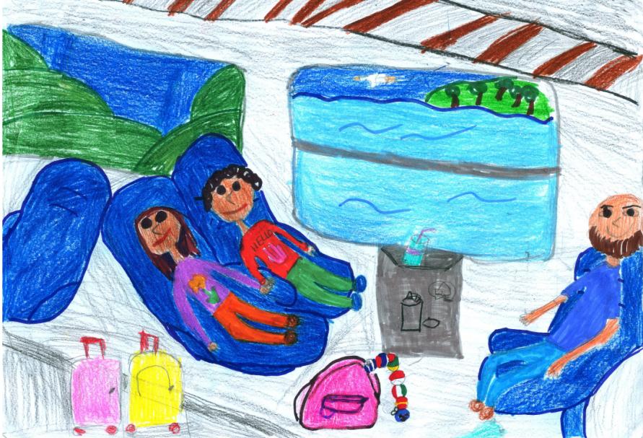

Reza invited the children to spend some time with him in Rome. As soon as they disembarked in Bari, they went to the station to take the train to Rome. During the journey Reza saw the caterpillar coming out from Dalia’s rucksack. Reza was overwhelmed by emotions: the man told Dalia that he had given her the caterpillar as a present when she was a baby. Then Reza thought about the children’s parents. Lulled by the train, Ahmet and Dalia fell asleep dreaming of their parents.
When they arrived at Rome railway station, the children were struck by the noise and the crowd. Reza took them to eat a pizza and then to his place. The day after they walked around visiting the historic city centre: they were amazed by the grandeur of the monuments: the Coliseum, The Trevi Fountain, and the Spanish Steps. Finally they went to Villa Borghese gardens where they played and had an ice cream.

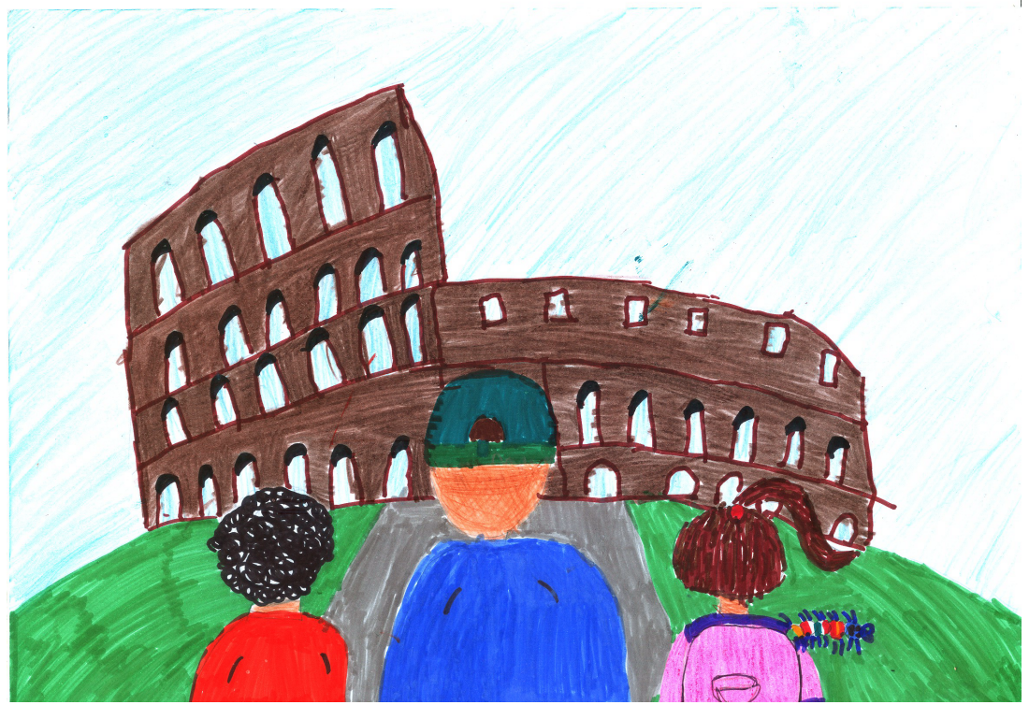

A few days later Reza thought about his friend Souad, a distant cousin of the children and he called her on the phone…...Souad told him that she was in Italy, in Santa Margherita Ligure, a small town on the Ligurian Riviera where she worked as a villa janitor. The children talked with her on the phone and she reassured them that Italy was a safe place to live. She said that they could stay with her but only for a few days because the villa owners would arrive soon and from that moment on she would be very busy. The children accepted joyfully. Souad took a day off to pick Ahmet and Dalia up at the train station.
The children left Rome by train: Reza bought the tickets and with the money left they had an ice cream in the restaurant car. When they arrived in Santa Margherita, they were impressed by how calm the place was; they visited the villa and they are amazed by the fact that they could see the sea from their room window. For a moment they felt like they were back in Syria! There was also a swimming pool where the following day they would splash happily all day long.

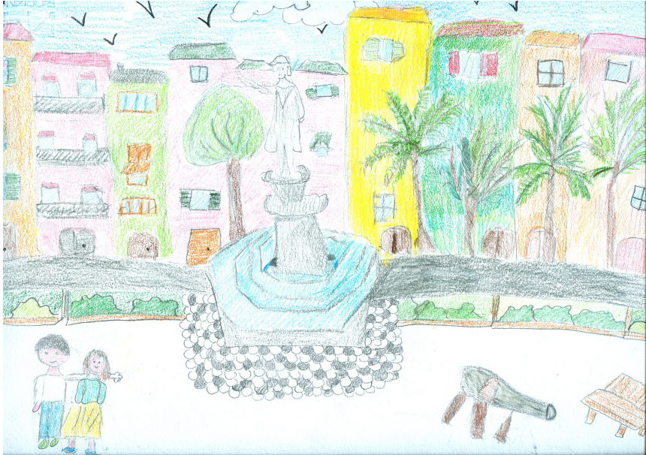
During the night, the children were woken up by strange noises which scared them. They decided to lie side by side and, to give each other courage, keeping their caterpillar, their “adventure buddy”, between them. In the morning they discovered that the noises were produced by a broken tent flapping in the wind. Moreover, some bats had been flying back and forth from the attic above.
After having breakfast with juice, bread and jam, Ahmet and Dalia took a walk around Santa Margherita. They stopped in front of a building where a lot of children were playing in the courtyard: it was the Scarsella School! This made them realize how much they missed their school. It was destroyed by bombs…..Who knows when they could go back there…... What a wonderful time!

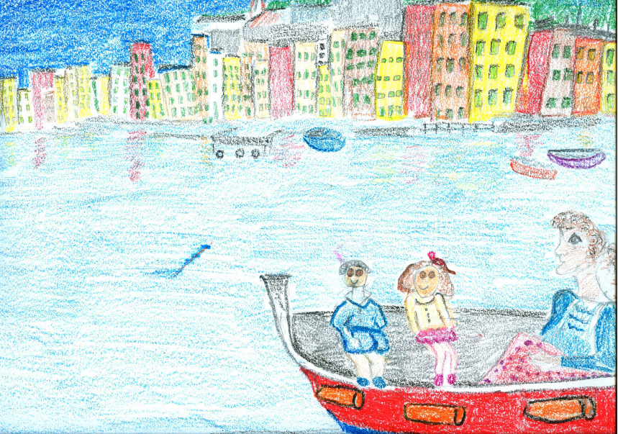

They also went on a boat trip with their cousin and admired the Ligurian Riviera.
After a few days, with mixed feelings, Ahmet and Dalia had to leave again. Where would they go? They remembered that, some years ago, Dalia’s uncle, Abkader, had moved to Slovakia to search for a job and he finally got a position as a supermarket cashier. In the rucksack, they found an old address and they quickly sent a telegram there. Abkader answered promptly sending them money for the train tickets to Bratislava and a picture of him so they would recognize him on their arrival.

