Chapter 4

The journey from the Slovakian town - Turčianske Teplice to Cracow, elapsed in a very pleasant atmosphere. They crossed the border in Chyzine. Outside the window, they could see mountains. As they came closer to Cracow, the mountains seemed lower.
Finally they have arrived at the bus station, where Farah was waiting. She invited them to her dorm where they left their luggage, next they went to the main square. It was almost midday, they noticed a crowd of people in front of St. Mary's Basilica and they stopped, surprised Dalia asked.
- Why are those people standing in front of the church?
- You will see and hear in a moment – answered the girl mysteriously.
Suddenly, out of nowhere, the sound of trumpet reverberated. Everyone looked up toward the tower of the church.
- I see the trumpet! – screamed the girl.
- Every hour from that tower you can hear a bugle call played by a bugler – she explained, very proudly. It had been a few months since she had come to Cracow to study and she had already had a chance to get to know this beautiful and historic city.
When the sound of trumpet stopped, they went to see Cloth Hall.
- It is a renaissance building, inside you can find small souvenir and handicraft shops – explained Farah.
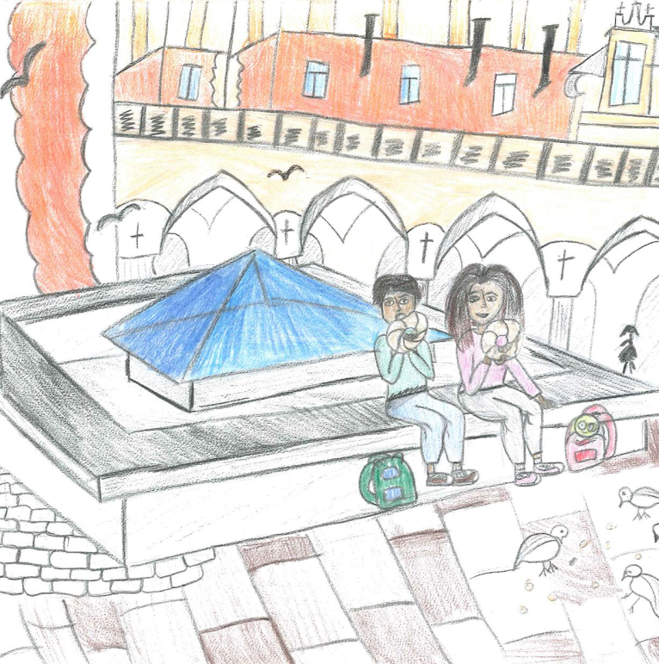
Next all of them went towards Wawel, where the royal castle was located. On the way there, they noticed a cart with glazed pretzels shaped like a ring. Everyone got a pretzel from their uncle. When they arrived, they went up the spiral stairs to the bell tower from there they could admire the sights of Cracow and the whole neighbourhood. The river Vistula flowed at the bottom of the city. After they came down to the foot of the castle. There was a stony dragon and out of nowhere a huge fire came out of his mouth. The small girl was startled. Farah told everyone that it was just one of the tourist attractions; their uncle took a picture of them and took them on a cruise around Vistula. During the cruise, out of the speakers they could hear a voice which told the legend of the Wawel Dragon.
“Many, many years ago, during the reign of the King Krak, a founder of the Cracovian castle town located on the slope of the Wawel, an evil dragon had settled. He was a huge creature with a mouth and a very long tail. He ate the sheep and cows, which the people pastured on the meadows along the Vistula river.
The King had decided that he would give his daughter as a wife to anyone who could extinguish the dangerous dragon. Many brave knights started to appear in Cracow, but none of them could defeat the dragon. Then one day a young apprentice cobbler Skuba, appeared before the king and promised that he would defeat the beast. The king’s court laughed at him as they thought it was a joke. Fortunately, he did not get discouraged so easily.
The very next day, he got a sheepskin and filled it with brimstone and left it in front of the dragon’s den. The dragon, allured by this tasty snack, ate it right away. And then brimstone started to burn his stomach and the dragon began breathing real fire. He tried to stop the burning by drinking massive amounts of water from the Vistula. He drank, drank, drank and got bigger at the same time until eventually he exploded with an enormous bang.
That was how clever and inconspicuous apprentice cobbler saved Cracow from the dangerous dragon. He married the princess and they lived happily together for a very long time.”
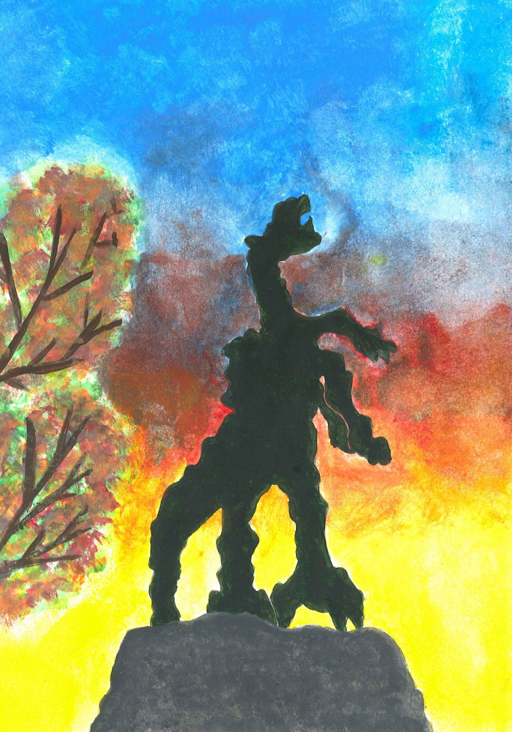

The children were fascinated and listened to the story very carefully. At the end they asked if it was true but Farah explained to them that was just a legend. When the cruise was over they went to a restaurant for dinner. Their uncle asked the waiter for something from polish cuisine and he offered żurek (rye soup) and cabbage roll with tomato sauce. All the food that was served was delicious and everyone tasted it.
The children fell asleep at the dorm exhausted from the trip around Cracow. At the dorm on the windowsill there was the caterpillar mascot on which the moon’s rays were shining.
The next day in the morning breakfast, prepared by Farah, was waiting for them. They noticed that their uncle Abkader was not with them. Farah was very quiet. Finally around ten o’clock, their uncle appeared in the dorm with a very mysterious smile on his face. He ate breakfast in a complete silence and then said:
- My dear children, my brother and your father, was always saying that family has to
stay together. Unfortunately the war disrupted your fate but I have received a letter from International Red Cross, which my wife sent me via email. Your older sister was found somewhere in Lithuania. I was at the station and I bought you tickets for a train to Warsaw. Farah will take you there because I have to go back home. Over there she will put you to the bus which will take you to Vilnius and there, your sister will be waiting for you.

Ahmet looked at his uncle with huge disbelief and tears were falling down Dalia’s face. Suddenly the children started to hug their uncle and thanked him for all his help. They packed their things and went to the railway station. On the platform they said goodbye to their uncle and went into the train. Dalia took the caterpillar out of bag and put it on the table next to the window and rocked by the rhythm of the Pendolino train she fell asleep. Her older brother Ahmet, looked outside the window and he couldn’t believe how fast the train sped to Warsaw. He thought about meeting his sister and his heart started to beat faster. Then the conductor said:
- We are approaching Central Warsaw.
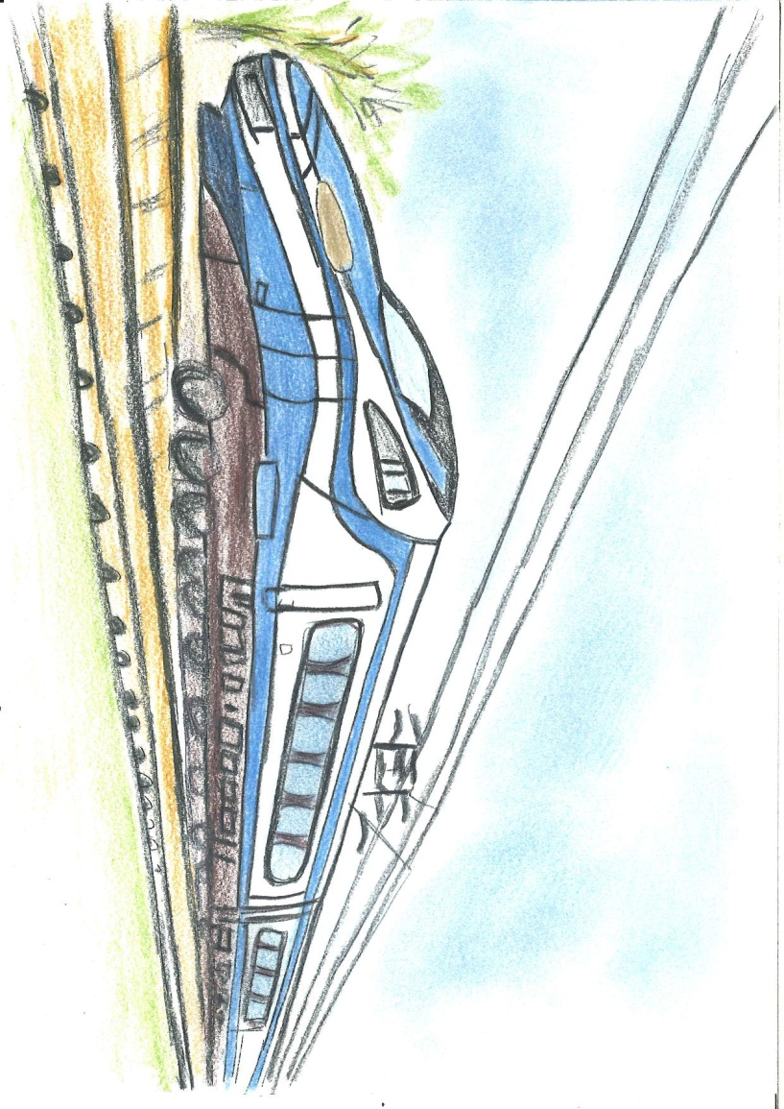

Farah helped the children get out the train and they all went toward the bus station, from where the Syrian siblings were supposed to go on the next part of their journey. This time the journey was with the huge hope of a family reunion.

