Chapter 1

The inflatable boat was going up and down the waves that wanted to swallow it. There was a cry of pain and tears of desperation from people who had left something behind…their whole families under house debris, it wasn’t their fault, they weren’t responsible, and it wasn’t fair, was it?
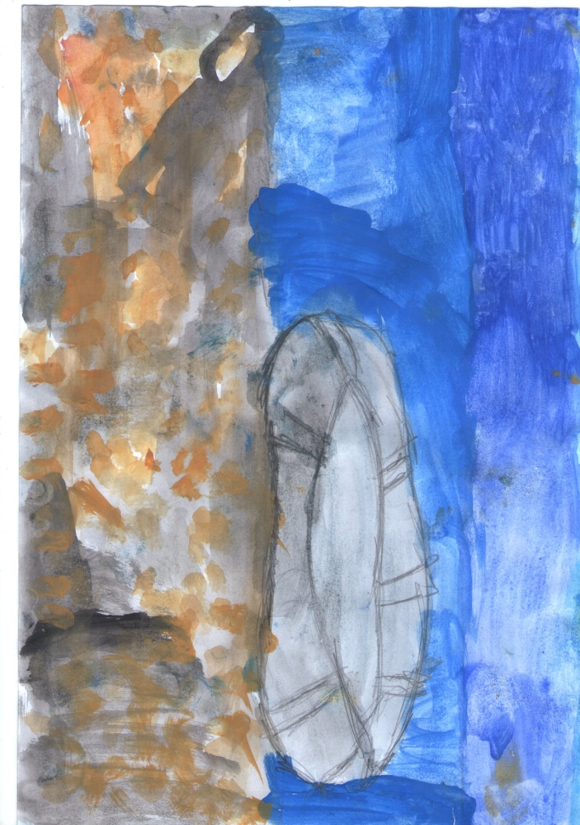
Among them there were two children, exhausted and sad, Ahmet and Dalia. They were two refugees who had lost their families in a bombing of Damascus. However, they hadn’t lost their kindness or their humanity.

- I’m cold, I can’t stand it anymore. I wish I were at home right now, said Dalia.
- Be patient. I promise you everything will be better soon.
- Do you remember those wonderful days before the war?
- How can I forget them? I still remember how happy we were when we came back from school and a dish of wonderful smelling food was waiting for us with our mother’s a loving embrace.
After a tiring and dangerous trek they saw the lights of a town on the horizon. They were the lights of hope for every helpless refugee. By sunrise the boat was in the port. When they went ashore they saw happy faces all around them and open arms to welcome them.
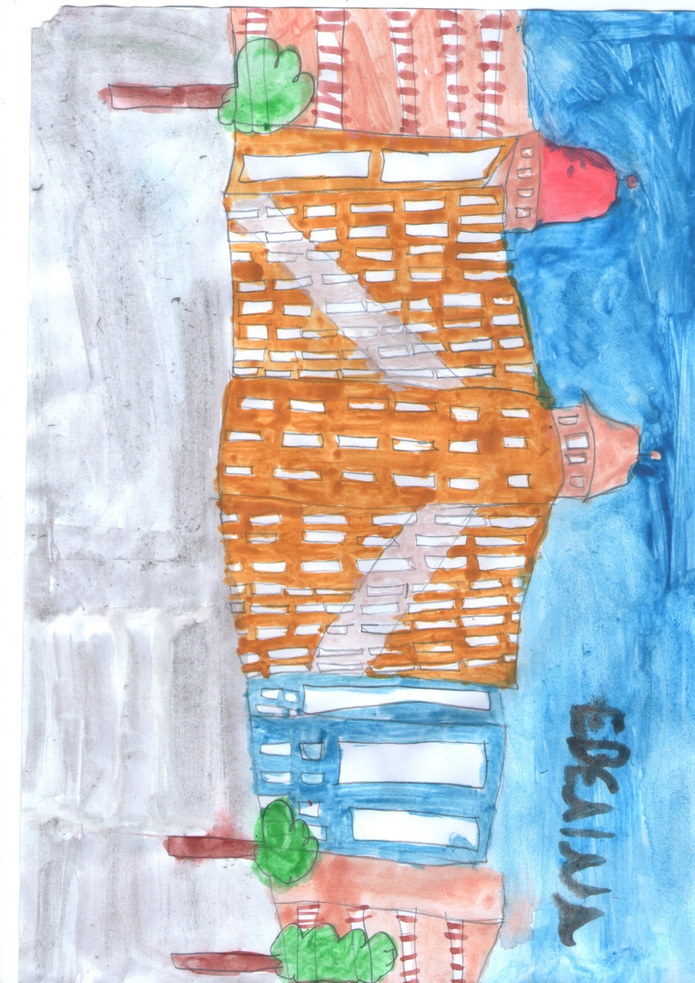
- Where are we? Wondered Dalia.
- I have no idea…
- You are in Volos, a beautiful city in Greece.

The children’s look wandered and a hint of a smile appeared on their faces.
- It’s nice here. Both of them said at the same time.
The days following the children stayed with a family that offered them care and love.

However, this was not the end of their adventure as it continued on in other European countries so they could find their relatives. So, one sunny morning they said goodbye to the hospitable family and took the train from Volos Railway Station to their new destination, Athens.
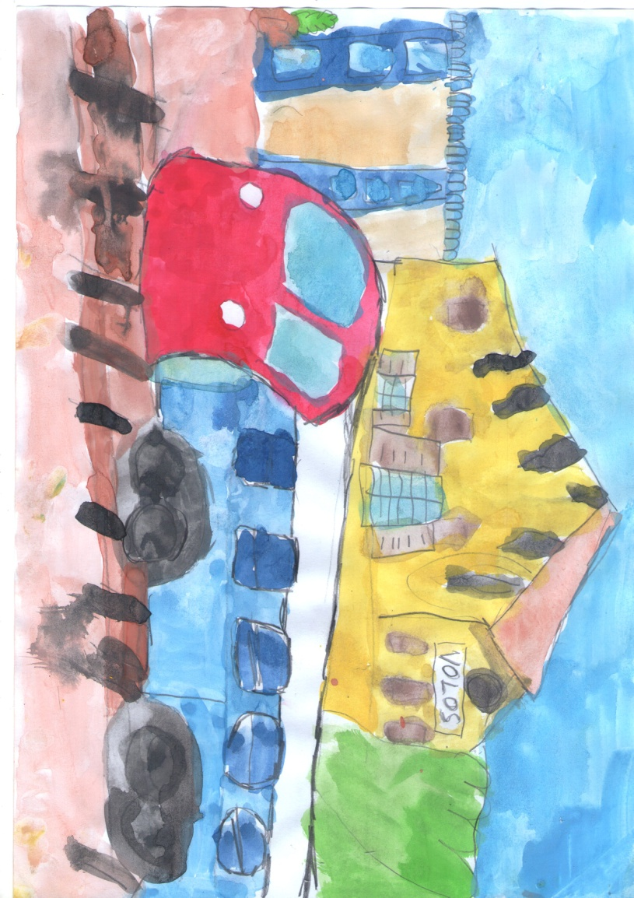

The train was overcrowded, but in the children’s soul was is a serene overcrowding unlike the terrible sounds of bombing. The train looked like a huge, tall and colorful caterpillar to them. It was like the teddy caterpillar they had brought with them from their country. By the time they got on, they could not take their eyes from the window. They watched everything anyone can imagine. Actually, they saw whatever their eyes wished to see. Mountains! Trees! Big roads! They even saw tunnels, something unique to them.

But what drew their attention was a huge plane tree. By the time Ahmet saw it, nostalgic memories crossed his mind. Like those days before the war, when he was sitting with Dalia under such a huge plane tree. He remembered that he had made a swing on a branch and they would spend hours and hours of happiness. Then he sighed and said:

- I haven’t seen a plane tree for a very long time.
- Yes, indeed. A very long time. Not since we were playing on the swing after school.
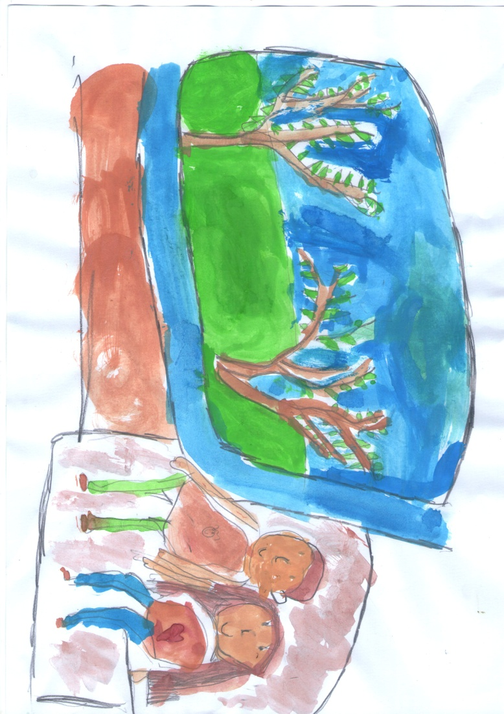

With the sound of the loud whistle their thoughts were suddenly interrupted. They had arrived in Athens. They were surprised when they realized that over 5.000 people had gathered in and around the station. Deafening voices were heard with offensive comments for the children and other refugees.
- What’s going on? You left your caves and came here to infect us with your diseases?
- You are from the Ukraine too, you are not Greek. You have no right to talk like this, another man replied.
Then this man grabbed Ahmet and Dalia and took them out of the station.
- Thank you very much. What’s your name? Asked Dalia, relieved.
- My name is Haris Domazopulos. Do you want to come and stay with me?
- Yes, we do! Only aren’t we a burden?
- No, you are not.
During the following days the kids stayed with Mr. Haris. They went on a lot of walks with him; he bought them new clothes and also some souvenirs, something so important for them.
The next day Mr. Haris advised them to travel to Patra by train. He accompanied them to the station and kissed them goodbye.
The train started rolling on the rails and called them to enjoy their journey. After a three hour journey and having passed the channel of Korinthos, they arrived at Patra. As Mr. Haris had told them, they asked the conductor the way to the reception center and tired but relieved they found shelter.
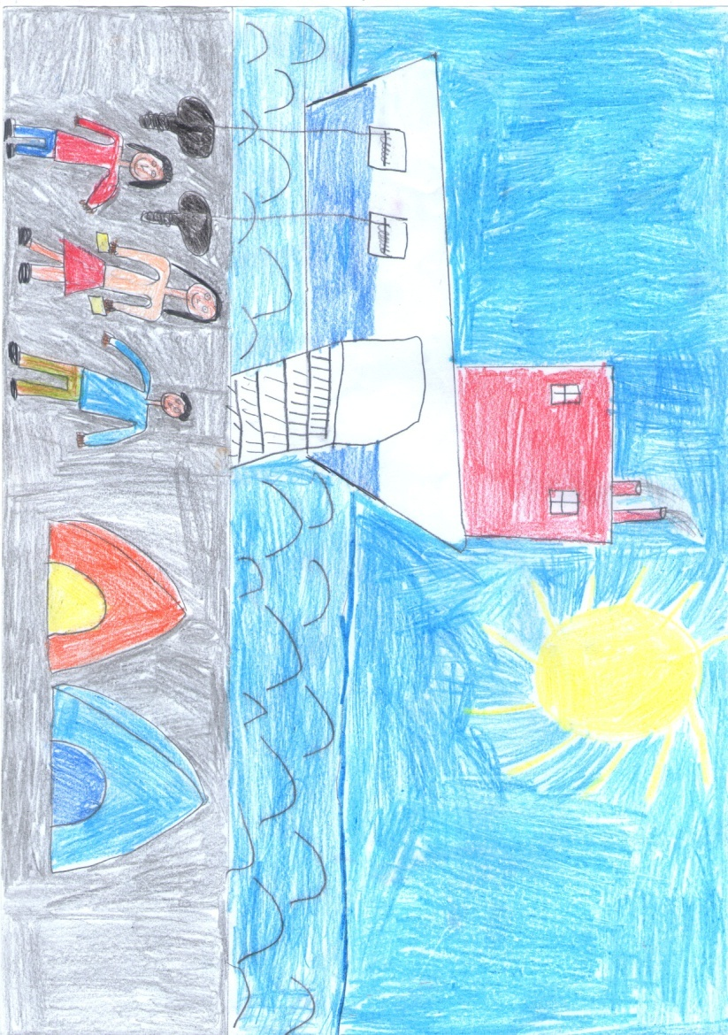
They spent their night in a tent among thousands of other refugees, and the next day made their way to the port in Patra, as their destination was the Italian city Bari. Suddenly they realized that they had no more money to pay for their tickets and they started crying. An old lady took pity on them as they look desperate; her parents were refugees from Asia Minor too, so she was willing to pay for their tickets.

This was their first step in Europe…

