Chapter 3
Ahmet and Dalia arrived in Bratislava by train. When they got off the train, a man approached them, who looked a little familiar. When they looked at the photo, they understood that this is their uncle Abkader. He was older than how he looked in the photo, but he looked a lot like their father. Abkader was very happy when he saw them and hugged them tight. Ahmet and Dalia were both very excited to meet their father’s older brother for the first time.

Abkader suggested they have lunch and they agreed. On the way to the restaurant they saw a big castle and they asked their uncle about it. He explained that it was the Bratislava castle, a very famous and popular symbol of Slovakia’s capital city. They stopped suddenly and the children noticed that they are in the middle of a bridge. The children wanted to know why they had stopped and where the restaurant was, but Abkader just smiled and told them the restaurant was directly above their heads. Ahmet and Dalia looked up and saw that above the bridge there was something that looked like a big plate. He explained that inside that plate was the restaurant, where they were going to have their lunch.
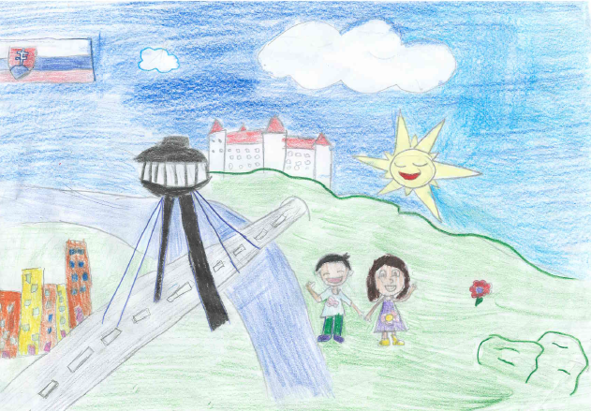

Still surprised, the children got on the elevator with Abkader and went up and into the restaurant. They were amazed when they saw the view from the restaurant. They could see almost the whole city. Their uncle ordered pancakes with chocolate for them and started to tell them about his life in Slovakia.

He had come to Slovakia many years before Ahmed and Dalia were even born to look for work. He had worked as a supermarket cashier for many years, but he opened his own confectionery store a few years ago, when he moved to the middle part of Slovakia, where he got married to a Slovak woman Zuzana. They were surprised to learn that he had two children now, a son and a daughter. His sons name was Zdenko and he was 11 years old. His daughters name was Farah and she was 19 years old. And he told them, he would be very happy to take them to his home and introduce them to his family.
Later they got on a train and traveled to Abkaderʼs home. He lived in a town called Turčianske Teplice. It was a spa town visited by many tourists and patients. It was a long trip, but the children admired the beautiful countryside. They saw high mountains, green meadows, fields covered by flowers, deep forests and beautiful rivers. Sometimes they even saw herds of cows, sheep and horses walking across the fields. 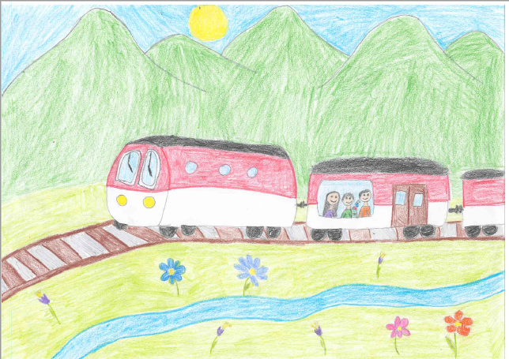

When they arrived in Turčianske Teplice, he took them to his house, where they met their Slovak aunt Zuzana and cousin Zdenko for the first time. Zuzana was very kind and cheerful and she was happy to welcome them to their family home. She told them she worked as a teacher in a primary school in a nearby village called Mošovce. Zdenko also went to this school. That’s why they told Ahmet and Dalia, that they would take them to visit the school if they wanted to. Both children agreed instantly. When Ahmed and Dalia asked why Farah wasn’t home, they explained to them, that Farah had begun studying at a University in Poland that year, in a town called Krakow. Abkader made them a typical Slovak dish for dinner – dumplings with sheep cheese.

The next day, they went to visit the school with their aunt and cousin. When they arrived at school they were surprised how nice and kindly the teachers and pupils treated them. It wasn’t a big school, but they felt comfortable and safe there. Almost as if they were back to their old school. Their aunt showed them all the classes and after that they stayed in Zdenkoʼs class for a while and played with the pupils. Dalia even showed them her stuffed caterpillar, which the Slovak pupils found very cute.
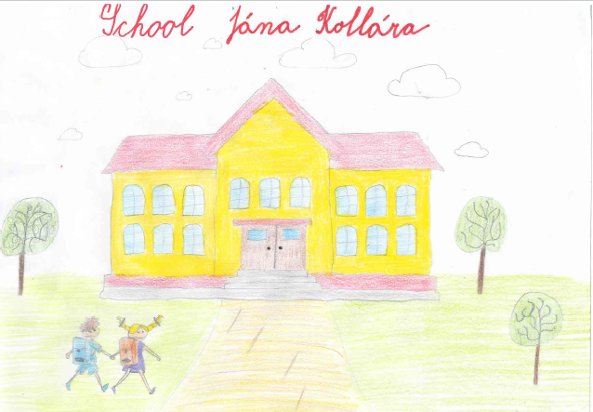

When they returned from school, Abkader took them to visit his confectionery shop. The Slovakian sweets tasted a lot different. In the evening they went to the spa aqua park, where they enjoyed an evening swimming under the starry sky

Ahmet and Dalia were enjoying their visit in Slovakia very much, but they wanted to meet their cousin Farah too, so they agreed with Abakder, that he would take them to visit her in Poland. The next day, they packed everything and said goodbye to Zuzana and Zdenko. Abakder paid for the bus tickets and they went on their trip to Krakow.

