360° Photos

I – First step – the photo

You do not need a special camera, simply use your smartphone and a 360 camera application.
We tested 3 apps for IOS and android.

Google Street View
Android: https://play.google.com/store/apps/details?id=com.google.android.street
IOS: https://apps.apple.com/us/app/google-street-view/id904418768
FOV
IOS: https://apps.apple.com/us/app/fov-360-photos-immersive-panorama-sharing/id1059352208
Panorama 360 Camera
Android: https://play.google.com/store/apps/details?id=com.vtcreator.android360
IOS: https://apps.apple.com/us/app/panorama-360-camera/id1034161360

Another app is Panoraven.com
Or even Occipital 360.com

II – Second step – resize the photo

You can use this freeware tool Photofiltre 7 : http://www.photofiltre.com/

Or you can use an online tool like https://resizeimage.net/
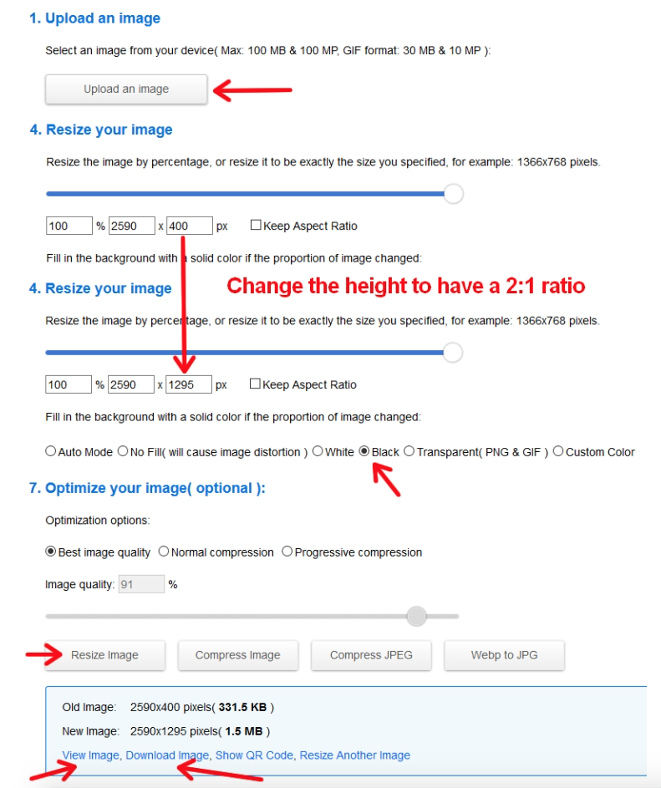

Download your image in a 2:1 ratio and put it on https://www.thinglink.com
There you can add all the information you want to give.
Finally click on „Share“ and choose „Embed media“ and copy the code between scr=“ ... “

III – Third step – Embed your image in the Twinspace

Go to the page where you want to embed your image

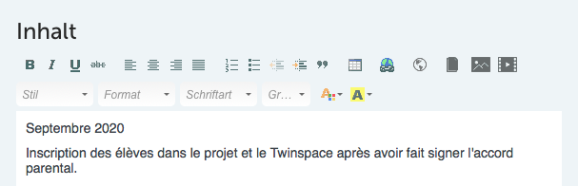

Create an iframe (the forth symbol from the right side)

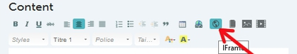

Add your code to SCR (URL)*
Click on „Allow fullscreen“ and then on the green button OK.
Don’t forget to send the page at the bottom.

