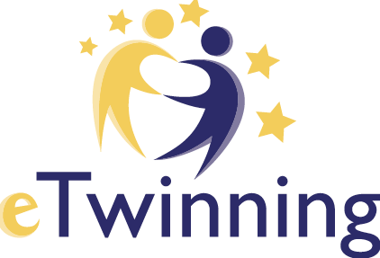

Planning your project with your partner(s)

Partners

Age of pupils and classes involved

Other partners

Language(s) used for the project

Project duration and global timeline
(Hours pr week/ pr month)
Communication between the partners

Title of the project and main ideas
Brief description of the project
Objectives of the project – pedagogical objectives and skills

Work procedure and calendar of activities
Expected results – final production(s)
Collaboration between students – (how will they work together?)
Digital tools used
Evaluation
Dissemination

