LearningApps Tutorial
https://learningapps.org/ is a Web 2.0 application, to support learning.
- Registration – Login. Register with a new account. Enter a login name, email and a password. Accept the terms of the use of the app
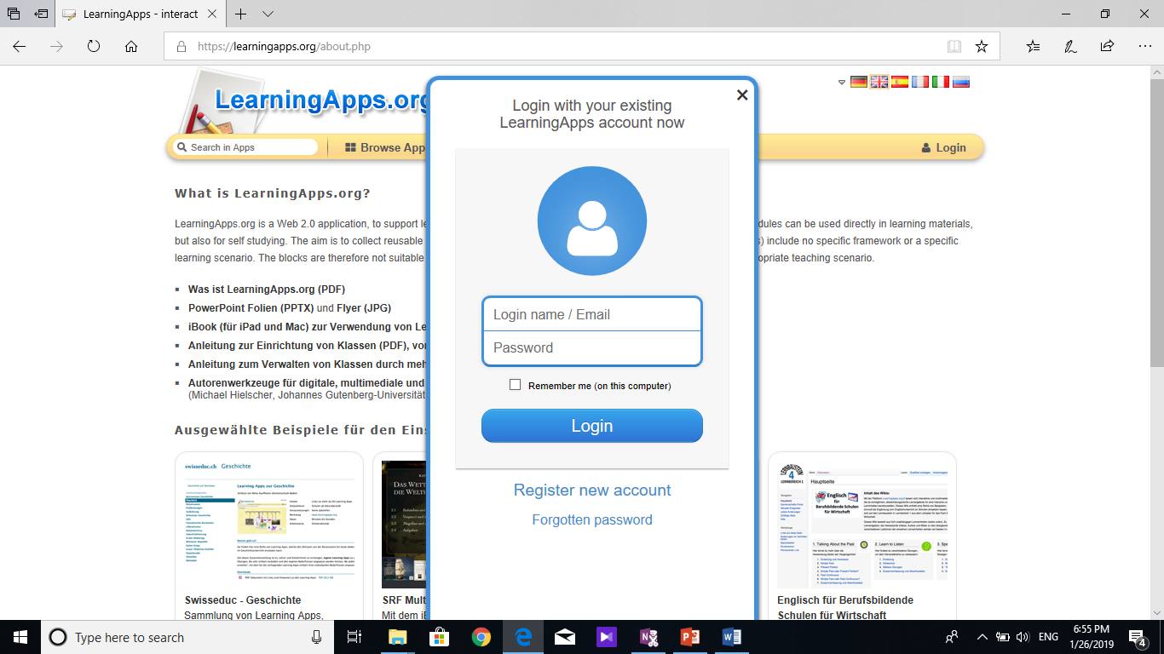
- Create an app

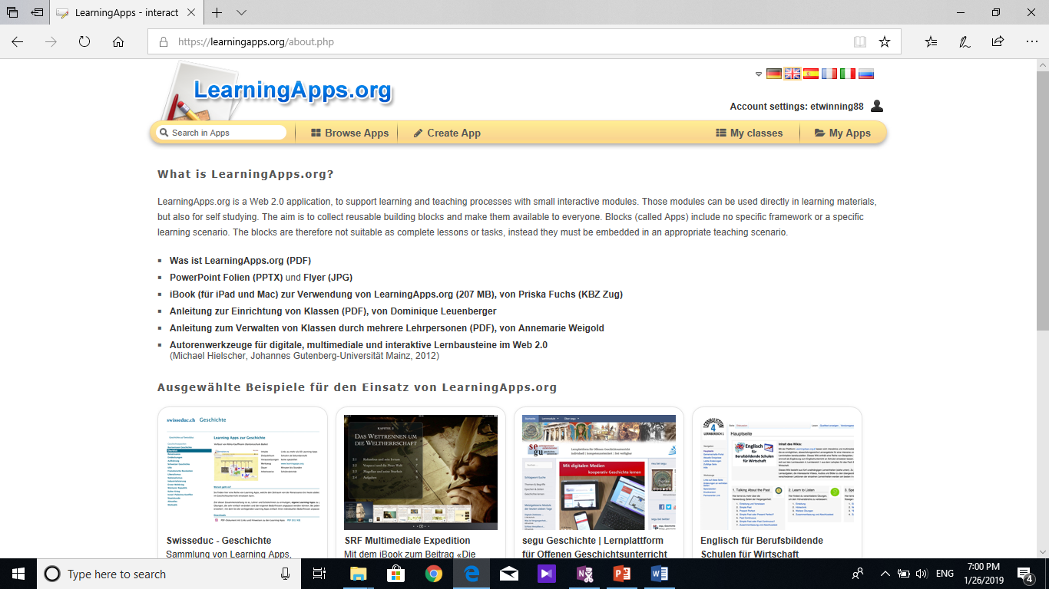
- Choose the app you would like to use
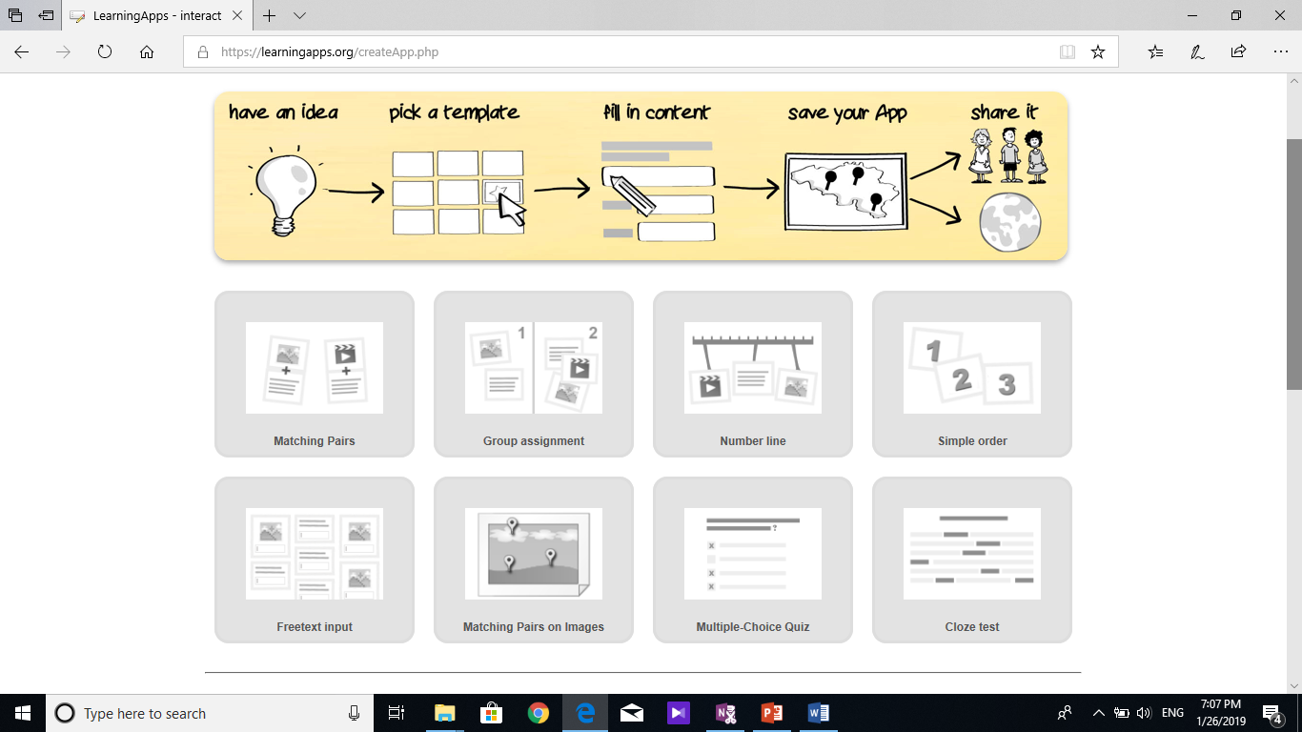
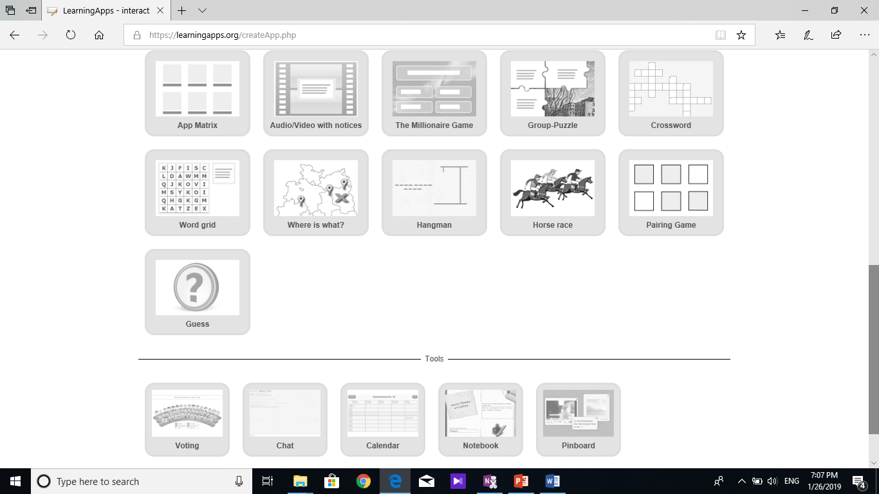
- Once you have chosen it, look through the examples
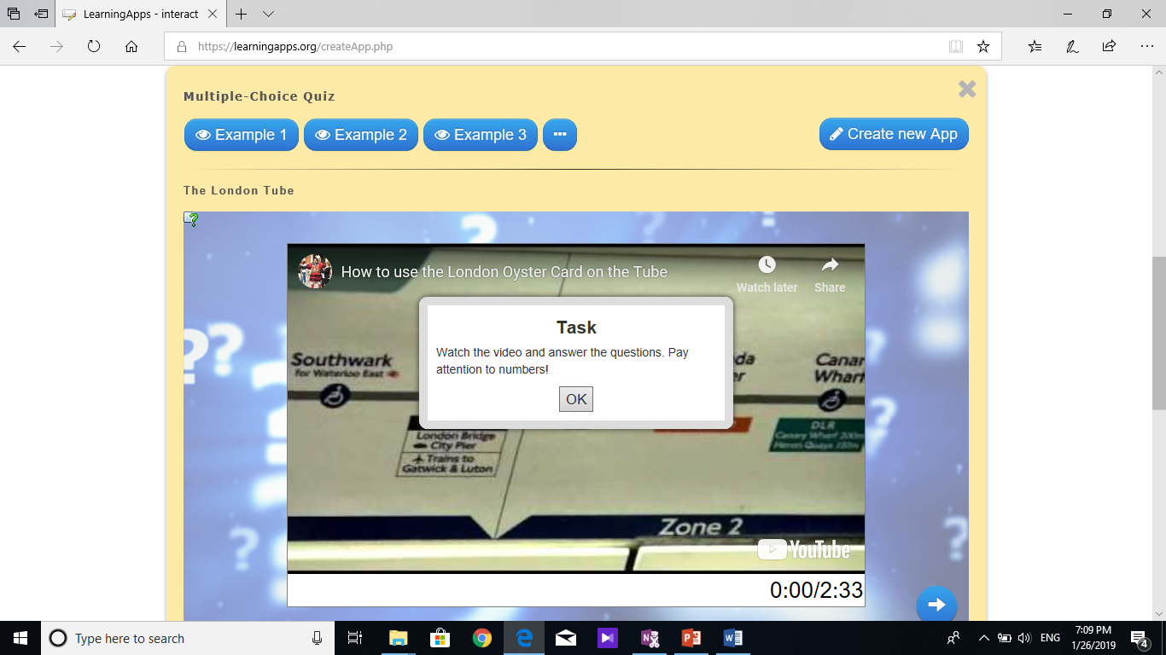
- When you have decided on the example you need, click on Create new App
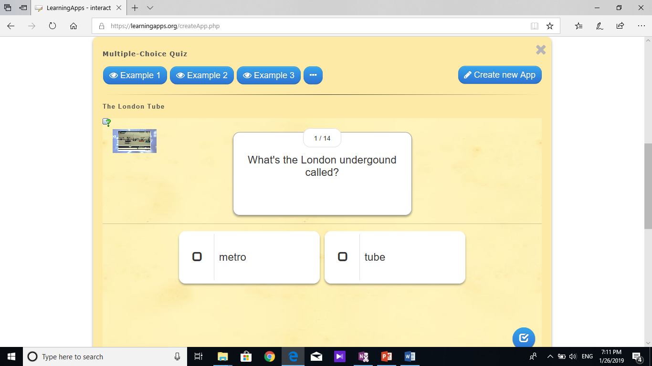
- Start creating your app. Add a title. You can add a description and introduction.
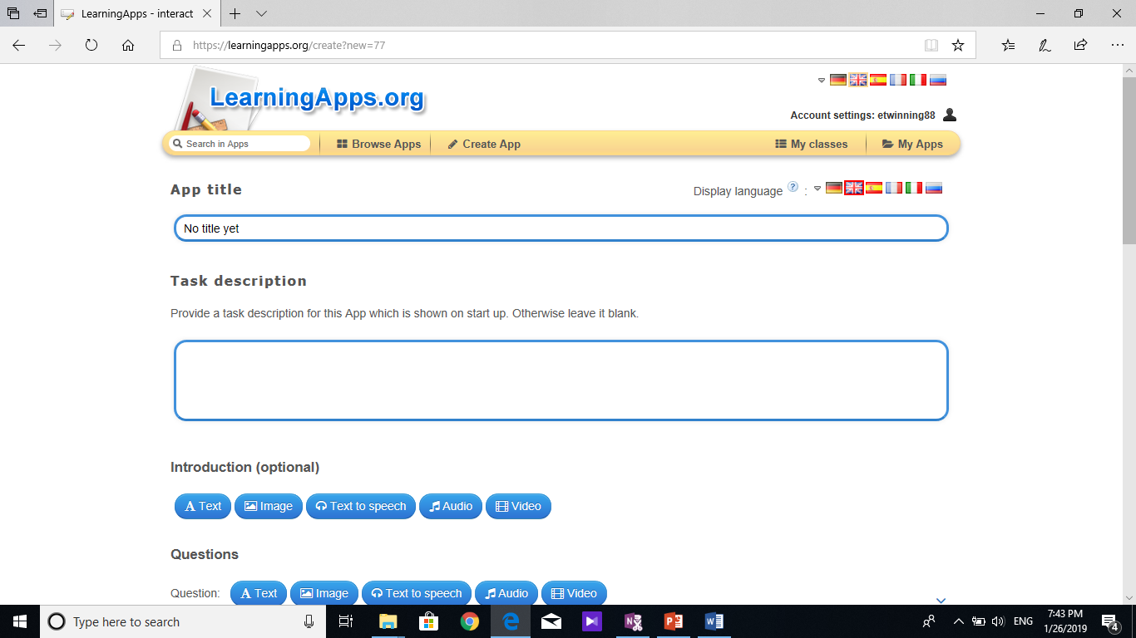
- Write the first question. And the first answer – it may be a text, image, text to speech, audio or video. Tick the box under the question if the answer is right. Then, add the second answer, etc.
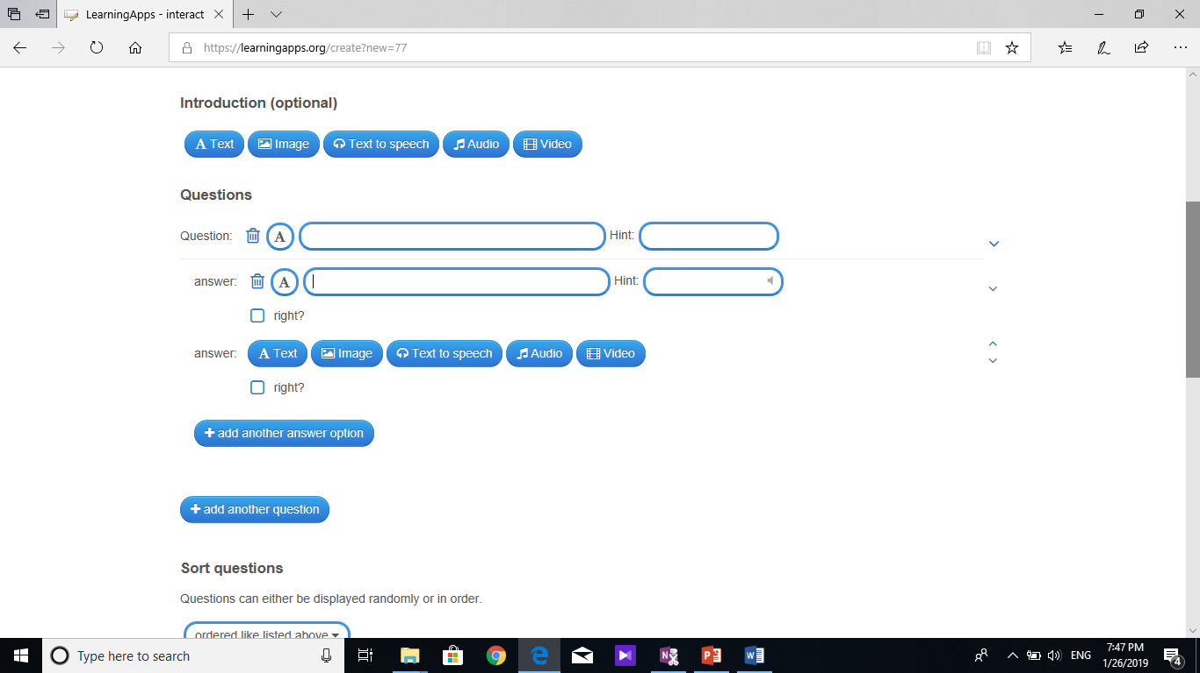

- If you need more answers, click on add another answer. Do the same with the other question.
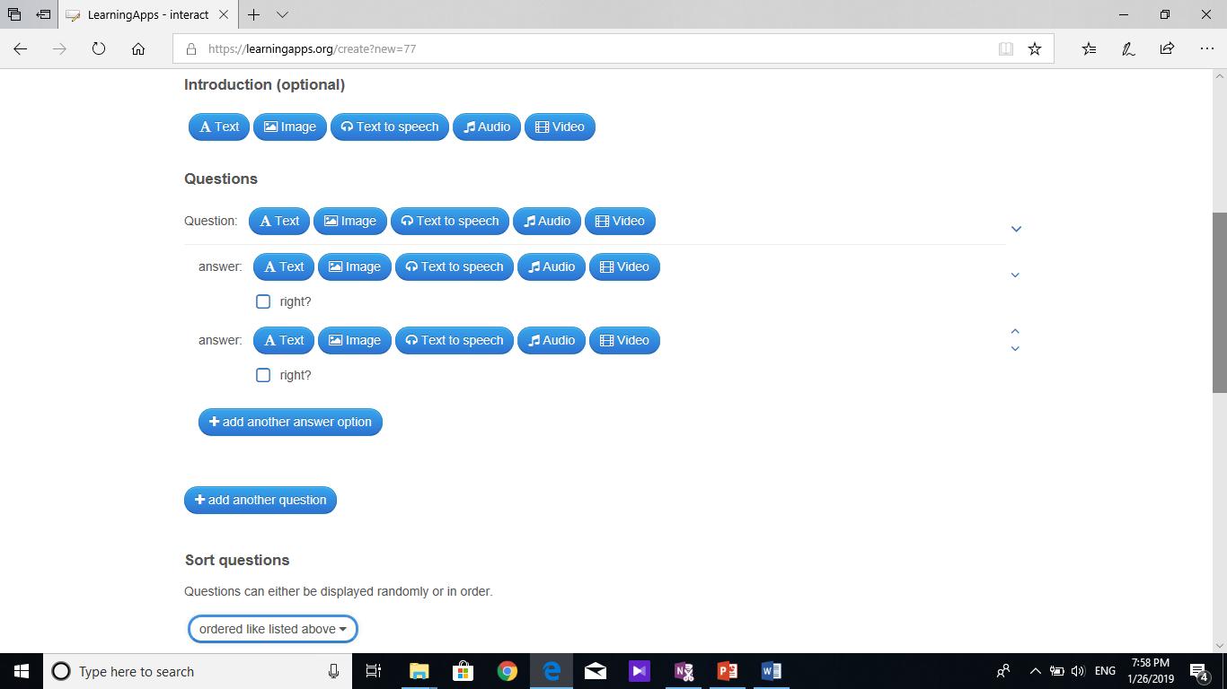

- When you are ready, you can sort questions, evaluate the end, select a background image, and provide feedback for those who answered all the questions correctly. Finally, save the app
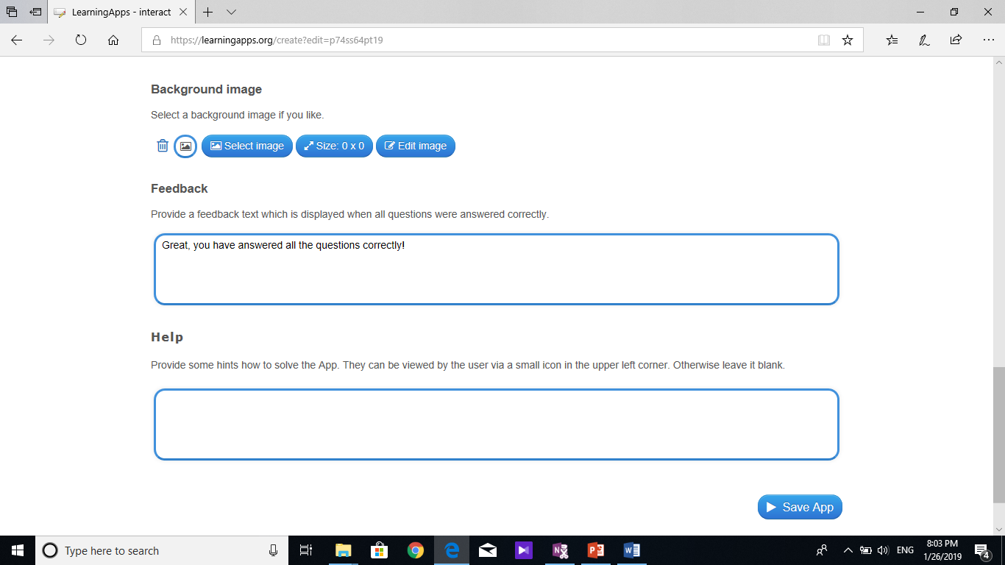
- When you are ready, you can play it or edit the app. You can also change privacy – private app or public app.
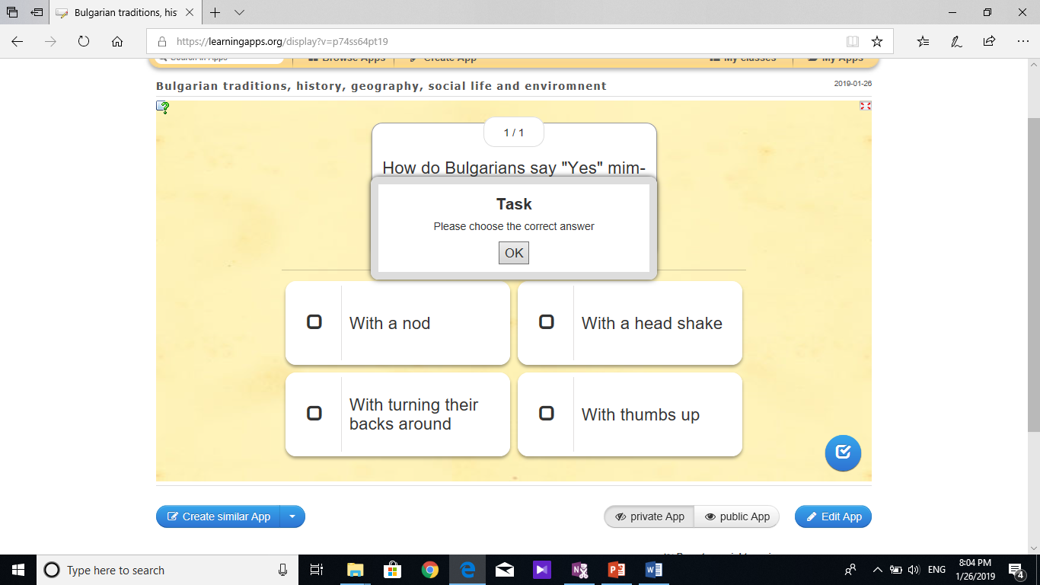
- When the app is complete, you can use the link or QR code to send to people to play the game. There is an embed code too.
