Misterytwinning

Find out the continent
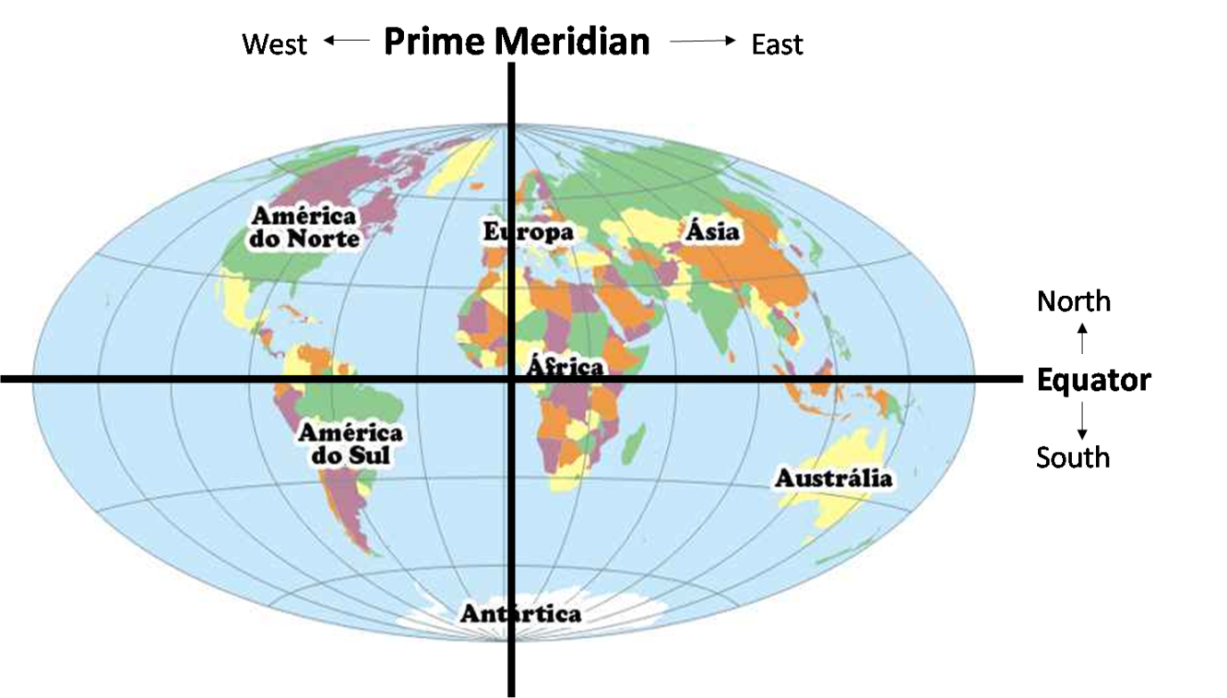
Africa
Antartica
Australia
Asia
Europe
South
America
North
America
1. Do you live EAST of the PRIME MERIDIAN?
Yes No

2. Do you live NORTH of the EQUATOR?
Yes No

3. Do you live in ______________?
Asia Europe South America North America
Africa Antartica Australia
Find out the country
4. Do you live EAST of _______?
continent
5. Do you live NORTH of _______?
continent

WEST EAST
NORTH SOUTH
6. Are you landlocked?
Yes No
6.1. Do you border ________?
Atlantic ocean Pacific ocean Indian ocean
Mediterranean sea Baltic sea Adriatic sea Black sea North sea

7. Do you live in a country that starts with a letter A trough L?
Yes No
8. Do you live in ___________?
country names

Find out the city
9. Do you live in the NORTHERN part of your country?
10. Do you live in the EASTERN part of your country?
NORTHERN SOUTHERN
WESTERN EASTERN
11. Do you live in a city that starts with a letter A trough L?
Yes No
12. Do you live in ____________?
city names
Other Questions in the end of the contest
What do you do after school?
