MysteryTwinning Activity 5 :
International restaurants
Preparation stage

Owner : Beata WÓJCIK
Count of participants : 46
Activities : 7
Messages : 1

INSTRUCTION:
Hi my Dearest Students! There are 20 of you, 9 beautiful girls and 11 handsome boys, all really cheerful and extremely bright students. And apart from the regular school work, you're taking part in an international eTwinning project - MysteryTwinning. Good job, guys!
I have the pleasure to present and get your feedback on our next project activity 'International restaurants'. Entering each slide, read the instruction which you can display by clicking on the 'i' icon in the top right-hand corner of the screen. Answer all the tasks please and enjoy yourselves. Thank you for taking part:)

List of participants

Name
Sebastian.c..1
Gabriela G.
Jan.l..1
Bartosz S
Mateuszp14
Aleksandrap13
Damian.z.
Klaudias17
Paulinam
Arkadiuszr15
Jakubb1
Kingap12
Beata WOJCIK
Pawel.m

Wordle activity

MysteryTwinning - how do you feel about it?

INSTRUCTION:
Decide on one or more words that can be used to describe our MysteryTwinning project. Send your words to add to the word cloud.

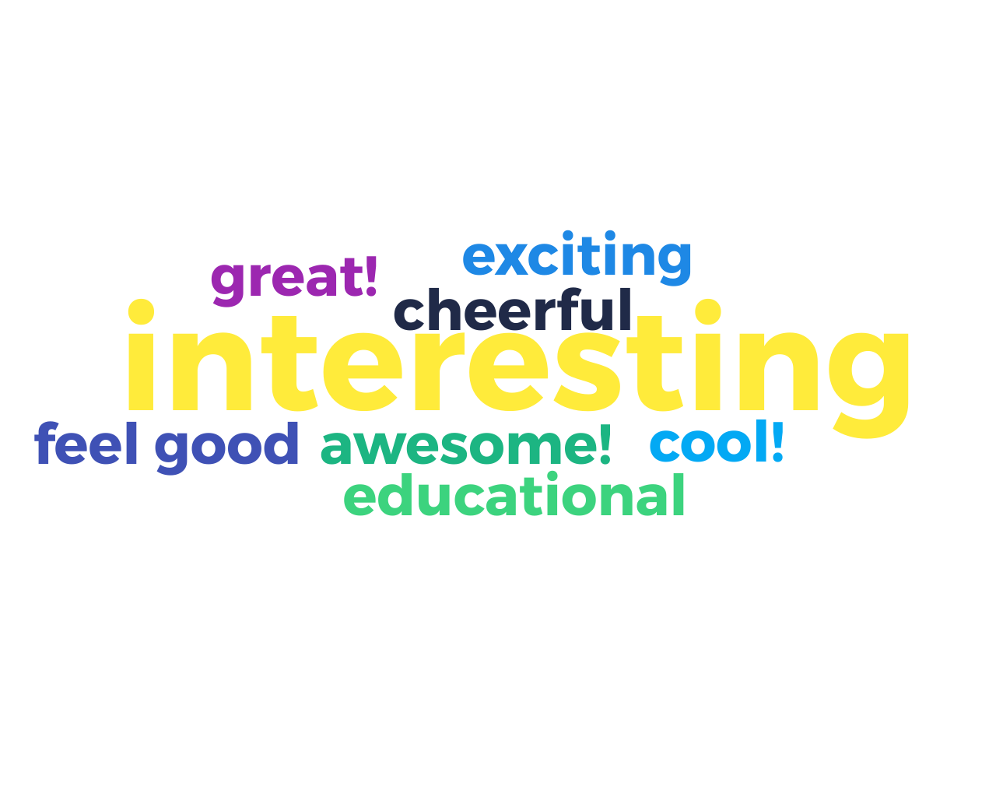

 | Sent words | 8
 | interesting | 4 ×
 | Participants | 11

Words | Occurrences
interesting | 4
awesome! | 1
cheerful | 1
cool! | 1
educational | 1
exciting | 1
feel good | 1
great! | 1

Selfie-wall activity

Class 1A Mickiewicz High School Strzyżów, Poland

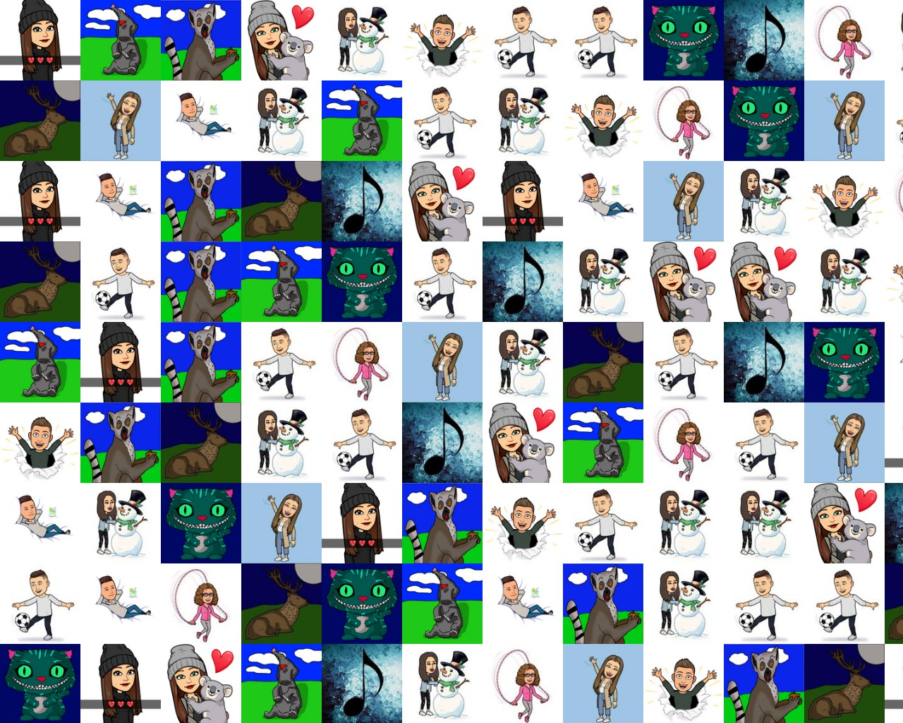

 | Selfies | 15
 | Participants | 15

Prioritization activity

Type of food served in our international restaurant

INSTRUCTION:
What type of food would you like your international restaurant to serve? Award 10 points to your number one option or divide the points between several choices (eg. give 5 points to your most favourite type of food, 3 points to your second best choice, 2 or 2x1 points to another idea/other ideas you quite like too).
 | Top proposition | desserts

 | Proposition | Distributed points | Votes
1 | desserts | 18 (18 %) | 7
2 | meat dishes | 10 (10 %) | 5
3 | fast food and takeaway | 10 (10 %) | 5
4 | romantic dishes | 9 (9 %) | 5
5 | traditional dishes | 7 (7 %) | 3
6 | colourful dishes | 7 (7 %) | 5
7 | salads | 6 (6 %) | 4
8 | legendary dishes/dishes with a legend | 5 (5 %) | 2
9 | crepes/pancakes à la... | 4 (4 %) | 3
10 | soups | 4 (4 %) | 2
11 | pasta dishes | 3 (3 %) | 2
12 | dietary dishes | 3 (3 %) | 2
13 | children's menu | 2 (2 %) | 2
14 | green dishes | 2 (2 %) | 1
15 | one-pot dishes | 2 (2 %) | 1
16 | vegetarian dishes | 2 (2 %) | 2
17 | holiday specialities | 2 (2 %) | 2
18 | potatoes à la... | 2 (2 %) | 1
19 | spring dishes | 1 (1 %) | 1
20 | national soft drinks | 1 (1 %) | 1
21 | meat-free dishes | 0 (0 %) | 0
22 | quick dishes | 0 (0 %) | 0

Wordle activity

Food type - more ideas

INSTRUCTION:
Perhaps you have a different idea? Be as creative as possible and suggest your concept(s).

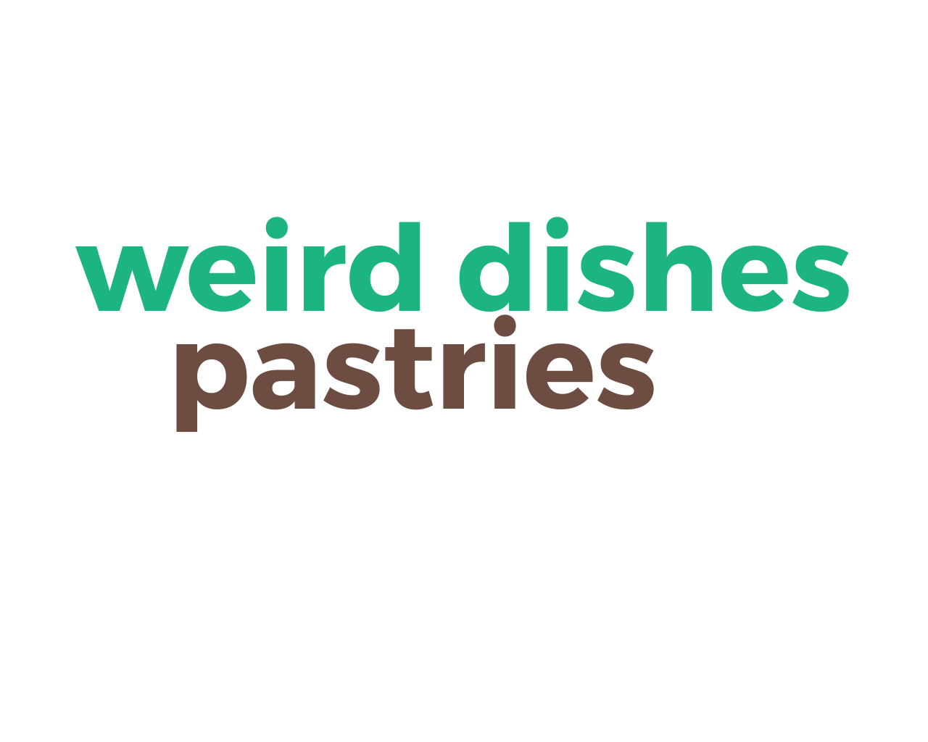

 | Sent words | 2
 | pastries | 1 ×
 | Participants | 2

Words | Occurrences
pastries | 1
weird dishes | 1

Prioritization activity

The features of an international restaurant

INSTRUCTION:
You are soon going to create a presentation of your international restaurant. What should this presentation include? Below you will find 10 ideas. Which of them do you find absolutey necessary and which are unnecessary in your opinion? Award points to each feature (0-2) according to its importance.
 | Top proposition | Name

 | Proposition | Distributed points | Votes
1 | Name | 32 (21 %) | 9
2 | Picture/Drawing (design) | 24 (15 %) | 8
3 | Menu - name/ingredients/national name and English equivalent | 23 (15 %) | 9
4 | Price list | 14 (9 %) | 8
5 | Description/Presentation (dialogue?recording?) | 14 (9 %) | 6
6 | Specials (Sunday/Weekend/Holiday Specials/Chef's special)) | 13 (8 %) | 9
7 | Children's menu | 11 (7 %) | 6
8 | Recipes | 10 (6 %) | 7
9 | Photos of the dishes | 10 (6 %) | 7
10 | Other | 4 (3 %) | 3

Wordle activity

Other features of a restaurant

INSTRUCTION:
If you have another idea that should be included in the presentation of the restaurants, add it here.

 | Sent word | 1
 | nice service | 1 ×
 | Participant | 1

Words | Occurrences
nice service | 1

