My favourite movie

By: Ana Rasinhas, 14 years old 9.ºE

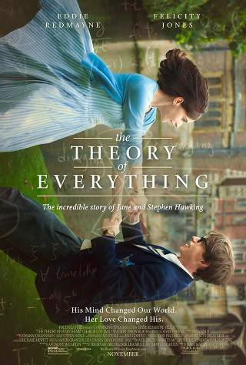

Directed by | James Marsh
Produced by | Tim Bevan, Eric Fellner, Lisa Bruce, Anthony McCarten
Srceenplay by | Anthony McCarten
Based on | “Travelling to Infinity: My life wiyh Stephen” by Jane Hawking
Starring | Eddie Redmayne and Felicity Jones
Music by | Jóhann Jóhannson
Cinematography | Benoît Delhomme
Edited by | Jinx Godfrey
Production Company | Working Title Films, StudioCanal
Distributed by | Focus Features, Universal Pictures
Release dates | 21 November 2014 (USA)
Country | United Kingdom
Language | English, French, Latin
Budget | $ 15 million
Box Office | $ 104.1 million
Running Time | 123 minutes
Gender | Drama
Awards | - Academy Award for best Actor (Eddie Redmayne, 2015); Golden Globe Award for Best Original Score (Jóhann Jóhannson, 2015); Golden Globe Award for Best Actor – Motion Picture – Drama (Eddie Redmayne, 2015); BAFTA Award for Best British Film (James Marsh, Tim Bevan, Eric Fellner, Lisa Bruce, Anthony McCarten, 2015);BAFTA Award for Best Screenplay, Adapted (Anthony McCarten, 2015); BAFTA Award for Best Actor in a Leading Role (Eddie Redmayne, 2015); Screen Actors Guild Award for Outstanding Performance by a Male Actor in a Leading Role (Eddie Redmayne, 2015)

Movie Pictures

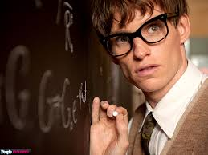

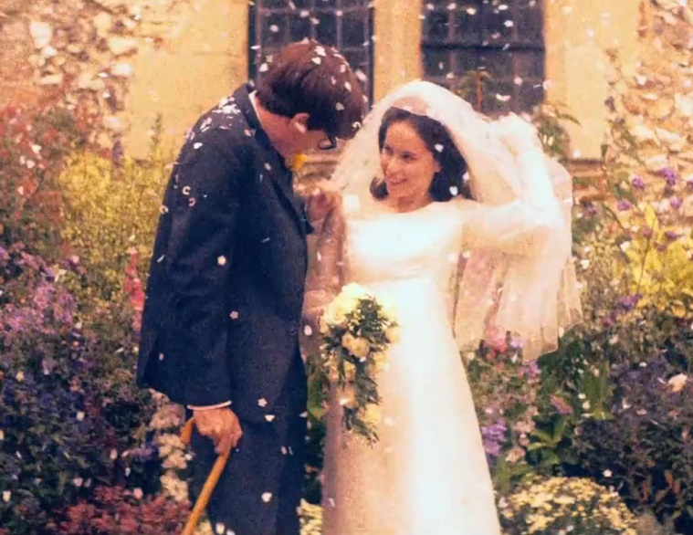

Summary

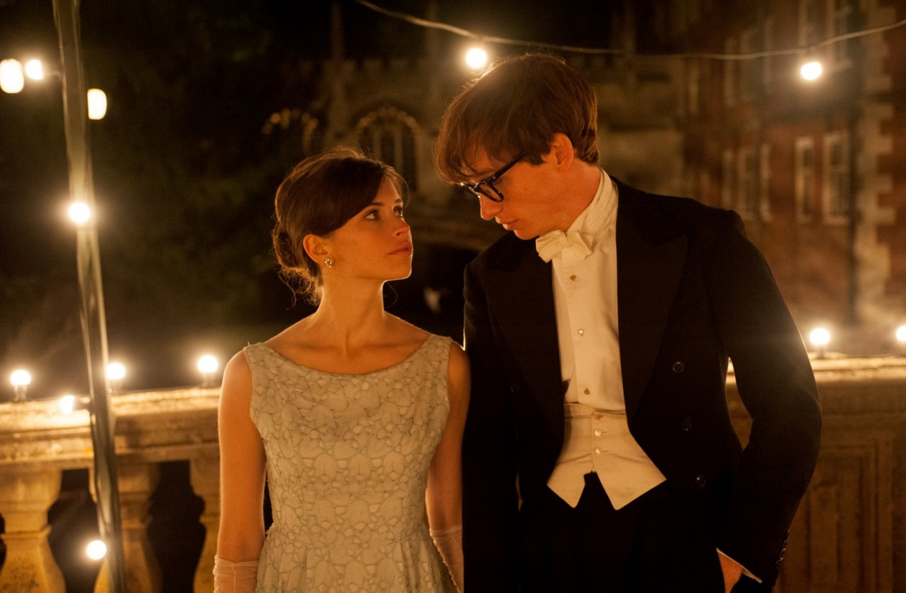
In the 1960s, Cambridge University student and future physicist Stephen Hawking (Eddie Redmayne) falls in love with fellow collegian Jane Wilde (Felicity Jones). At 21, Hawking learns that he has motor neuron disease. Despite this -- and with Jane at his side -- he begins an ambitious study of time, of which he has very little left, according to his doctor. He and Jane defy terrible odds and break new ground in the fields of medicine and science, achieving more than either could hope to imagine.

Justification for the choice of the movie

I love this movie because is about love, courage, strength to overcome difficulties, it’s genuine and real.
The movie addresses the will of personal development in a very real and hard way.
Stephen has managed to become one of the most respected physicists of today and this is a true example of willpower and personal development. Is wonderful to see him build a family and a career with a serious disease.
Jane unconditionally supported her husband and was always there for him when he needed, moreover, was mother and homemaker. She did not cry in front of Stephen and instead of whining, conveyed her hope and optimism for him to continue to fight for life. Jane was the pillar of the husband and without it he would not be where we arrived. She owns an incredible force and is an example for all people who mourn for everything and anything.
This move is amazing because is a true story. It’s my favorite movie!

