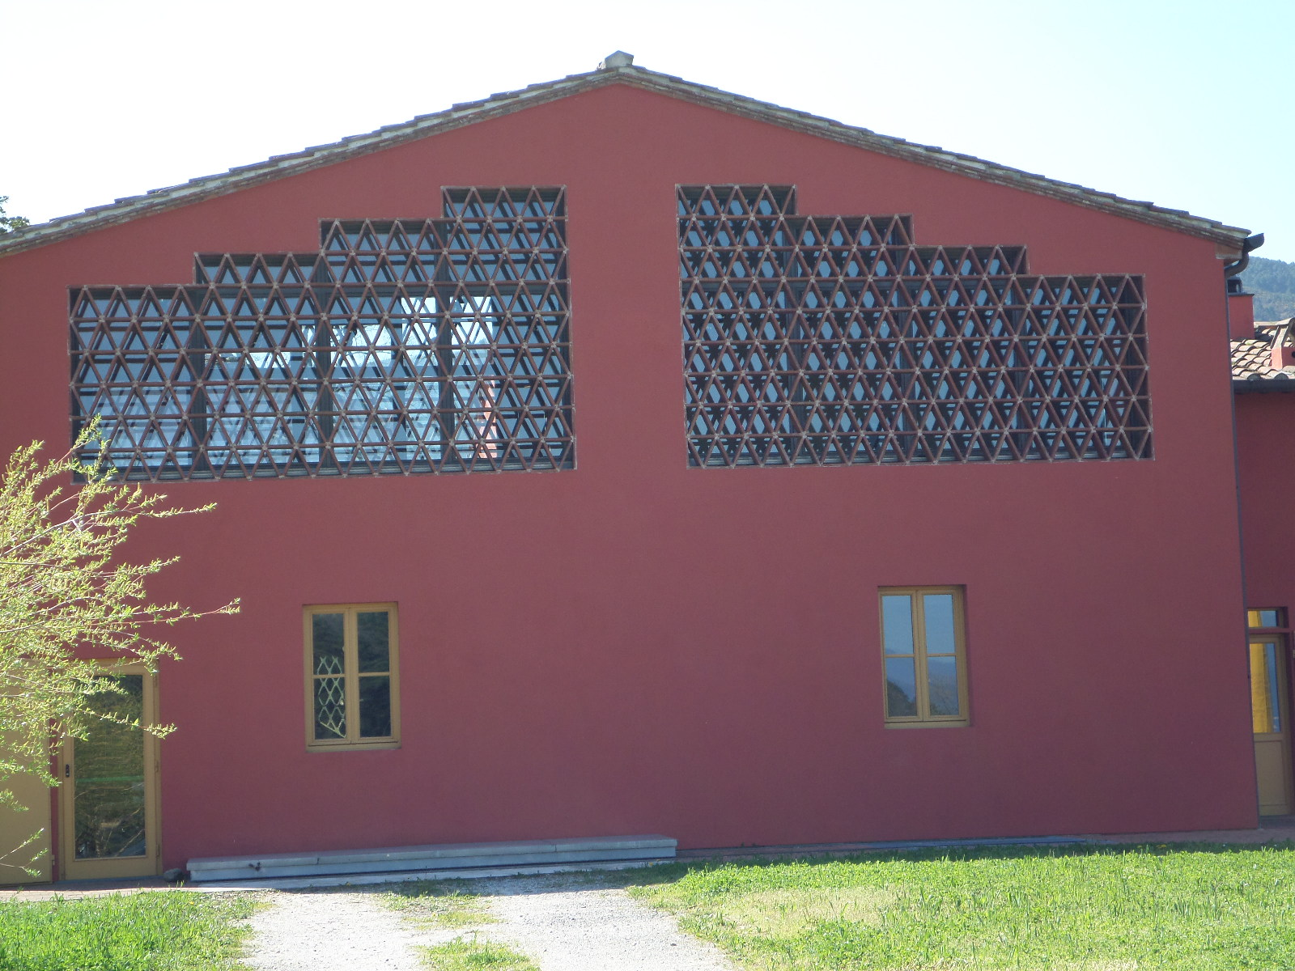

MANDOLATE

The mandolate are architecture made with tiles .

They are windows of hayloft.

The tiles made with clay didn't let dampness or rain spoil hay stocks. Now they have become fashionable country cottages.