Something special at my school: Environment-friendly schools

I'm a student at D. Egas Secondary School in Resende and what has called my attention so far is the Environment-friendly schools’ project. I think that is a special programme. It is a subject that has asked the world's attention several times but it hasn't been done enough by many countries . The Eco-schools’ main goal is taking and following several actions in defence and protection of the environment. The club looks after the school environment and the best ways to manage the green school spaces. At the same time it sensitizes the social community for the urgent need to preserve and protect it.
The main message of this project is to ask to each one of us to participate actively to stop the degradation of our environment and asks to every single person to change habits and to look after the planet where we live.
The main goals of this project are:
- To promote learning experiences in the defence of the environment.
- Allow students to put in practise their own projects to interfere actively at school and green school spaces , as well as to improve and preserve them.
3- call attention all school community to the need of reducing energy and water, or using other natural resources promoting at the same time habits of reusing and recycling different materials.
Being a new student at this school ,I had the opportunity to see some of the works made by the club. Other tasks that surprised me were the flag run with its hymn , the national day of the sea with a power-point made by the students. At Christmas all the school spaces were decorated with
beautiful ecological Christmas trees and fireplaces, both gave an enormous happiness and special feeling to the moment.
With everything I have mentioned I'm proud of being student of a school like this one, that so well preserves, protects and defends not only the environment but also our planet, the Earth.

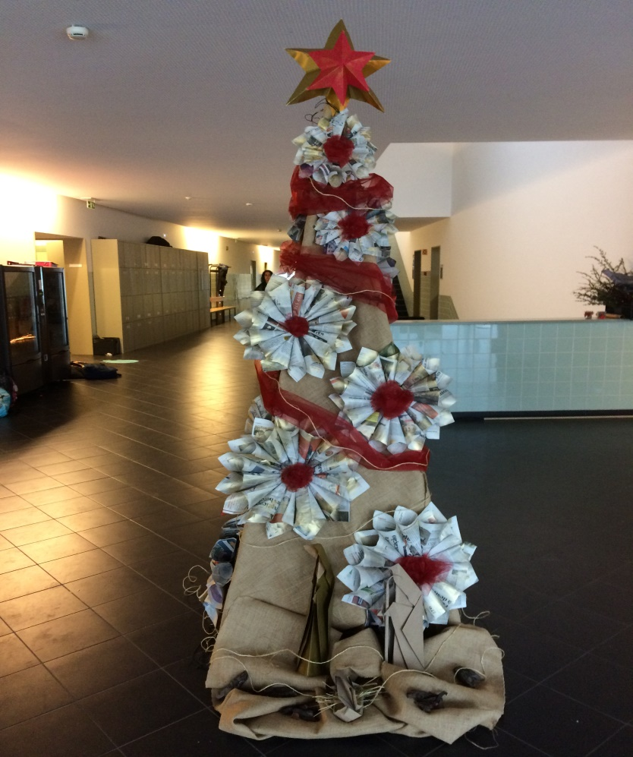
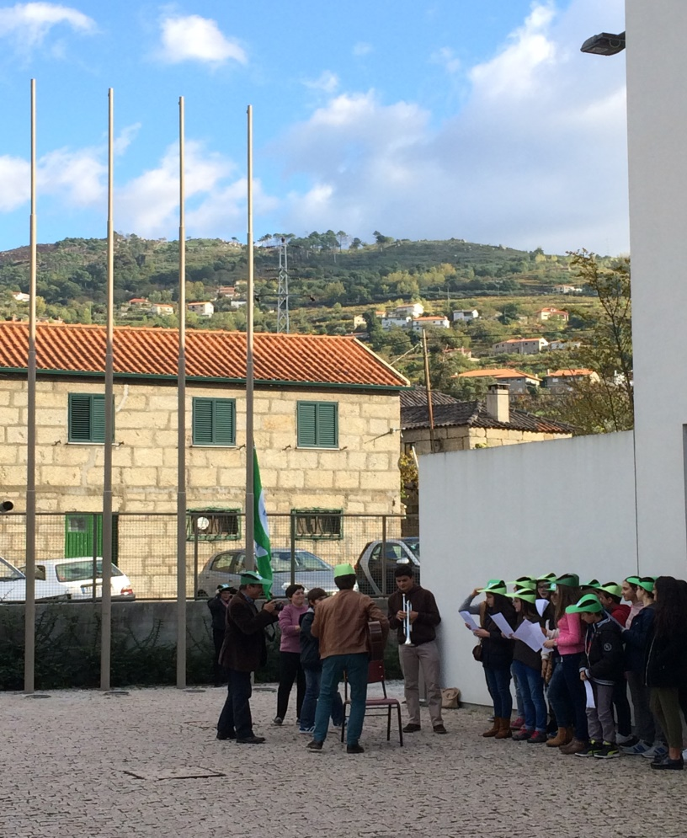

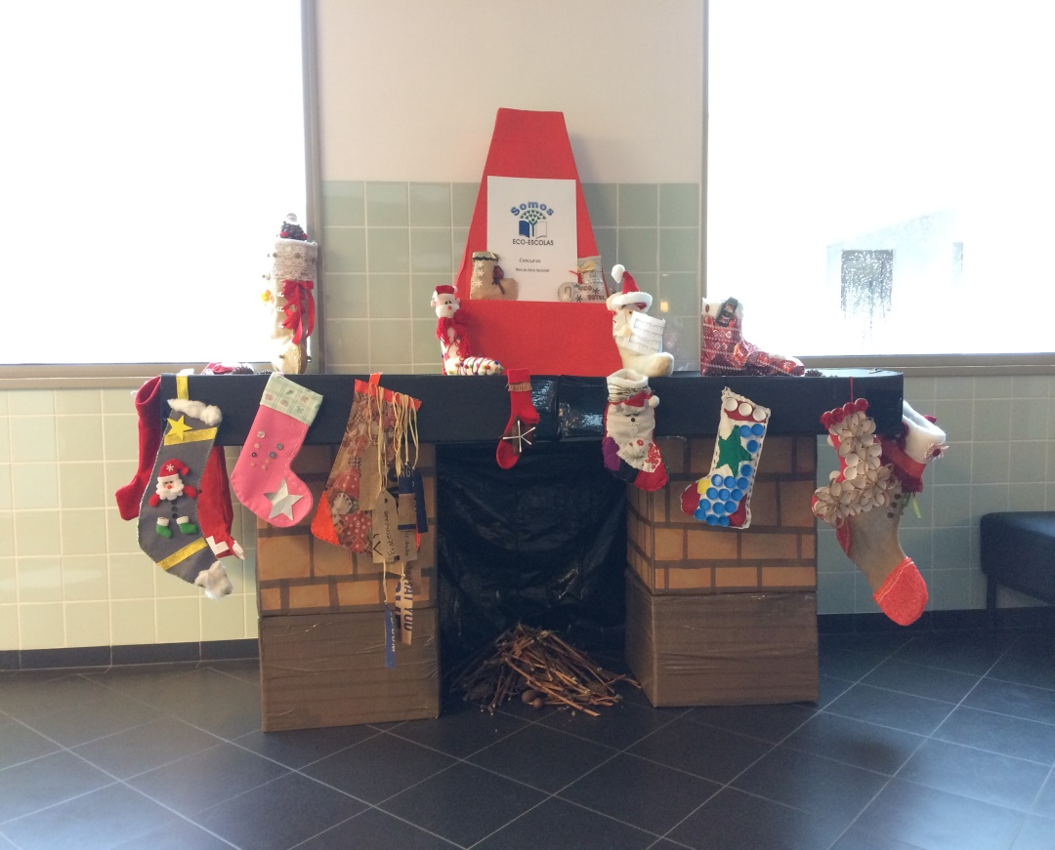

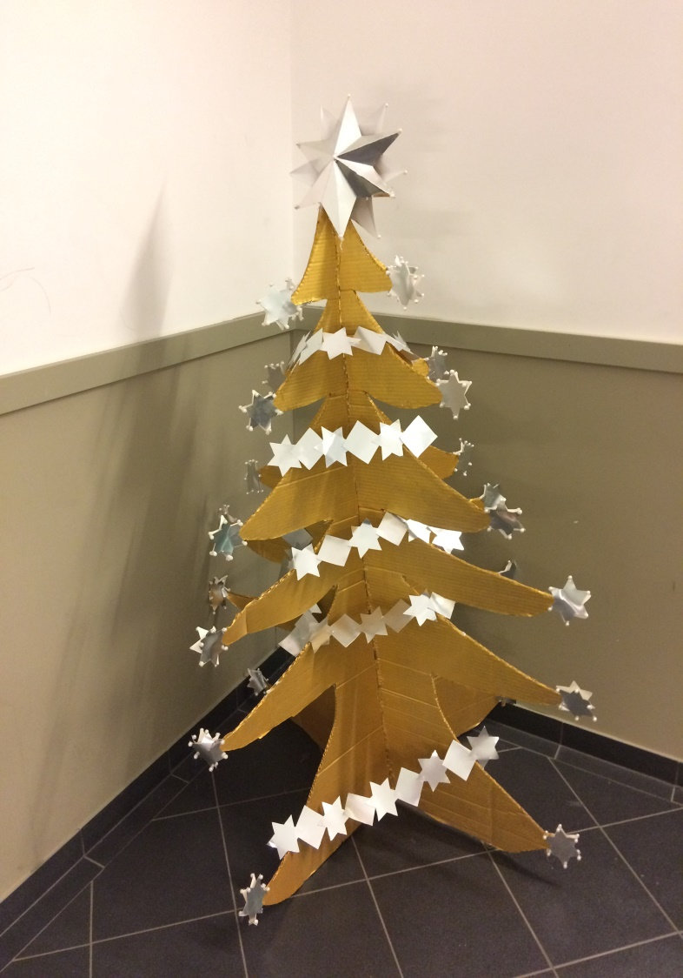

Name:Maria Margarida Mendes Cardoso
Class:10ºC
Number:25
Erasmus+ Club

