My favourite film

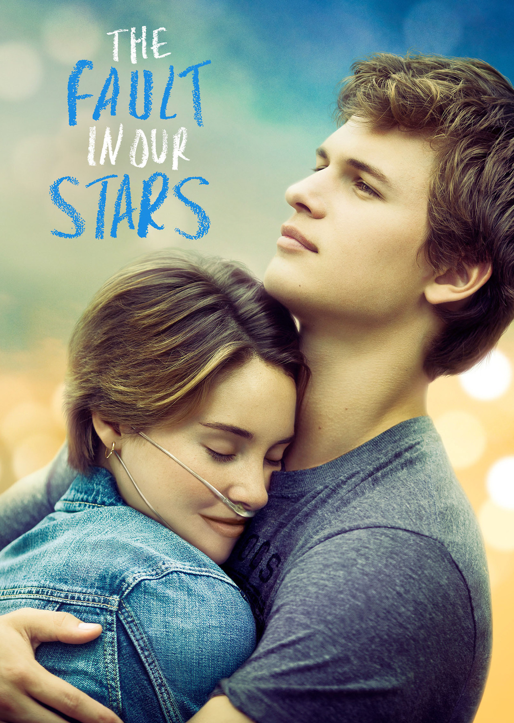
Jéssica Loureiro, Portuguese student
9ºE
14 years old

DVD’s Cover
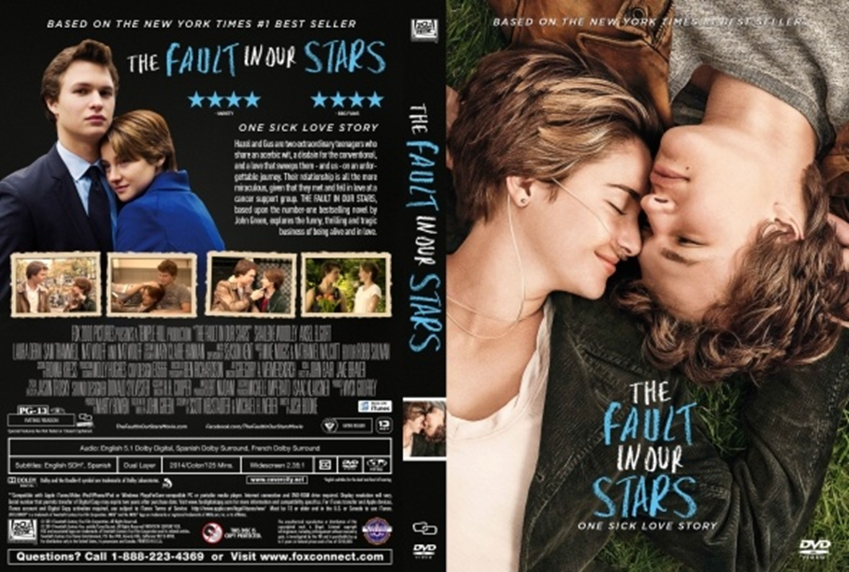

DATA SHEET

TITLE: The Fault in Our Stars
PRODUCTION YEAR: 2014
DIRECTED BY: Josh Boone
RELEASE: CINEMA- May 16th 2014
DVD- September 12th 2014
DURATION: 125 minutes
CLASSIFICATION: 12 -Not recommended for children under 12 years old
GENDER: Drama and Romance
COUNTRY OF ORIGIN: USA

Synopsis

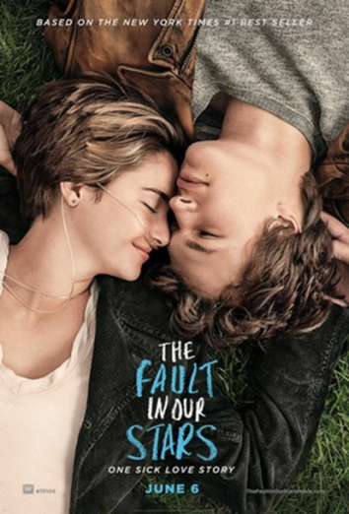
The story is narrated by a sixteen-year-old cancer patient named Hazel Grace Lancaster, who is forced by her parents to attend a support group. It’s where she meets and falls in love with the seventeen-year-old Augustus Waters, an ex-basketball player and amputee. A boy who will completely change her life.

Film scenes

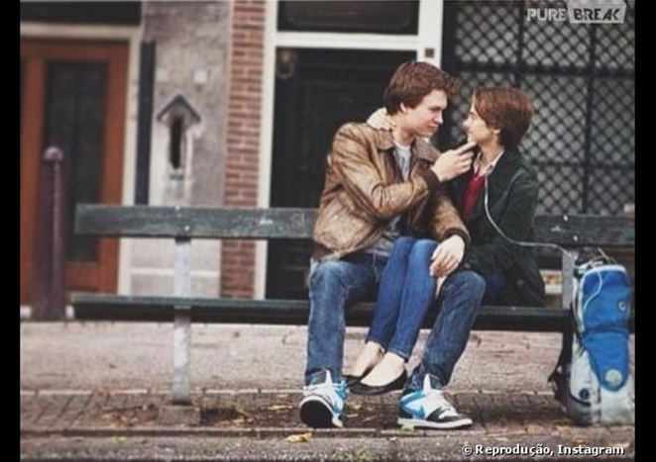
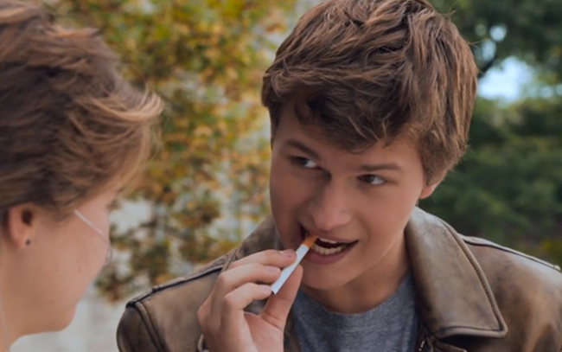

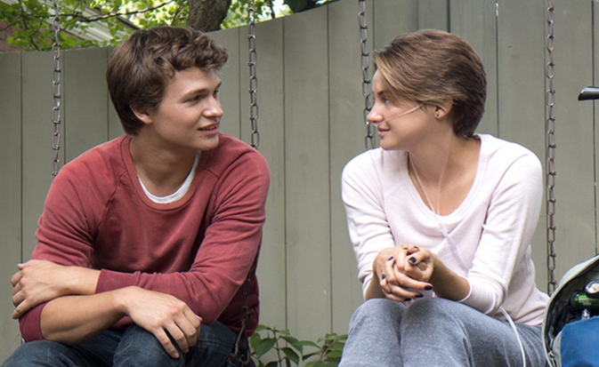

The reason I Chose this film

I liked this movie, because cancer is a popular topic in literature and at fiction and non-fiction worlds. The Fault in Our Stars is extraordinary. Fun and simple. Often the "cancer books/films" are overwhelmed with the drama that saturates the reader with sadness. Fortunately, this film changes that. The film is mainly humorous, it isn’t sad. However, this does not mean, that the severity of the characters‘ situation is ignored. Instead, cancer becomes a support character, always near the narrator, but it never influences the development of the plot. The characters are not wise and all-knowing children with cancer which is common in many stories of young people who suffer from this disease. Hazel, often offers fun comments on the world she lives in and the situation she is in. The book, which was adapted to cinema, doesn´t intend to have an endless knowledge towards the illness, but only conveying a touching and different message.
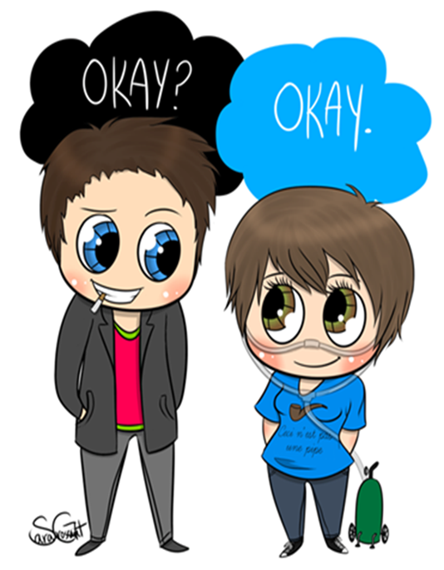
The same should be said about Gus, our heroic best friend. It is a stubborn short film, and it will not be easily forgotten like so many others. Dialogue is witty maintaining a kind of silenced beauty. In this film lacks extravagance, this does not prevent it from becoming one of the best novels I’ve recently read and one of the most beautiful films I have ever seen.

