The Art and the Architeture
of the Compitese area
Le Mandolate (The mandolata windows)
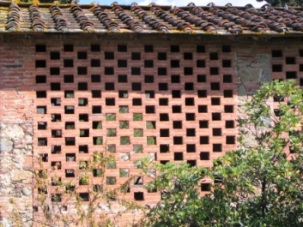
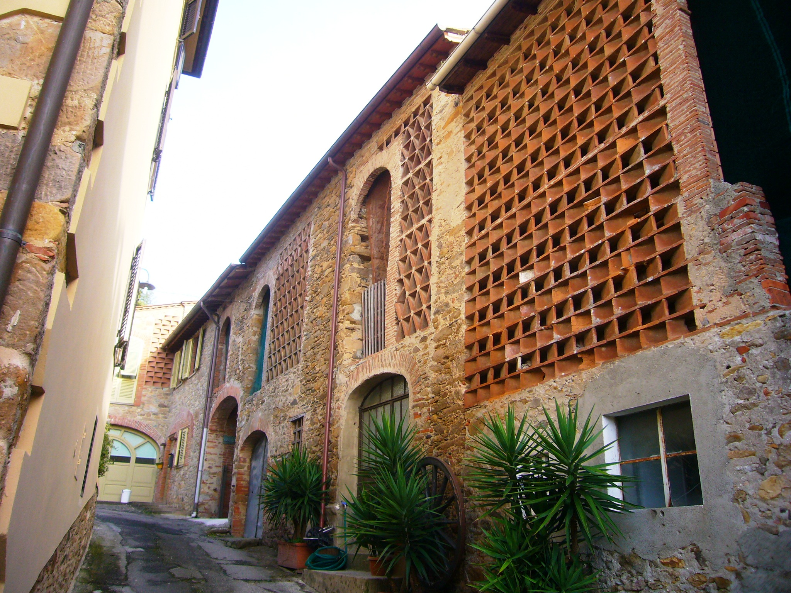 the straw
The " mandolate" were architetures of tiles, types of windows that let to the air enter and keep the winter stock of hey dry and healthy for the cattles in the winter . now they are fashionable country homes.

The water mill wheels
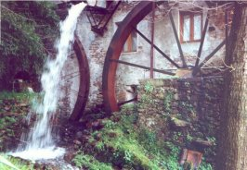

The water wheels are are still visibile in many of our villages alongside streams
The aqueduct
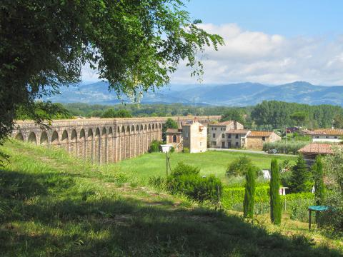
in 1832 the architect Nottolini built the aqueduct that we can see now running from Guamo village to the town of Lucca.

The Marginette
The "marginettes" are little chaples or small church which are situate along the side of old country roads.
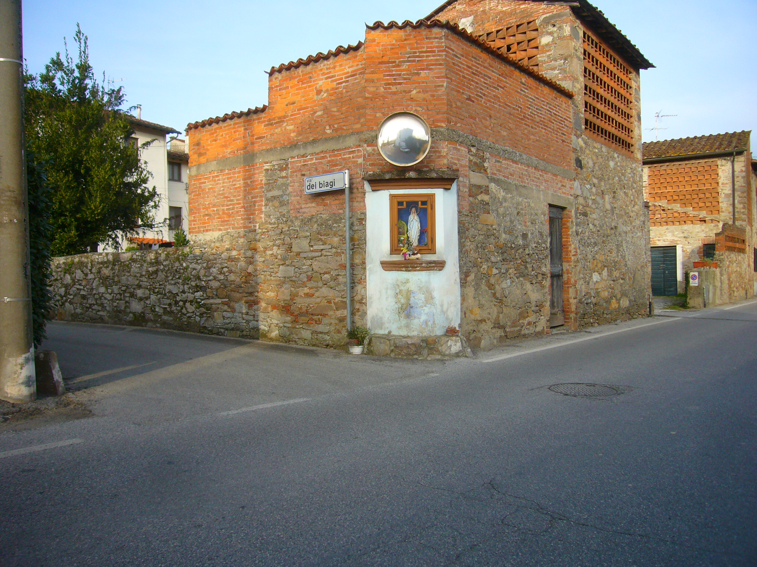
The villas
The "villa" is a big countryside mansion with some agricultural activities and a park sorrounding the house. They were built from 15th until 19th centuries. It was enclosed by walls with often a big gate and a large garden . The villa was the summer residence where rich people from Lucca lived .
