MARCH REPORT OF ACTIVITIES
We have already introduced ourselves to our partners by telling them who we are, what our country, towns and families are like. We have also spoken about the square of our town and the cellebrations that take place there. We have sent them videos, photographs, TED talks and hypertexts and, obviouly, we have received theirs.
Now it's time to know how much we have learnt about each other’s country.
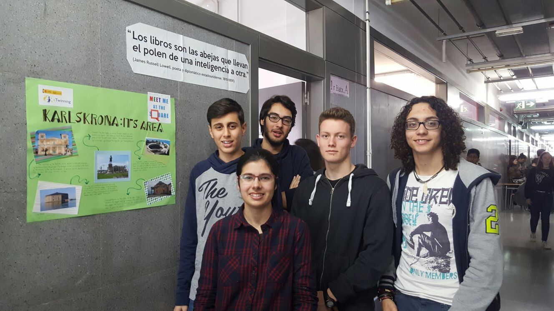
Thus, the students from both Sweden and Spain have dedicated the month of March to delve into our partners’ country, towns, cultural life, etc.
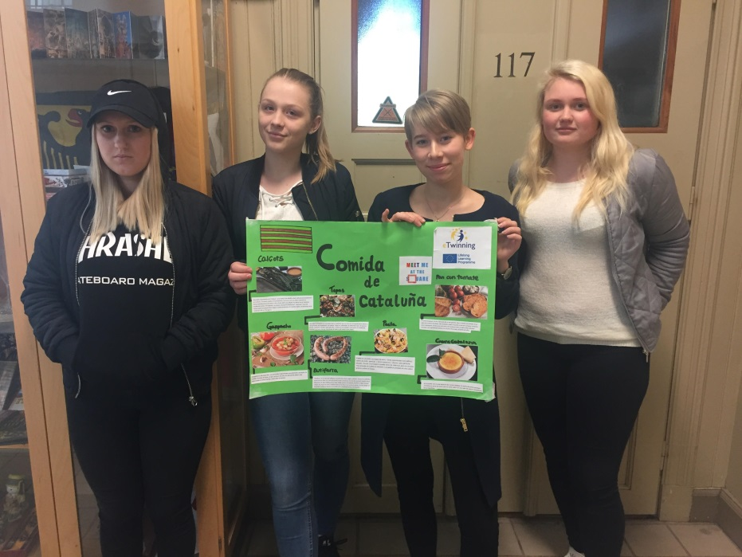
Each team specialized on a certain topic, such as the history of our partners’ country or towns, their cultural life, economy, politics, geography, music, food, etc.
We made posters with all the information we gathered and placed them in a visible place in our school so that everyone there could learn about our project.
Then the groups prepared oral presentations about their posters in front of their classes so as to share our information with the other students in the class.
It has been a very enriching experience! Especially for the recipes, they all looked very tasty!
We created a blog where to place together all the information about our squares!

By: Irene Palou (Spain) and Alexander Christensson

