Lesson Plan
Teachers Team Work • Zoltan (Hung.), José (Port.), Doina (Rom.), Serkan (Turk.), Balazs (UK), Michela (Italy)
To build this plan teachers use e-mail, and twinspace.
Topics • Team work, colaboration, read and follow instrutions, problem solving | Age • 9 -11 |  | STEM topics • inter-disciplinary: robotics, engineering, ICT
What students will learn • the basic components of a WeDo set; the basic components of WeDo software; how movement is transmitted and how energy is transferred; to use the tilting and the movement sensor; to programme the model to change its speed and to respond to interfering objects.
Materials •LEGO WeDo kit, tablet, computer |  | Estimated duration • 120 min.
Lesson
- Students are divided in pairs and receive the WeDo sets.
- Interactive discussions: what is rotation, what is speed.
- The teacher makes a short presentation of how to use transmission belts and wheels.
- The teacher makes a general presentation of WeDo software.
- Children build the DANCING BIRDS model and the CROCODILE model
- The teacher explains how the models work
- Each pair build the model and then add the movement sensor or the tilting sensor
- Students programme the model to change its speed.
Images•
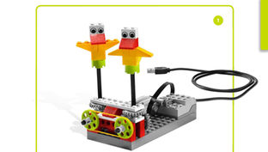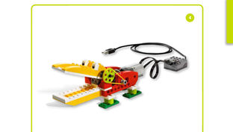
Evaluation • At the end of the lesson the teacher can apply a questionnaire to assess the interest, participation and commitment of the students during the tasks.
Observations •

