ST’ART: CLIL Lesson Porto - Students’ HANDOUT

Welcome to Porto CLIL Lesson!
During St’ART Project you have already studied cities as well as their cultural and traditional aspects. Today you are going to learn about the particularities of our city.

A. Before going further we invite you to take some minutes and, together with your class, brainstorm the words “urban island” (What do you think an urban island is? What are its characteristics? When did it appear and why?)

B. Now watch an excerpt of the video attached (from minute 1.22 to 1:42). It will give you some visual hints of what an “ilha” is. (https://www.youtube.com/watch?v=v64DSFSBkTk&t=55s)

LET’S ST’ART
Read the following text and check if your predictions concerning the “Ilhas” were correct.

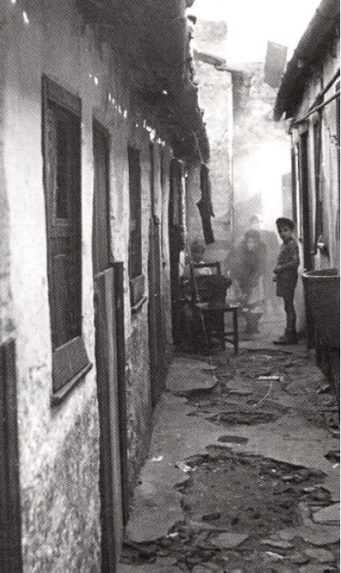
THE “ILHAS” (Islands)
Typical of Oporto the “Ilhas”, as they are known, are the main form of workers’ housing associated with industrialization in the second half of the century XIX. The physical and constructive solution of the “ilhas” is strongly linked to the city’s characteristics and are therefore very different from worker neighborhoods that have emerged in other European cities, and even in other Portuguese cities.

The city of Oporto grew within the Gothic walls into narrow streets that lead to several health problems. In the second half of the XVIII century, estimating the continued population growth of the city, it started extending outside the walls, creating wider streets, larger lots and larger squares. But the city did not have the expected growth in the first decades of the XIX century. There was even a certain population decline because of political factors such as the French invasion (1807-1813) and the Civil War (1832-1834). It is only during the second half of the century XIX, with the growth of the industry and with the decline of agriculture in the northern fields of Portugal, that you start to see a substantial increase in population. Between 1864 and 1900 the population of Porto doubled. The mass construction of “Ilhas” occurred in that time, emphasizing the social differentiation of spaces and thus the transformation of the urban space.

Unique architecture of Porto – the “Ilhas”
With some influence of the British, who already had working-class neighborhoods whose homes had only one front, the so-called back to back houses, the builders created an unique architecture for Porto – the “Ilhas” and knew how to take advantage of the business opportunity by combining the strong demand for cheap accommodation (aimed at industrial workers) with the spatial characteristics of the city.
The typical Porto building was approximately 5.5 m wide and 30,0m long. The owners of these lots, who were often also the owners of the factories, built their houses in the first 30m. They then opened a gateway on the ground floor level of their homes to the street behind it and the remaining 70m were divided into several houses, all served by this same very narrow pedestrian street.
(Watch an excerpt of the video attached - from minute 1.48 to 2:50)
(https://www.youtube.com/watch?v=v64DSFSBkTk&t=55s)
Each house (from 9mto 16m each – inhabited by families of up to 10 members) consisted of a small living room, a tiny bedroom and kitchen with no water supply nor sanitary conditions. Sanitary facilities were usually common to all homes and were located at the back of the street. The houses had a door and a window open to the living room. The other spaces were unhealthy and without natural ventilation. Whole families lived in these houses without the minimal conditions of habitability and coomonly kept their animals inside the house.

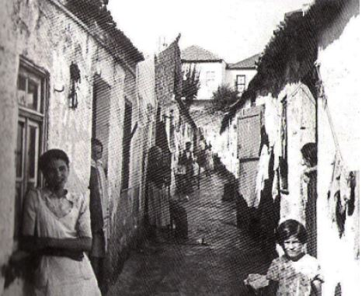

This semi-private area of ​​”Ilhas” generated a climate of mutual care among its inhabitants. In fact the “Ilhas” always functioned as a place of urban integration for newcomers. The fact that the houses had such small areas made people use semi-public spaces as an extension of their private space, since the constructions were of very poor quality (no isolation and lack of privacy). Also the fact that the toilets were outside and common to the various houses reinforced this lack of intimacy of families.

With the threat of epidemics (cholera and bubonic plague) rulers started feeling concerned with health issues. This led to the emergence of revolutionary ideas and a strong mobilization for strikes and protests. In the late nineteenth century and the beginning of the XX century, in part to solve the health and social problems of the “ilhas” there were plans to move the most disadvantaged populations to the most peripheral areas of the city, leaving the valuable city center for the bourgeoisie. However these intents had no great consequence and this “hidden city” that lurked inside the blocks has persisted until today, especially in the Bonfim parishes and Campanhã, where the industrialization process was more intense and where, even today , lies part of the poorest population of Porto. Nowadays the Municipality is starting to reveal a true interest in the recovery of this unique architectures of Oporto – the “Ilhas”, thus valuing them as identity heritage of the city of Oporto.

1) What are “ilhas”? ___________________________________________________________________
____________________________________________________________________________________
____________________________________________________________________________________
2) When and why did “ilhas” appear? ______________________________________________________
________________________________________________________________________________________________________________________________________________________________________
3) What are their most common characteristics? ____________________________________________
________________________________________________________________________________________________________________________________________________________________________
4) Do the “Ilhas” still exist? ______________________________________________________________
________________________________________________________________________________________________________________________________________________________________________
5) What do you expect to see in an “ilha” in Porto? Can you describe how do you imagine one? _______
_________________________________________________________________________________________________________________________________________________________________________
6) What kind of intervention do you think can be done in order to rehabilitate the “ilhas”? _____________________________________________________________________________________
____________________________________________________________________________________
____________________________________________________________________________________
____________________________________________________________________________________

St’ART Creating

Based on what you have learnt about “ilhas” in pairs or groups of three you are going to create your own representation of an “ilha” in modern times. You should use manual techniques of manipulating pictures: drawings and colourings, picture coullage, use cut-outs from magazines and newspapers, natural elements (rocks, sand…) anything is possible. You have also learnt that “ilhas” were originally created to house factory workers. Now think about your “Ilha” and write a description of the profie of the inhabitant of your “ilha”.

Suggested Materials:
- scissors
- glue
- paint, markers, crayons
- fabrics
- coloured paper
- natural elements (sand, sticks, leaves, rocks …)
- needles
- string
- wool / cotton string
- …

Present your work to the class. Talk about your inspiration to create your “ilha”. The students who are going to take part in the mobility to Porto should bring their works to present to their peers.

Most Important of all: HAVE FUN!
Good Work!

