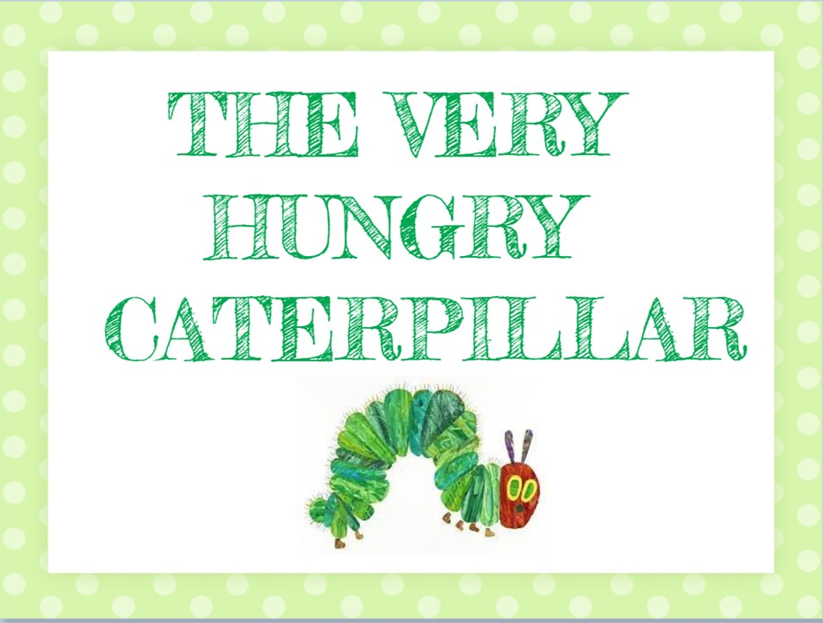

LINK BOOK CREATOR

https://read.bookcreator.com/Tuf1vqCkPXWi1sp7qTEl9FJGK742/1KOKQmW7ReSQ8MEA13YInw

