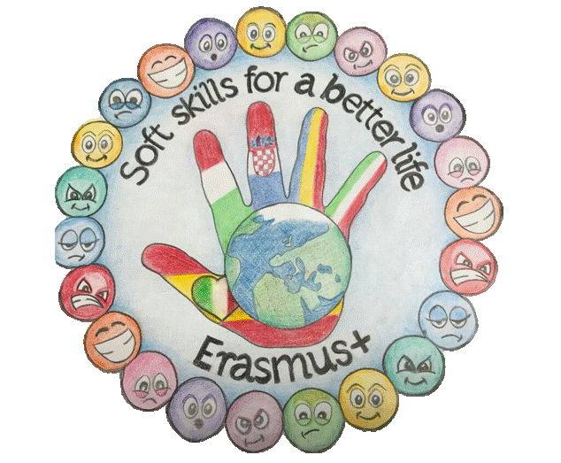
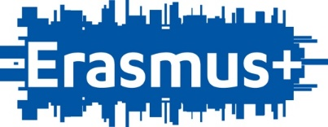

„SOFT SKILLS FOR A BETTER LIFE”
2019 -KA229
Tema:
THE LIGHTHOUSE KEEPER`S RESCUE

Descrierea activității:
The activity took place over several hours and covered several disciplines. The activities were integrated in the curriculum at the Romanian language classes for reading and understanding the text, in the hours of mathematics and science to discover how a beacon is made and what the mechanism of operation is.
Steps :
1. reading and understanding the text
2. reading the text with predictions
3. brainstormig for identifying possibilities of continuation of the text
4 making drawings and mini models
5 use of robots to save the whale

Objective of the activity:
using the accumulated knowledge to identify the most accurate animal rescue solutions on the waterfront
Objectives of the project:

x Encourage students to collaborate and work together.
X Development of communication skills (talking, presenting ideas and solutions to a problem, listening, understanding, empathy for a second and different opinion),
x Problem solving (thinking, critical thinking, developing skills to deal with a problem, etc.).
Development of skills for concentration and time management.
X Self-regulation of learning, working in a conflict-free group and how to cope with success and failure

Key competences (to round out the ones highlighted during the implementation of the above activities):
The eight key competences are:
X 1. Communication in the mother tongue: the ability to express and interpret concepts, thoughts, feelings, facts and opinions verbally and in writing;
2. Communication in a foreign language: as mentioned above, but also includes mediation skills (ie, compression, paraphrase, interpretation or translation) and intercultural understanding;
3. Mathematical, scientific and technological competence: good mastery of mathematical literacy, understanding of the natural world and ability to apply knowledge and technology to human needs (such as medicine, transportation or communication);
4. digital competence: the safe and critical use of information and communication technologies for work, recreation and communication;
5. learn how to learn: the ability to effectively manage one's own learning, alone or in groups;
6. social and civic competences: the ability to participate effectively and constructively in social and working life and to participate in active and democratic participation, especially in increasingly diverse societies;
7. A sense of initiative and entrepreneurship: the ability to transform ideas into activities through creativity, innovation and risk-taking, as well as the ability to plan and manage projects;
8. Cultural awareness and expression - The ability to appreciate the creative importance of ideas, experiences and feelings in the media, such as music, literature and visual arts and shows.

21st century skills (rounding and / or correspondence)
Creativity, organization, persistence, confidence, knowledge of languages, communication, desire for change, work for you,
Class (and age of students): II A Class, School Elena Doamna, Tecuci, Romania
Key question (s)
* Questions that encourage students to think and learn, questions with problems, motivational questions, questions that encourage discussion and dialogue.

What can Mr. Gringling see through the binoculars?
Why was the whale wrecked?
How does a whale live?
How and with what can I save the whale on the water's edge
STEPS | ACTIVITIES | AIM | RESULTS
MOTIVATION | reading the text in the classroom using in the presentation the images from the book  reading the text with predictions | - understanding  of the text and the possibility of reproducing the actions in the text  - increasing  interest in reading  - use of the  imagination and identify possible situations | the students were attentive throughout the reading of the text, gave possible solutions to continue the story
EXPLORATION | students searched for information on whale life on the internet  they discussed their way of life, their way of feeding | knowing the information about the animals in the marine environment | participated in debates on working groups where they presented the discovered information
CLARIFICATION
PRESENTATION OF RESULTS
EVALUATION

Trebuie adăugate fotografii cu activitatea studentului sau un link către videoclip și / sau rezultatele muncii
IMAGES | STEPS | STUDENTS

RUBRICA DE EVALUARE

My name is Adriana Lefter, primary school teacher in School Elena Doamna, Tecuci - Romania and with my 8 years old students we start a great adventure during this online teaching period.
Starting from the text The Lighthouse keeper`s lunch that we read together in the online activities, we explored the text and we carried out various activities. It was a good opportunity for students to communicate in their mother tongue, to express and interpret concepts, thoughts, feelings, facts and verbal opinins and also in writing activities as well as communicating in a foregn language for interpretations or translation of words and expressions. They do this creating comics about the text using online tools or drawings.
My name is Adriana Lefter, primary school teacher in School Elena Doamna, Tecuci - Romania and with my 8 years old students we start a great adventure during this online teaching period.
Starting from the text The Lighthouse keeper`s lunch that we read together in the online activities, we explored the text and we carried out various activities. It was a good opportunity for students to communicate in their mother tongue, to express and interpret concepts, thoughts, feelings, facts and verbal opinins and also in writing activities as well as communicating in a foregn language for interpretations or translation of words and expressions. They do this creating comics about the text using online tools or drawings.
Students reposted from the point of view of each character, surpassing the states, emotions and impressions.
We also learned about the history of lighthouses, studying on the geographical map, Google maps, the position of the most famous lighthouses, but also how they were built, the height, position, shape of the headlamps. It was the first time students discovered what a radar is, where it is used and how. Together with the parents the students discovered how an electrical circuit works, what materials are needed and what is the lightning bolt, located at the top of a lighthouse.
Reading the text they discovered what lunch Mr. Gringling had and which we wanted to make as healthy as possible, the students writing different healthy lunch recipes and drawing and preparing lunch for him. They also find out the weight of different items in their lunch. What is the total weight? We choose two types of sandwich and we make a Venn diagram to show which they like / don't like.
It was a very pleasant experience when the students modeled from dough made of flour, salt and water the lighthouse, the house of the lighthouse keeper, the waves and the seagulls. Using this model, the students presented their ideas about other solutions they had developed so that the seagulls would not eat Mr. Gringling's lunch. How? using technology, changing habits, inventing new ways to pack the basket, to feed the seagulls so that lunch to reach Mr. Gringling.
Thus we acquired new skills, we practiced our creativity, organization, confidence, knowledge of languages, communication, desire to change all using STEM, because STEM is everywhere, STEM mean all disciplines together.

