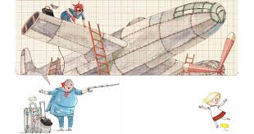
Rosie Revere, little engineer
de A .Beaty

Rosie Revere was a withdrawn little girl, silent, even strange, who made up all sorts of crazy devices: helium pants, python chase hat, hot dog food.
One summer, Aunt Rose, an aviation engineer, comes to visit them at home. The two had a very close relationship and, in a discussion, she tells the girl that she has an unfulfilled wish: although she had worked with airplanes all her life, she had not been able to fly.
Rosie begins to think about what aircraft her aunts can build. Night and day he thinks, masters and, in the end, builds his aircraft: the cheese-copter.
Students have to guess and design the aircraft that they believe was invented by Rosie: airplanes, helicopters, missiles.

Clasa a II a B.
Prof. Arghire Oana

