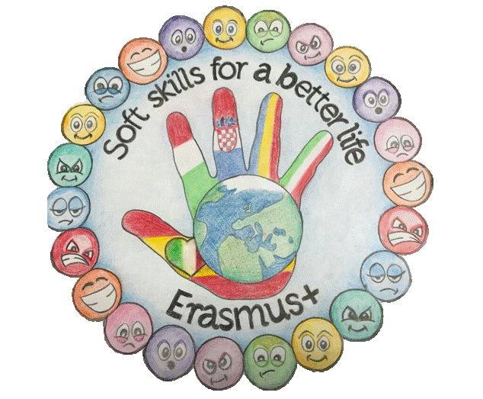

„SOFT SKILLS FOR A BETTER LIFEˮ2019 -KA229

RAPUNZEL
by the Grimm Brothers

A man lived with his wife in a house next door to a witch's house.
The wife longed to eat the lettuces in the witch̕ s beautiful garden.
One day, the husband decided to steal some of the lettuces for his wife. The witch caught him and asked for the baby the wife was to give birth to in exchange for the salad.
The little girl was born, the witch took her and named her Rapunzel.
When Rapunzel grew up, the witch locked her away in a tower in the middle of the forest. The girl had very large golden hair.
The witch visited her and to get to the tower she asked Rapunzel to let her hair down so she could climb on it.
One day, a handsome prince found the tower in the forest. He watched the witch come to the tower and climb Rapunzel's hair.
Suddenly the prince looked an ugly dwarf.
-You couldn’t bring Rapunzel!- the dwarf said.
- Fight with me, if you want the girl! I have a riddle for you! If you know it, Rapunzel is free. If you don’t, Rapunzel will live with me in the tower.
- Okey, I would hear your riddle! What is it?- the prince asked.
- One man read a book in a dark room! There is no light. How can the man read?
The prince thinking, and suddenly he said:
It’s not make sence dwarf. Fight with me as a man with a man!
The prince toke out his sword , and fight with the dwarf.
-Don’t kill me! Please! – the dwarf said.
Live with Rapunzel in happiness. Go away!
Prince and Rapunzel jumped out the tower with a parachute and
They live together for a long time with happiness.

BÎRA ILINCA, TECUCI

