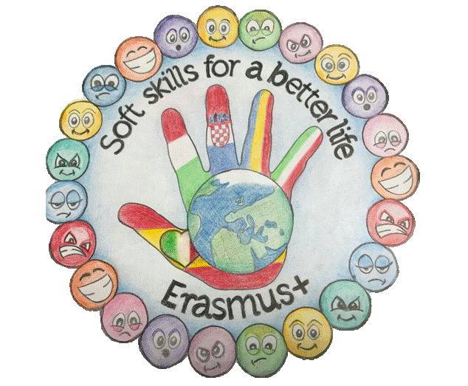

„SOFT SKILLS FOR A BETTER LIFEˮ 2019 -KA229

RAPUNZEL
by the Grimm Brothers

A man lived with his wife in a house next door to a witch's house.
The wife longed to eat the lettuces in the witch̕ s beautiful garden.
One day, the husband decided to steal some of the lettuces for his wife. The witch caught him and asked for the baby the wife was to give birth to in exchange for the salad.
The little girl was born, the witch took her and named her Rapunzel.
When Rapunzel grew up, the witch locked her away in a tower in the middle of the forest. The girl had very large golden hair.
The witch visited her and to get to the tower she asked Rapunzel to let her hair down so she could climb on it.
One day, a handsome prince found the tower in the forest. He watched the witch come to the tower and climb Rapunzel's hair.
When the witch had gone, the prince climbed Rapunzel's hair.
The two saw each other and decided to stay together.
The witch confuses their plans, but in the end Rapunzel and the prince found themselves and lived happily ever after in his kingdom.

BÎRA ILINCA, TECUCI

