Hi!
My name is Helen and I'm 10 years old. I'm in Class E.
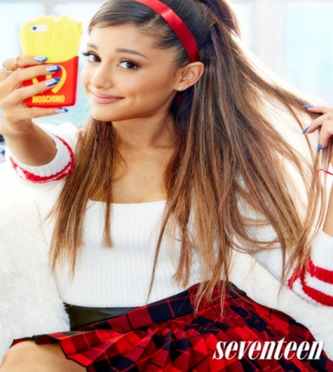
I live in Piraeus. My favorite singer is Ariana Grande. My favorite actor is Victoria Justus.

My favorite song is “Break free”. My favorite movie is “Frozen” and my favorite color is blue.
My favorite T.V. channel is Nickelodeon. I LOVE singing and dancing, too.
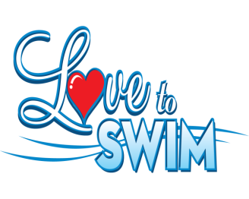
I like swimming and playing different games.

My hobby is drawing. What about you?

Please write soon.
Bye!

Helen

