Hello!
My name is Nassia.
I am 10 years old and I'm in E1 class.
I live in Greece, in the area of Kallithea.
I have got one mum and one dad but I haven't got a brother or a sister. My favorite hobbies are horse riding and dancing.
My favorite colour is blue.
Bye!
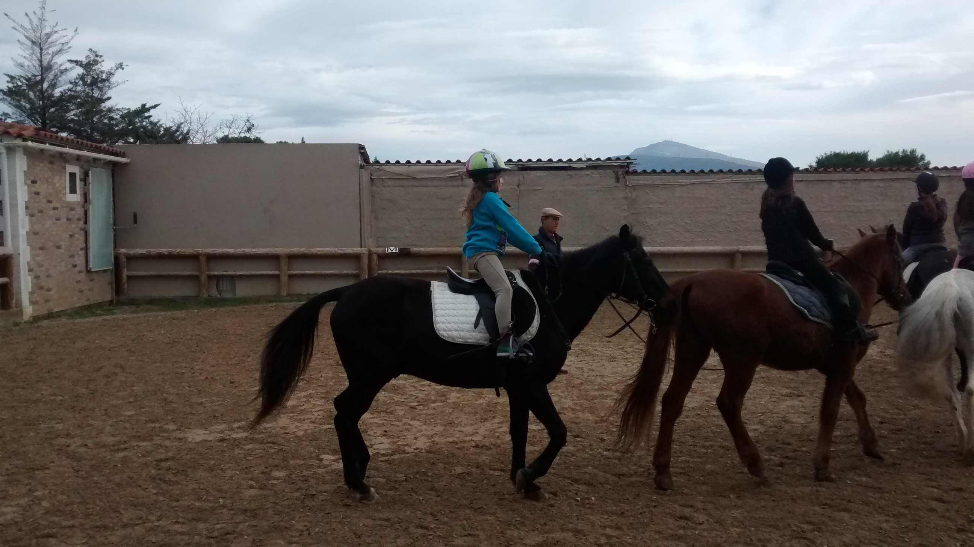
Nassia

