SECTION 1, ACTIVITY 6
HEALTHY EATING
THE ENGLISH/SCIENCE (CLIL) CLASS

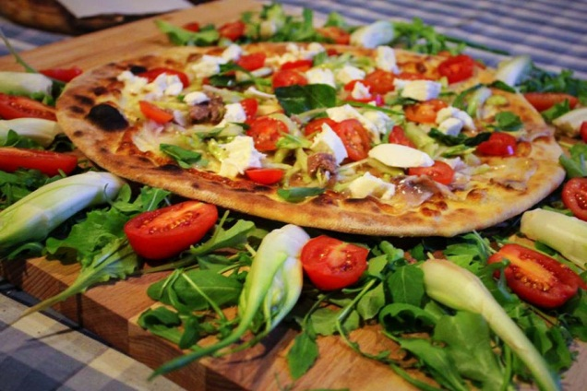 “A HEALTHY AND YUMMY DISH”

- DURATION: 60 minutes

- LEVEL: UPPER - INTERMEDIATE

- OBJECTIVES:

- to become aware of how important it is eating a nutritional balanced dish
- to understand that a nice-to- see and coloured dish can be healthy
- to learn how to prepare a meal that is complete in its nutritional ingredients

- MATERIALS: - photos, book, internet, notepads, markers, worksheets

- METHODS: brainstorming, research, reflection, pair and group work

- WARM UP:

The students are asked to think about the food they prefer and to consider if it is balanced with vegetables,fruits, grains,protein, dairy. They are asked to work in pairs first and then in group.

- METHODOLOGY:

- The teacher writes the concept “HEALTHY DISH” on the whiteboard and elicits some responses about what it means. He/she asks them what they think a balanced menu means.

- The teacher shows the students for 5 – 6 seconds, 7 or 8 photos representing different dishes and are asked to write down the answers to the following questions:
- What are the first words and impressions that come to your mind when you see them?
- What do you think about them?

- The teacher shows the photos on the whiteboard and asks them to write and describe the dishes in a small paragraph.

- Debate: The topic: What is the healthiest dish?

- The students are divided in groups and prepare different healthy menus.

- REFLECTION WORKSHEET AND EVALUATION:

QUESTION 1: What are the dishes or food that young people like?
QUESTION 2: How can people maintain good health and reduce their risk of disease?

Activity created by Italy.

