eTwinning project “ΖΟΟ”
COW
Draw spots in every cow. The number will tell you how many!
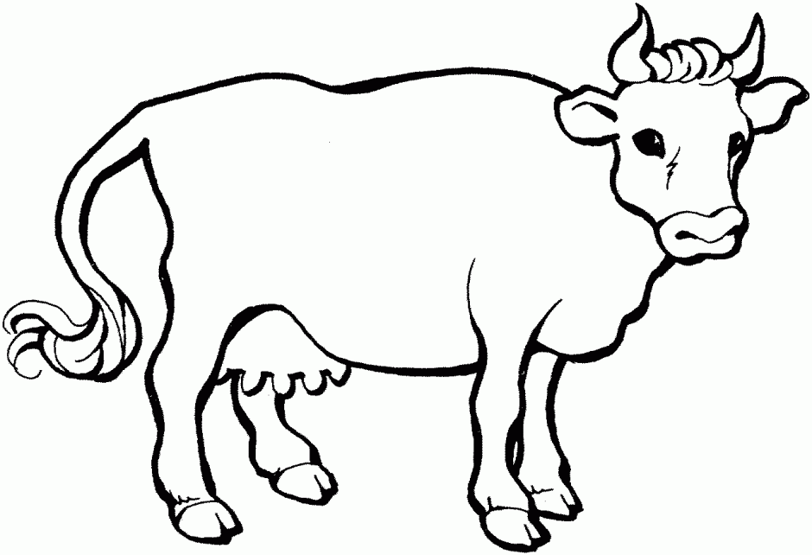 | 2
 | 4
 | 5
 | 6
 | 8
 | 1

