eTwinning project: “ZOO”
Subject: Bear
Color the letter B, with grey or brown. Then color the letter A with blue or green.
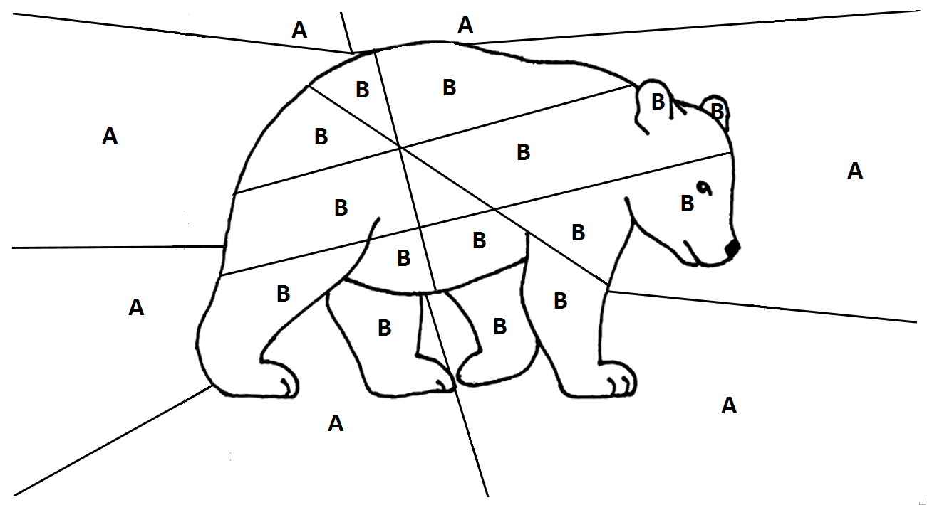
Kindergarten of Avlonari, Evia, Greece

