1. Activity Information
Subject/Course: Algebra | Teacher: Mihaela Git
Grade Level: 6th | Topic: Percents
Length of Period: 2 lessons

2. Expectations or Goals
Expectation(s) ( from school Curriculum):

Students will be able to define the notion of percent, to give examples of percentage reports.
Students will be able to transform an ordinary or decimal fraction in percent and reciprocally.
Students will determine the number of equal parts that divides a square sheet of origami after each folding.
Students will be able to determine the equals parts of the square.
Students will construct reports, comparing parts to the whole square. They will convert reports in percentage reports, then in percentage.
Students will calculate the area of a part from the square unit in the origami paper.

3. Content
- Definition: a percentage is a number or ratio expressed as a fraction of 100.
- It is often denoted using the percent sign, "%".
- A percentage is a dimensionless number (pure number).
- "Percent" comes from the latin Per Centum. The latin word Centum means 100, for example a Century is 100 years.
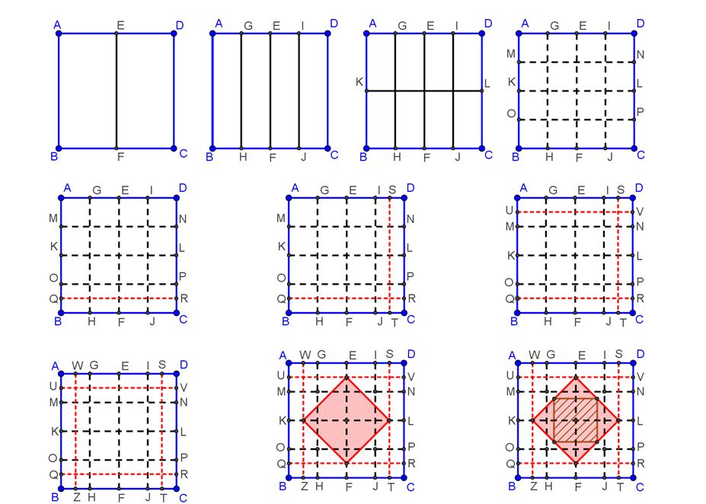

4. Description of Activity

How to make a heart-shaped CLOVER

Give to pupils 15cm × 15 cm square papers; to use pencil, ruler.
It asks the students to build with each folding origami clover and observe the parts of the square. They will determine relations between the areas of the rectangle or smalls squares in report with the square unit.
- the students will recognize the equals parts; they will construct reports, comparing parts to the whole square. They will convert reports in percentage reports, then in percentage.
- to find the values of the corresponding percents

Number of times folded | Percents | Figures
1. | $$A_{CDEF}=\frac{1}{2}A_{ABCD}$$  $$\frac{1}{2}=50\%$$
2. | $$A_{EFJI}=\frac{1}{2}A_{EFJI}=\frac{1}{4}A_{ABCD}$$  $$\frac{1}{4}=25\%$$
3. | $$A_{1}=\frac{1}{4}A_{ADLK}=\frac{1}{4}A_{CDEF}==\frac{1}{8}A_{ABCD}$$  $$A_{1}=\frac{1}{8}A_{ABCD}$$  $$\frac{1}{8}=12.5\%$$ | A₁
4. | $$A_{2}=\frac{1}{2}A_{1}=\frac{1}{16}A_{ABCD}$$  $$\frac{1}{16}=6.25\%$$ | A₂
5. | $$A_{3}=\frac{1}{2}A_{2}=\frac{1}{32}A_{ABCD}$$  $$\frac{1}{32}=3.125\%$$ | A₃
6.-8. | $$A_{4}=\frac{1}{2}A_{3}=\frac{1}{64}A_{ABCD}$$  $$\frac{1}{64}=1.5625\%$$  $$A_{5}={\left(\frac{6}{8}\right)}^{2}∙A_{ABCD}=\frac{9}{16}A_{ABCD}$$  $$\frac{9}{16}=56.25\%$$ | A₅  A₄
9.-12. | $$A_{6}=\frac{1}{2}A_{5}=\frac{9}{32}A_{ABCD}$$  $$\frac{9}{32}=28.125\%$$ | A₆
13.-16. | $$A_{7}=\frac{1}{2}A_{6}=\frac{9}{64}A_{ABCD}$$  $$\frac{9}{64}=14.0625\%$$ | A₇

5. Photos
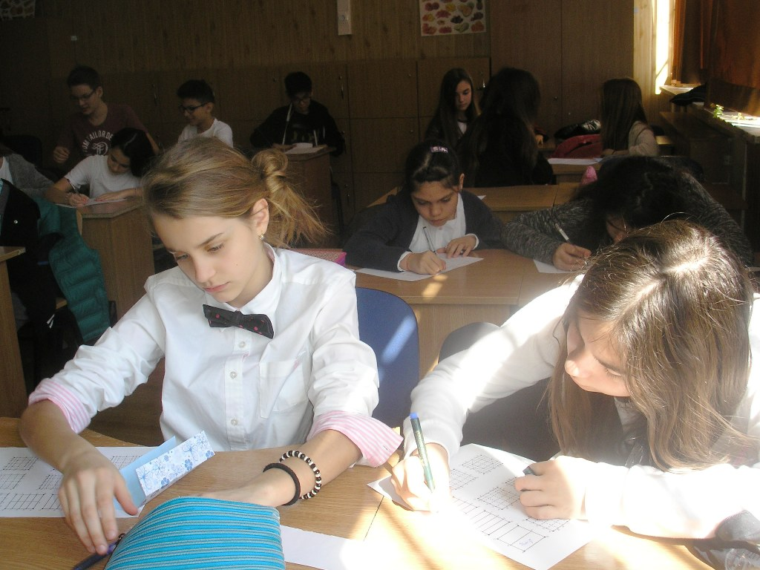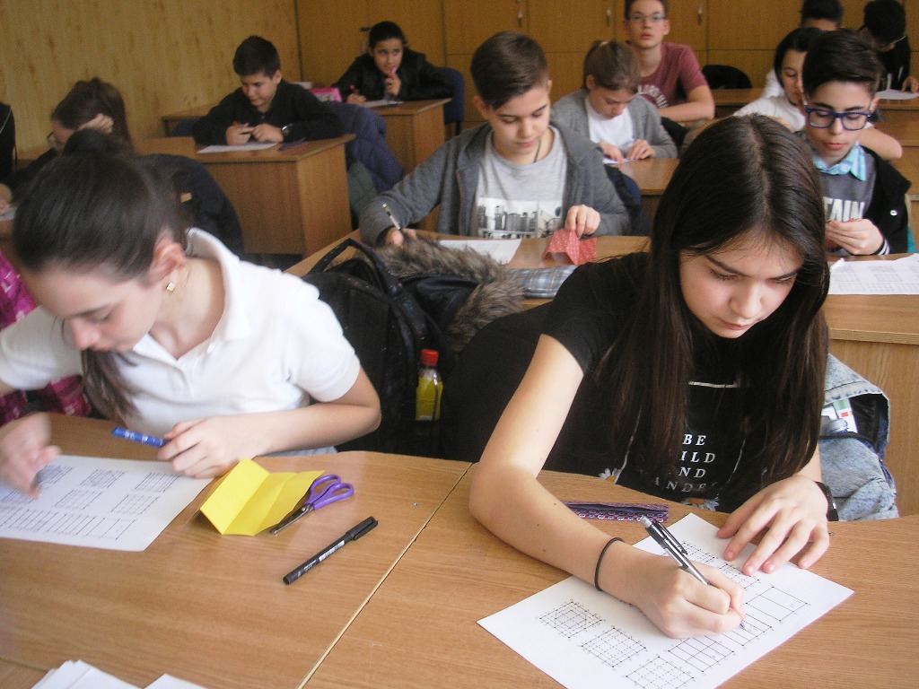

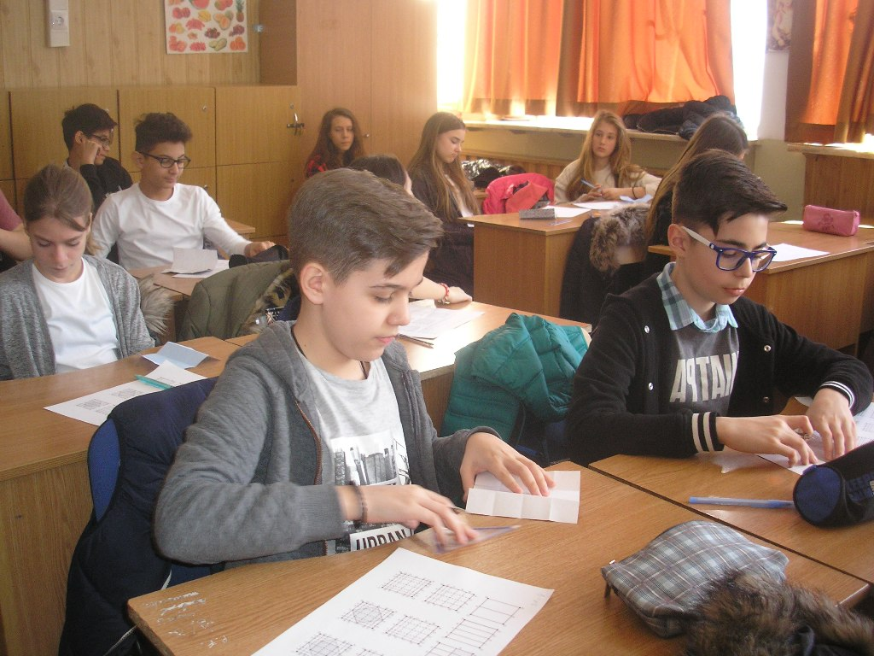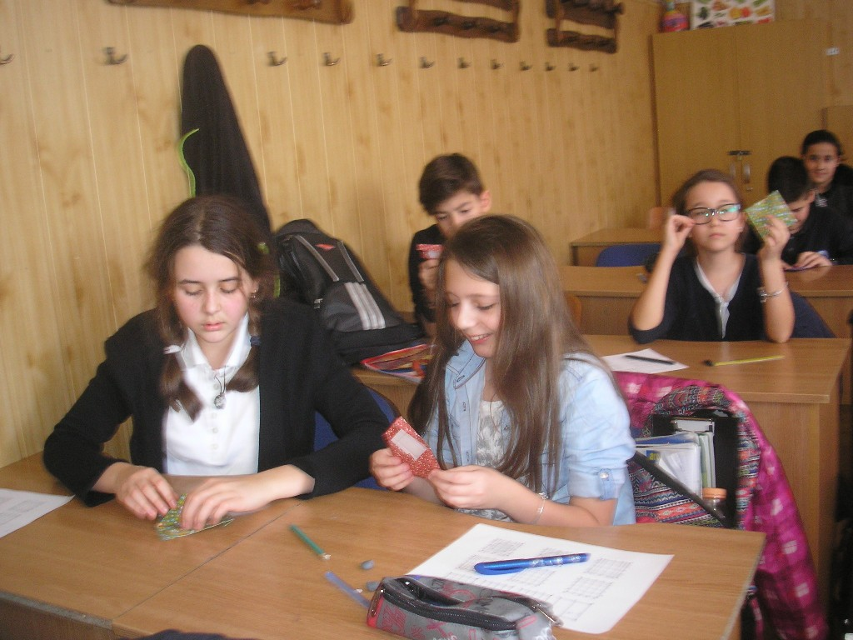

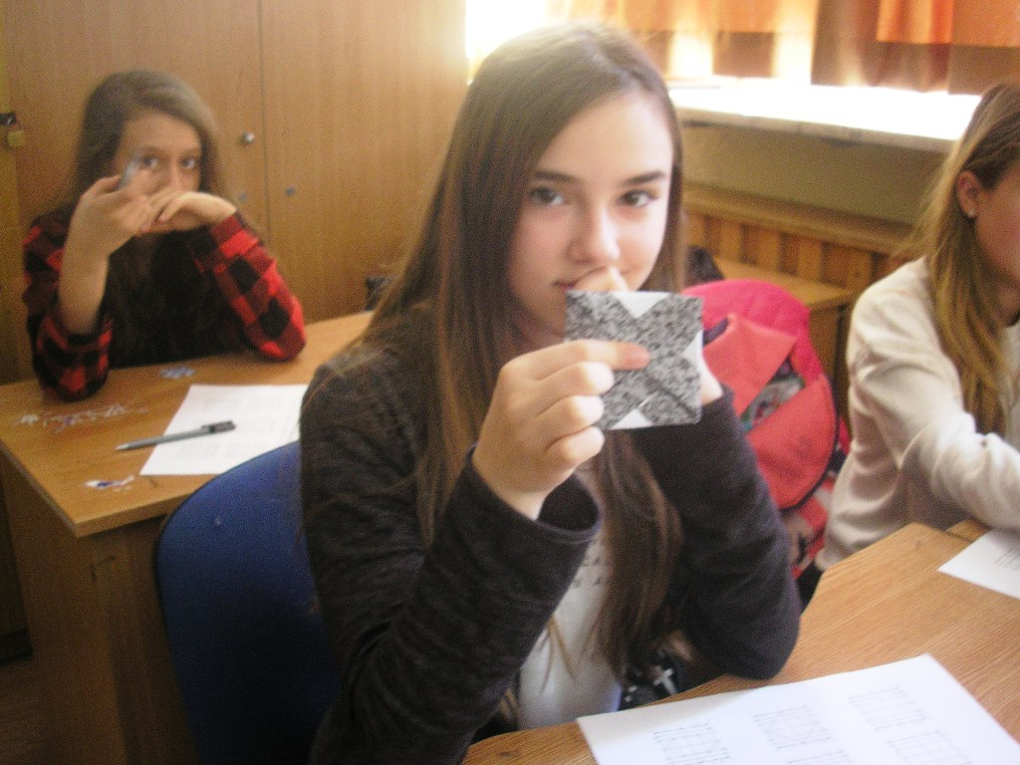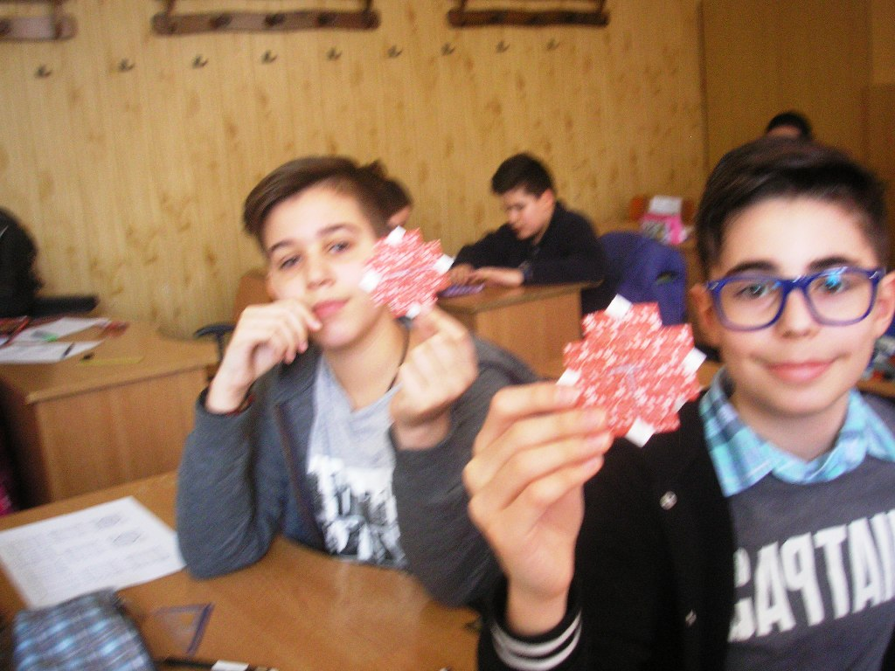

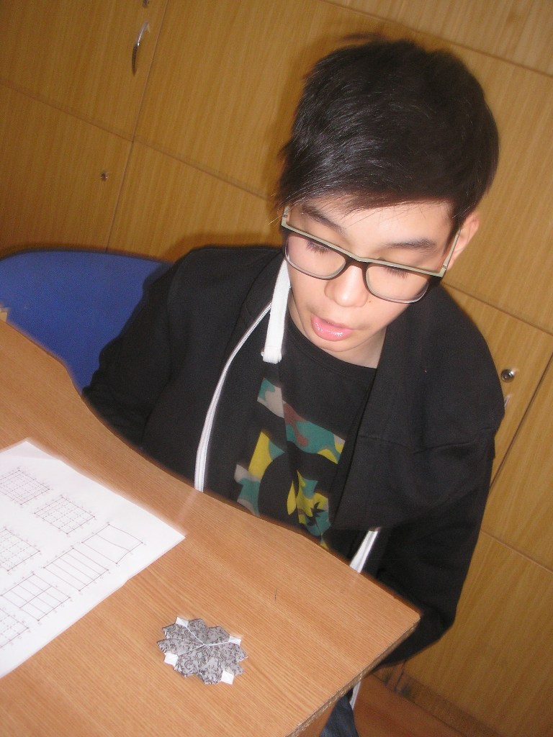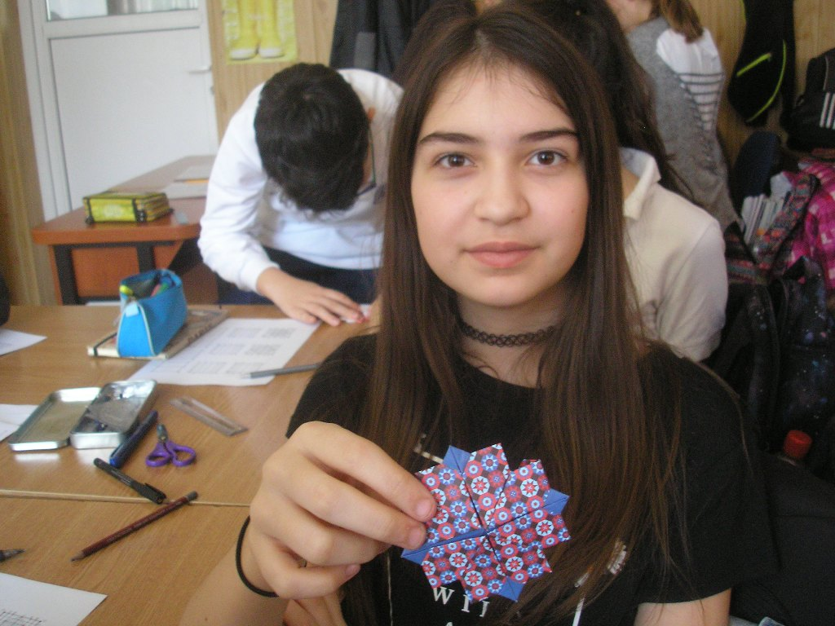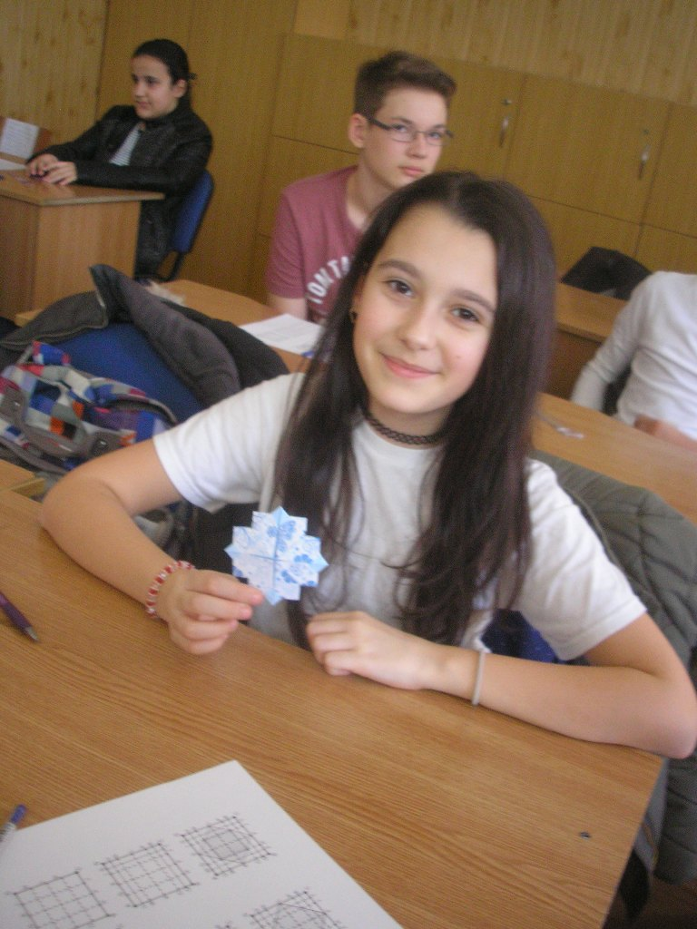

6. Video link:
https://www.youtube.com/watch?v=bQ-HArHr15Q for origami tutorial
http://www.kizoa.com/Video-Editor-Movie-Maker/d41844407k4586526o1l1/percents--origami-heart-clover

