International Co-operation
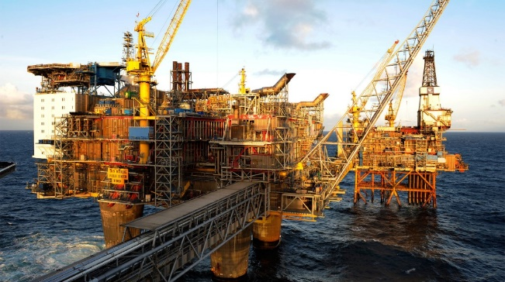
Norway’s use of energy upon the years is often associated with great access to renewable energy-sources like bioenergy, water-power and wind-power. We do also have great access to non-renewable energy like natural-gasses and oil. Oil has been an important role in Norwegian history, and ever since the norwegians found the oil in the 1960’s, it has been very useful for the Norwegian economy.

Windpower
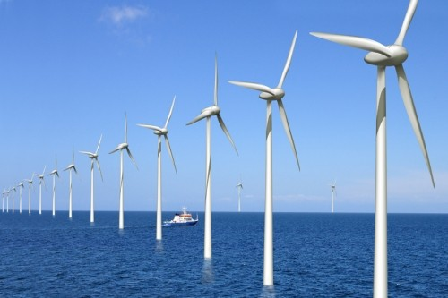
Windpower is one of the most environmentally friendly form of large-scale power generation. Wind turbines produce electricity by transforming the winds kinetic energy to electricity power. Europa's best wind resources are in Norway and Great Britain. Wind power is non-polluting.
Hydro energy
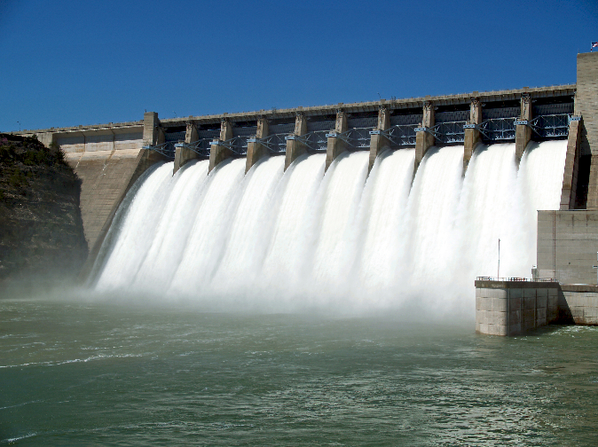
Hydro energy is an environmentally friendly, renewable power-source. 99% of all power-generation in Norway comes from hydropower. 1/6 of the earths total power-generation comes from hydropower. Hydropower is non-polluting.
Remote Heating system
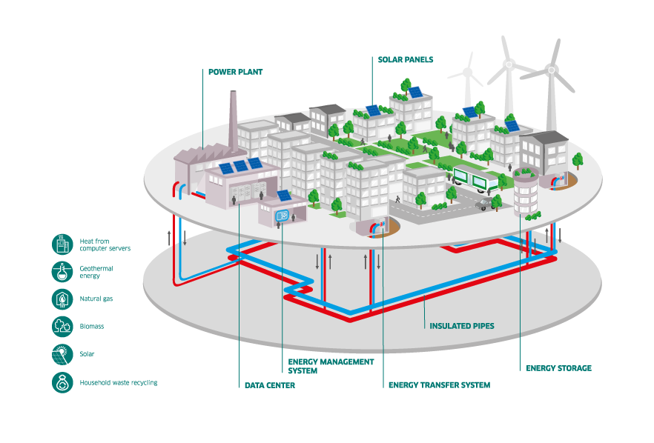
Remote heating is the concept of heating up water. A remote heating system can, supply one or more buildings with hot water. The hot water circulates between the heating central and the customers central in buried, insulated steel pipes.
Solar Power
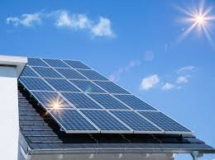
The energy from the sun`s radiations is named solar power. It comes in the form of heat and light, and it can be converted to different forms of energy. The most usual is electricity. Photovoltaic cells convert the energy from the sun to electricity.
Gas
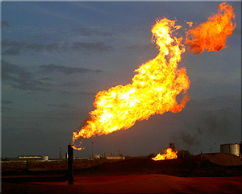
Gas power have the lowest CO2-emissions of all fossil fuel-based power plants and can replace the far more polluting oil and coal-based electricity production. In Norway the emissions in 2015 were 13,49 million tons.

